Final Portfolio

Networked Appetite

Team Members

-Aakriti Neupane

-Anamika Kafle

-Bishwas Ghimire

-Gaurab Rana

-Mansi Deep

Table of Contents

1. Project Planning
2. Project Charter V1 ---------------- 4
3. Project Charter V1.1 ---------------- 7
4. Belbin Analysis
5. Individual Belbin Analysis ---------------- 11
6. Team Belbin Analysis ----------------- 12
7. Skill Audit
8. Team Skill Audit ------------------ 20
9. Individual Skill Audit ------------------ 21
10. Project Management
11. Gantt Chart ------------------ 22
12. Task Sheet ------------------ 24
13. Timeline
14. Resource Sheet
15. Calendar
16. Network Diagram
17. Change Working Time
18. Work Breakdown Structure Code (WBS)
19. Communication and collaboration Tools
20. Team Meeting
21. Product Designing
22. EERD
23. ERD
24. Extended Entity Relation Diagram
25. Final Composite EERD
26. Logical
27. Use Case Diagram
28. Overview Use Case Diagram
29. Customer Use Case Diagram
30. Trader Use Case Diagram
31. Admin Use Case Diagram
32. Requirement Catalogue
33. Functional Requirement
34. Non-Functional Requirement
35. Logo Design
36. Wireframes
37. Product Development
38. Screenshots
39. Homepage
40. Early Testing Phase
41. Product Testing
42. Admin Interface Testing (Apex)
43. Trader Interface Testing (Apex)
44. Trader Interface Testing (PHP)
45. User Interface Testing (PHP)
46. Frequently Asked Question (FAQ’S)

**Project Charter 1**

|  |
| --- |
| Project Title:NetworkedAppetite  Sponsor: The British College  Project Manager: Rohit Raj Pandey  Customer: Citizens of Cleckhuddersfax |

Version Control

|  |  |  |
| --- | --- | --- |
| Version | Date | Summary of changes |
| 1 | Feb 3rd | *Initial version* |
|  |  |  |
|  |  |  |

Project Justification

|  |
| --- |
| This e-commerce site is based on those traders who put their joint effort to build an ecommerce platform in order to sell their fresh products and justify to customer basic needs and requirements. Traders like butchers, greengrocer, fishmonger, bakery and delicatessen are arranged to keep their respective items in an appropriate form so that they can be benefitted with self-profit while enjoying quality time with their family. Also, traders can be benefitted from their item as they reach to customers door step in their manageable time. In this site, both traders and customers are benefitted whereas management is also benefitted with their ideas and creativity. Traders are allowed to access their interface via user login.When adding an item to their particular interface, they are recommended to add their items with a short description about thecost of the item, amount per item, stock accessible, minimum as well as maximum order information and furthermore ought to incorporate about their positive and negative side of their items. For the payment purpose, API interface will be used which includes PayPal. Lastly, this e-commerce site is good for the productive use of customers as well as traders which is a plus point in this challenging world. |

Project Scope

|  |
| --- |
| *Objectives listed here should relate to the purpose stated above, so should be concerned with business improvement, end-user experience, quality enhancement etc. The objectives should be SMART:*  ***S – Specific***   * Ecommerce website for buying and selling fresh goods. * Business thrive more through online platform as it saves time for both traders and customers. * Local shop traders providing fresh goods to customers. * Prototype web based online system * Providing goods to customers on daily basis.   ***M –Measurable***   * Takes 58-62 days to complete * Higher profit with positive customer reviews * Higher goods order value and repeating customers. * Maintaining higher profile   ***A – Achievable***   * Policies, objectives and actions of a particular stakeholder who are obligated to have a clear and detailed understanding of the rights of obligations. * To meet the goal, we will set milestones to keep everyone motivated. Each member will contribute their part of work while helping each other in every milestone.   ***R – Relevant***   * Increasing margins contributes to improving profit that will help traders to gain confidence towards this online system.   ***T – Time Bound***   * Site’s completion within the mid of May with all the respective requirements.(A time-restrained goal is intended to establish a sense of urgency.) |
| ***Customer Interface***   * Navigation to products by shop or by product type. * Add goods to cart without logging to website. * Login and registration system. * Give reviews about products and change their account details. * Choose available collection slot after 24 hours of order confirmation. * Payment through PayPal.   ***Traders Interface***   * Products CRUD operations. * Generate daily and monthly reports. * Unique product items. * Specific trader account. * Admin role to access whole system.   ***Admin Interface***   * Admin dashboard to view overall statistics. * Daily reports of goods and quantities. * Weekly finance reports. * Monthly reports on product sales. |
| **Major Deliverables:**   * E-commerce website with customer and trader interface. * Implementing PayPal API for all payments done by customers. * Admin has full authority on managing the products. * E-commerce website is linked with database. |

Duration

|  |
| --- |
| Initial: Feb 3rd 2020  Work in Progress: March 18th 2020  Final: May 15th 2020 |

Estimated Budget

|  |
| --- |
| Gaurab Rana   * Daily = 2.5 hrs * Weekly = (2.5*5)= 12.5hrs * Monthly=(2.5*20) = 50 hrs * Up to week 12=12.5*12=150   Mansi Deep   * Daily = 2 hrs * Weekly = (2*5) = 10hrs * Monthly= (2*20) = 40 hrs * Up to week 12=10*12=120   Bishwas Ghimire   * Daily = 2 hrs * Weekly = (2*5) = 10hrs * Monthly= (2*20) = 40 hrs * Up to week 12=10*12=120   Aakriti Neupane   * Daily = 2.5 hrs * Weekly = (2.5*5) = 12.5hrs * Monthly= (2.5*20) = 50 hrs * Up to week 12=12.5*12=150   Anamika Kafle   * Daily = 2.5 hrs * Weekly = (2.5*5)=12.5hrs * Monthly=(2.5*20) = 50 hrs * Up to week 12=12.5*12=150   TotalEstimated Hourup to week=690 hours |

Roles and Responsibilities

|  |  |
| --- | --- |
| Name | Role |
| Aakriti | *Primary= Monitor Evaluator- Considers all resource available and weighs up the team’s option.*  *Secondary = Implementer-Plan a workable strategy and work accordingly.*  *Least Likely=Plant-Free thinking and generates idea.* |
| Anamika | *Primary= Co-ordinator-Focus on the team’s objective and delegate work accordingly.*  *Secondary =Monitor Evaluator- Considers all resource available and weighs up the team’s option.*  *Least Likely=Implementer- Plan a workable strategy and work accordingly.* |
| Bishwas | *Primary= Team-worker- Co-operate and helps the team to complete the work.*  *Secondary = Resource Investigator- Collect resource and find ideas*  *Least Likely=Co-ordinator- Focus on the team’s objective and delegate work accordingly.* |
| Mansi | *Primary= Resource Investigator-Collect resource and find ideas.*  *Secondary =Team worker- Co-operate and helps the team to complete the work.*  *Least Likely=Implementer-Plan a workable strategy and work accordingly.* |
| Gaurab | *Primary= Specialist-Provides specialist knowledge in depth.*  *Secondary = Shaper- keeps the team devoted to their work.*  *Least Likely=Completer Finisher-Checks the project after completion and finalizes.* |

Communication and Collaboration Tools

|  |
| --- |
| * *Documentation –* All documentation generated on the project will be stored in a sharedgoogle drive. * *Team Meetings –* Everyday 15-20 minutes before continuing the project. * *Communication-* A slack group, Skype, Discord, Igloo will be used to communicate between team members. * *Project Tracking –*MS Project 2010. |

**Project Charter 1.1**

|  |
| --- |
| Project Title: Networked Appetite  Sponsor: The British College  Project Manager: Rohit Raj Pandey  Customer: Citizens of Cleckhuddersfax |

Version Control

|  |  |  |
| --- | --- | --- |
| Version | Date | Summary of changes |
| 1 | Feb 3rd | *Initial version* |
| 2 | April 15th | Final version |
|  |  |  |

Project Justification

|  |
| --- |
| This e-commerce site is based on those traders who put their joint effort to build an ecommerce platform in order to sell their fresh products and justify to customer basic needs and requirements. Traders like butchers, greengrocer, fishmonger, bakery and delicatessen are arranged to keep their respective items in an appropriate form so that they can be benefitted with self-profit while enjoying quality time with their family. Also,traders can be benefitted from their item as they reach to customers door step in their manageable time. In this site, both traders and customers are benefitted whereas management is also benefitted with their ideas and creativity. Traders are allowed to access their interface via user login.When adding an item to their particular interface, they are recommended to add their items with a short description about thecost of the item, amount per item, stock accessible, minimum as well as maximum order information and furthermore ought to incorporate about their positive and negative side of their items. For the payment purpose, API interface will be used which includes PayPal. Lastly, this e-commerce site is good for the productive use of customers as well as traders which is a plus point in this challenging world. |

Project Scope

|  |
| --- |
| *Objectives listed here should relate to the purpose stated above, so should be concerned with business improvement, end-user experience, quality enhancement etc. The objectives should be SMART:*  ***S – Specific***   * Ecommerce website for buying and selling fresh goods. * Business thrive more through online platform as it saves time for both traders and customers. * Local shop traders providing fresh goods to customers. * Prototype web based online system * Providing goods to customers on daily basis.   ***M –Measurable***   * Takes 58-62 days to complete * Higher profit with positive customer reviews * Higher goods order value and repeating customers. * Maintaining higher profile   ***A – Achievable***   * Policies, objectives and actions of a particular stakeholder who are obligated to have a clear and detailed understanding of the rights of obligations. * To meet the goal, we will set milestones to keep everyone motivated. Each member will contribute their part of work while helping each other in every milestone.   ***R – Relevant***   * Increasing margins contributes to improving profit that will help traders to gain confidence towards this online system.   ***T – Time Bound***   * Site’s completion within the mid of May with all the respective requirements.(A time-restrained goal is intended to establish a sense of urgency.) |
| ***Customer Interface***   * Navigation to products by shop or by product type. * Add goods to cart without logging to website. * Login and registration system. * Give reviews about products and change their account details. * Choose available collection slot after 24 hours of order confirmation. * Payment through PayPal.   ***Traders Interface***   * Products CRUD operations. * Generate daily and monthly reports. * Unique product items. * Specific trader account. * Admin role to access whole system.   ***Admin Interface***   * Admin dashboard to view overall statistics. * Daily reports of goods and quantities. * Weekly finance reports. * Monthly reports on product sales. |
| **Major Deliverables:**   * E-commerce website with customer and trader interface. * Implementing PayPal API for all payments done by customers. * Admin has full authority on managing the products. * E-commerce website is linked with database. |

Duration

|  |
| --- |
| Initial: Feb 3rd 2020  Work in Progress: March 18th 2020  Final Presentation: June 15th 2020  Team Portfolio: June 18th 2020 |

Estimated Budget

|  |
| --- |
| Gaurab Rana   * Daily = 2.5 hrs * Weekly = (2.5*5)= 12.5hrs * Monthly=(2.5*20) = 50 hrs * Up to week 16=12.5*16=200   Mansi Deep   * Daily = 2 hrs * Weekly = (2*5) = 10hrs * Monthly= (2*20) = 40 hrs * Up to week 16=10*16=160   Bishwas Ghimire   * Daily = 2 hrs * Weekly = (2*5) = 10hrs * Monthly= (2*20) = 40 hrs * Up to week 16=10*16=160   Aakriti Neupane   * Daily = 2.5 hrs * Weekly = (2.5*5) = 12.5hrs * Monthly= (2.5*20) = 50 hrs * Up to week 16=12.5*16=200   Anamika Kafle   * Daily = 2.5 hrs * Weekly = (2.5*5)=12.5hrs * Monthly=(2.5*20) = 50 hrs * Up to week 16=12.5*16=200   Total Estimated Hour up to week 16=920 hours |

Roles and Responsibilities

|  |  |
| --- | --- |
| Name | Role |
| Aakriti | *Primary= Monitor Evaluator- Considers all resource available and weighs up the team’s option.*  *Secondary = Implementer-Plan a workable strategy and work accordingly.*  *Least Likely=Plant-Free thinking and generates idea.* |
| Anamika | *Primary= Co-ordinator-Focus on the team’s objective and delegate work accordingly.*  *Secondary =Monitor Evaluator- Considers all resource available and weighs up the team’s option.*  *Least Likely=Implementer- Plan a workable strategy and work accordingly.* |
| Bishwas | *Primary= Team-worker- Co-operate and helps the team to complete the work.*  *Secondary = Resource Investigator- Collect resource and find ideas*  *Least Likely=Co-ordinator- Focus on the team’s objective and delegate work accordingly.* |
| Mansi | *Primary= Resource Investigator-Collect resource and find ideas.*  *Secondary =Team worker- Co-operate and helps the team to complete the work.*  *Least Likely=Implementer-Plan a workable strategy and work accordingly.* |
| Gaurab | *Primary= Specialist-Provides specialist knowledge in depth.*  *Secondary = Shaper- keeps the team devoted to their work.*  *Least Likely=Completer Finisher-Checks the project after completion and finalizes.* |

Communication and Collaboration Tools

|  |
| --- |
| * *Documentation –* All documentation generated on the project will be stored in a shared Google drive and though slack as well. * *Team Meetings –* Every week 15-20 minutes before continuing the project. * *Communication-* A slack group (other informal communication tools) or phone calls will be used to communicate between team members. * *Project Tracking –*MS Project 2010. |

Individual Belbin

|  |  |  |
| --- | --- | --- |
| Version:1.0 **Belbin’s Analysis** Date reviewed:28th Feb,2020 | | |
| Primary role | Aakriti Neupane | Monitor Evaluator |
| Secondary role | Aakriti Neupane | Implementer |
| Least likely role | Aakriti Neupane | Plant |

**Your Name: Aakriti Neupane**

|  |  |  |
| --- | --- | --- |
| Do you think the descriptions of these roles are an accurate description of your behaviour in teams? How do you see yourself differently? |  | Yes, I think the roles I've picked describes my behaviour in team i.e. monitor evaluator, Implementer and Plant as primary,secondary and least likely roles respectively. Evaluating and analysing the proposals, ideas and contributions of others in the team.I need things to be done appropriately, am principledas an Implementer, recommend new and innovative methods for critical thinkingin the group. I see myself diversely as having a portion of those characters on me. |
| Are there roles identified by Belbin that you might like to develop in yourself more? Which ones and why? |  | I might want to create myself as a specialist, as a specialist provides knowledge and skills in the narrow area,dwelling on practicalities in their expert area, and will, in general, be single-minded and professional. |
| What possible situations in the coming months can you identify where you could work on developing these skills? |  | Team itself means a work towards interchangeable achievements, and share common attainments. Also, research tells us that students learn best from tasks that involve doing tasks and involve social interactions.In this way, there are the greatest potential outcomes to learn better, developing skills in ourselves possibly. |
| Considering your team working, how do you think you could improve your effectiveness in group work and in contributing to the success of teams that you work in? |  | Themain aim of this project includes learning how to manage stress, improving your communication skills, and making a move on career development.All of these can have a major impact on your effectiveness at work. However, it's important we keep learning and developing our skills.So, it's definitely worth the effort to enhance our skills here whichmakes us more confidential in our field. |
| Are the results of this inventory consistent with how you worked in the Foundation Project in your small groups for discussions and presentations? |  | No, there was no collaboration and communication between teammates. It didn’t work well as I expected. Though it succeeded, I wasn’t satisfied by the work. |
| How well do you want to contributeto group presentations? |  | I want to fulfil my role and do all the works given to me and help my team mates when needed, also dealing with the presentation to go well keeping slides short, interactive and speaking fluidly. |

Team Belbin

***Team Members***

Anamika Kafle

Aakriti Neupane

Mansi Deep

Bishwas Ghimire

Gaurab Rana

|  |  |  |
| --- | --- | --- |
| Version:1.0 **Belbin’s Analysis** Date reviewed: | | |
| Primary role | Anamika | Co-ordinator |
| Aakriti | Monitor Evaluator |
| Mansi | Resource Investigator |
| Bishwas | Team Worker |
| Gaurab | Specialist |
| Secondary role | Anamika | Monitor Evaluator |
| Aakriti | Implementer |
| Mansi | Team Worker |
| Bishwas | Resource Investigator |
| Gaurab | Shaper |
| Least likely role | Anamika | Implementer |
| Aakriti | Plant |
| Mansi | Implementer |
| Bishwas | Co-ordinator |
| Gaurab | Complete Finisher |
| Do you think the descriptions of these roles are an accurate description of your behaviour in teams? How do you see yourself differently? | Anamika | Yes, the above-mentioned roles exactly define the type of person i am because i have the ability to focus on a group's objective and assign work accordingly. Also, I have the quality of making impartial decisions which can lift up team member involvement. I can easily make applicable planning and do it as effectively as could be expected under the circumstances which is a plus point for the project. |
| Aakriti | Yes, I think the roles I've picked describe my behaviour in team i.e. monitor evaluator, Implementer and Plant as primary, secondary and least likely roles respectively. Evaluating and analysing the proposals, ideas and contributions of others in the team. I need things to be done appropriately, am principled as an Implementer, recommend new and innovative methods for critical thinking in the group. I see myself diversely as having a portion of those characters on me. |
| Mansi | Yes, I believe it’s an accurate description of my behaviour because when it comes to gathering other people’s thoughts and promoting them, I personally think its effective in me while I can also adapt to different situations and boost team spirit by setting team goals above personal interest. Having self-control along with the willingness to see the potential outcomes in anything new is from where I see myself different. |
| Bishwas | Yes, the role accurately defines me, as I see myself as a supportive, caring and a concerned member towards teammates. Besides being a good listener, I can also adapt to different situation and people through which I see myself different from any other team members. |
| Gaurab | Yes, the role accurately defines my behaviour in the team as I have very good knowledge on PHP programming, HTML, CSS and JavaScript needed for this project. I like to get things done in proper way. I always explore options available before doing something. As a shaper, I keep record of work done by my fellow members and suggest them proper methods so that they keep moving forward towards the goal. |
| Are there roles identified by Belbin that you might like to develop in yourself more? Which ones and why? | Anamika | Yes, of course. I would like to develop myself as a plant. As a plant refers to being highly creative and good at problem solving in any circumstances which I may not be. So I really want to develop myself to be creative with extra knowledge and work hard on my problem solving skills which can lift up my confidence in a definite manner. |
| Aakriti | I might want to create myself as a specialist, as a specialist provides knowledge and skills in the narrow area, dwelling on practicalities in their expert area, and will, in general, be single-minded and professional. |
| Mansi | At the point when question arises about developing more, Implementer is where I want to progress. Though having self-control and discipline, I lack when it’s comes to curve ideas into manageable projects. Implementers have viable presence of mind and can transform group thoughts and ideas into reasonable activities and plans which is important when working in a group and in which I lack progress. |
| Bishwas | If there is something that I would like to develop more in myself is Resource Investigator as they are skilled at finding out what is available and what can be done, which is where I want to progress in so that in future I don’t have to depend fully on other. |
| Gaurab | I would like to develop as a specialist and a team worker more than any other roles. I have sound knowledge of programming languages required for my profession. I want to put my pride in my skills and knowledge. Since I am good at my field, I always help my fellow members with their problems. A team moves forward when every member work properly and help each other. I think working together brings out more of each member. |
| What possible situations in the coming months can you identify where you could work on developing these skills? | Anamika | I think I will be able to handle given work in efficient order with better leadership quality. Also I may be able to handle worst situations with easy problem solving skills. |
| Aakriti | Team itself means a work towards interchangeable achievements, and share common attainments. Also, research tells us that students learn best from tasks that involve doing tasks and involve social interactions. In this way, there are the greatest potential outcomes to learn better, developing skills in ourselves possibly. |
| Mansi | The time will come when organising and planning the project needs to be made, in that situation along with the team, I will also support in completion while also get along in solving the problems related to the task so I can develop my implementer skills. |
| Bishwas | Will grab every opportunity I get in future. Get around with people and try my best to bring ideas and information back to the team for discussion. |
| Gaurab | Coding an e-commerce website using programming languages like PHP, HTML, CSS, and JavaScript will help me develop my programming skills more and while I am at it, I can help my members with debugging and testing in case they need help. |
| Considering your team working, how do you think you could improve your effectiveness in group work and in contributing to the success of teams that you work in? | Anamika | Better way to improve the effectiveness in group work is communication which may solve problems discussed and also mutual cooperation among team members. |
| Aakriti | The main aim of this project includes learning how to manage stress, improving your communication skills, and making a move on career development. All of these can have a major impact on your effectiveness at work. However, it's important we keep learning and developing our skills. So, it's definitely worth the effort to enhance our skills here which makes us more confidential in our field. |
| Mansi | Being a resource investigator and a team worker, put my best effort in analysing available choices, developing contacts and handle resources to help the team accomplish its target and always going to keep on encouraging every individual in team to achieve objectives. Ensure everybody contributes their fair contribution and offer each other support. |
| Bishwas | As my role defines itself, I will keep on encouraging everyone in my team. Make sure group members is collaborating well and communicating with each other. Also, look forward to find ideas in unexpected spots which will help me to improve my skills too. |
| Gaurab | Being present in every team meeting and putting ideas in front of the team and keeping track of progress is the major factor to make a team work smoothly. From coding in different programming languages to motivating my team members whenever they lose focus, I will provide my team with everything I have in my assets as a specialist and shaper. |
| Are the results of this inventory consistent with how you worked in the Foundation Project in your small groups for discussions and presentations? | Anamika | Yes, I am completely satisfied with my previous projects as it went very smoothly and the teacher of that particular subject was happy with our presentation more than we expected. We had great communication with all the team members. |
| Aakriti | No, there was no collaboration and communication between teammates. It didn’t work well as I expected. Though it succeeded, I wasn’t satisfied by the work. |
| Mansi | Yes, it helped because it made me focused on how I can obtain the expected line of output. Helped on organizing operation in a team and maintaining a proper balance between them along with how we can work in progress to meet the clear target of presentations. |
| Bishwas | No, the working strategy of my previous group was not up the mark as team members were working on their own. Team collaboration and communication was lacking in our team. Team members were not punctual .There was no time management, so work used to get piled up but no one were bothered to finish it on time. |
| Gaurab | No, the way I have worked in my previous projects was unmanaged. Everyone used to do what they know and what they want to do. There was not much collaboration between teammates. |
| How well did you contribute to group presentations? | Anamika | By working with the group, sharing ideas to one another and helping each other throughout the project. And also completing all my roles and responsibilities. |
| Aakriti | I want to fulfil my role and do all the works given to me and help my team mates when needed, also dealing with the presentation to go well keeping slides short, interactive and speaking fluidly. |
| Mansi | If there comes the time when our group need support of enhancing isolated, I will make sure to hand over my full effort in searching and providing inside information on the action and ensure that the group thoughts would convey to the world outside the group. |
| Bishwas | I want to make my group presentation best by contributing best from my side using all the skills that I have got. |
| Gaurab | I want to make my group presentation best from the rest. Keeping slides clean and short, memorising information and being able to speak fluently is what I will be focusing on. |

Skill Audit (Individual)



Skill Audit (Group)

Gantt Chart

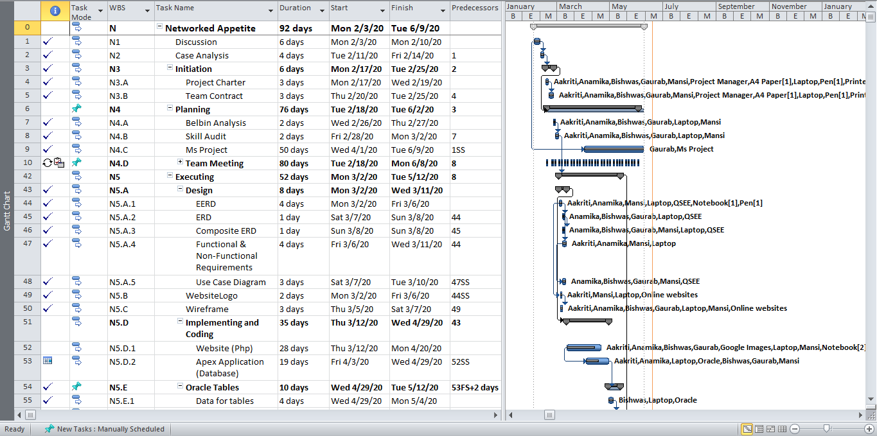

Task Sheet

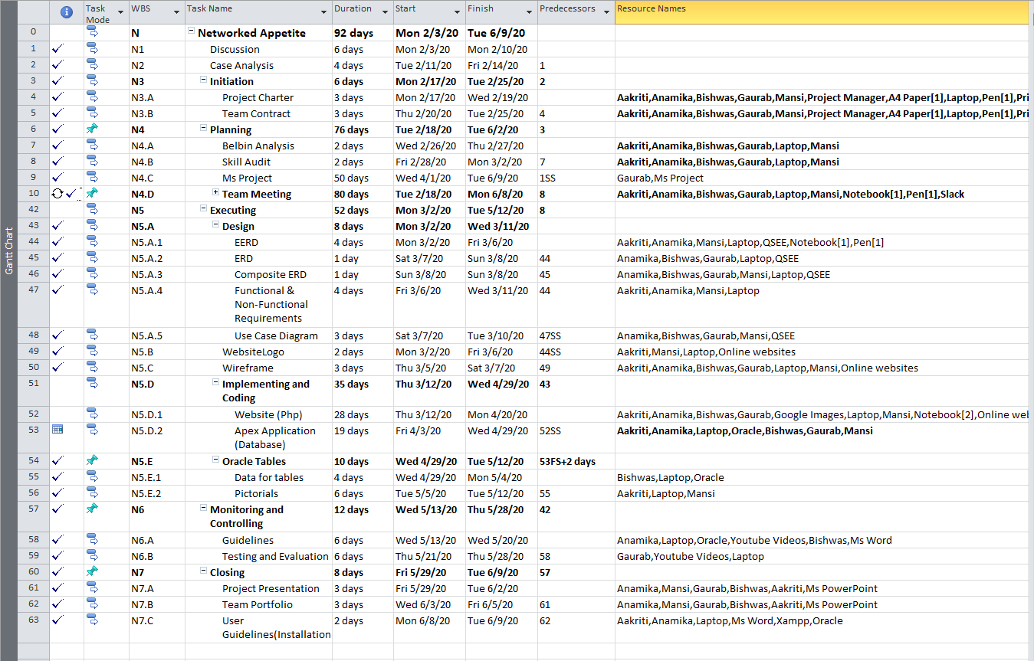

Timeline:

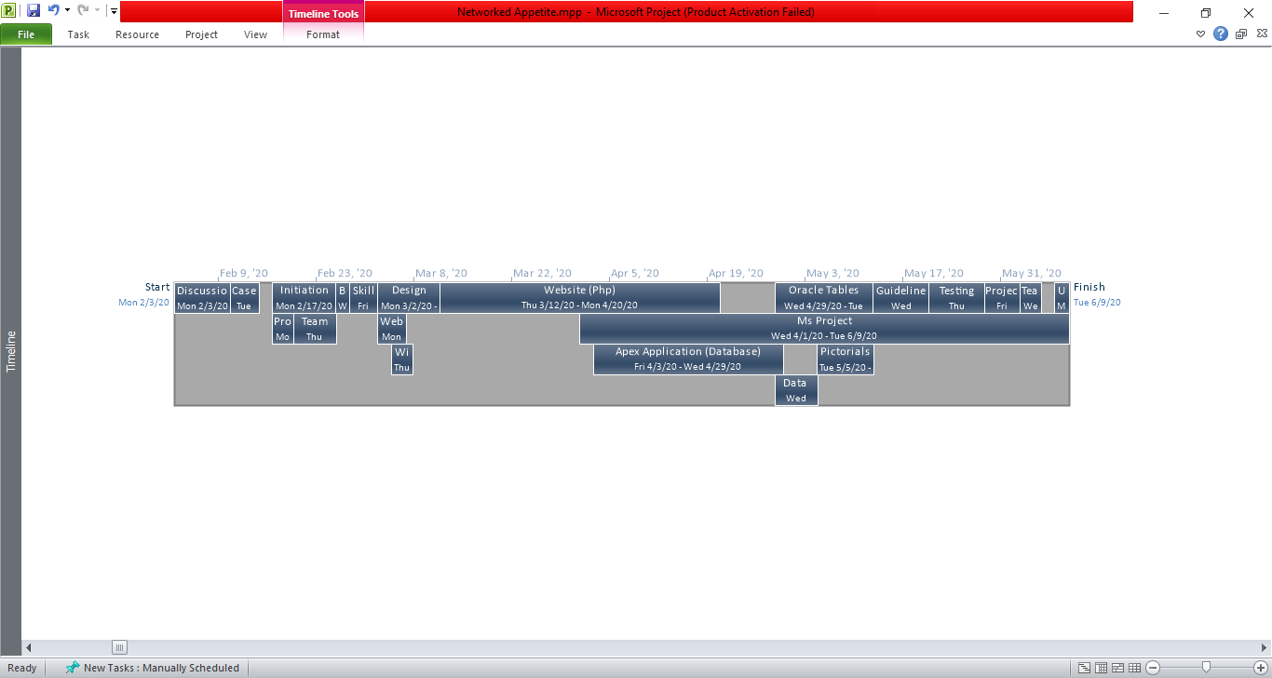

Resource Sheet

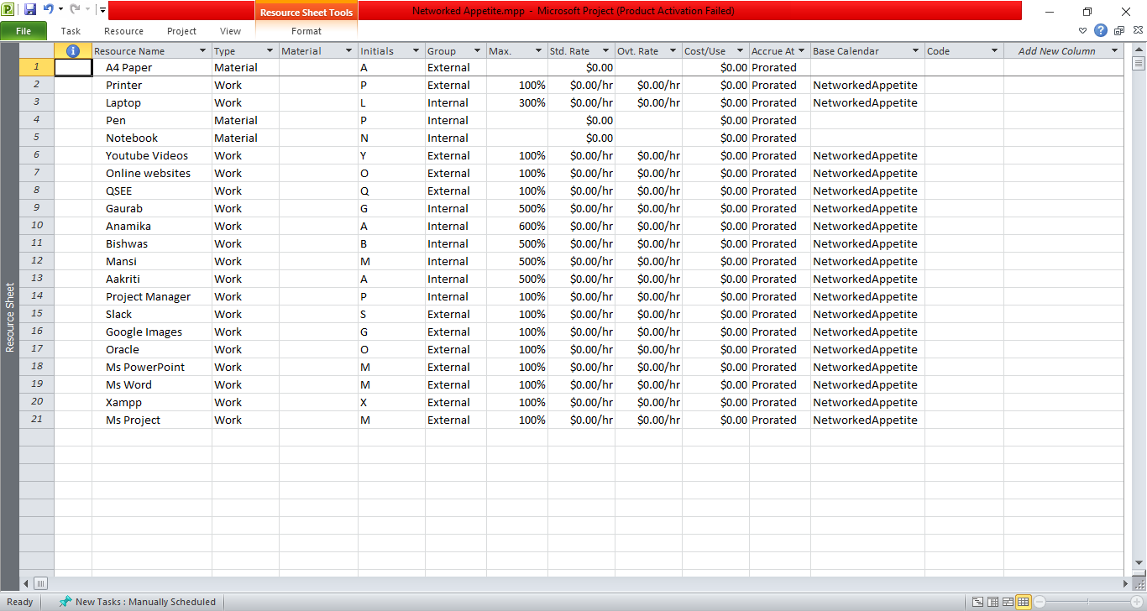

Calendar

February

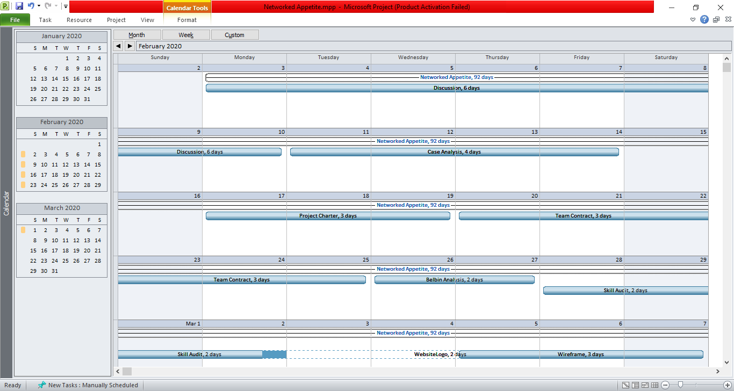

March

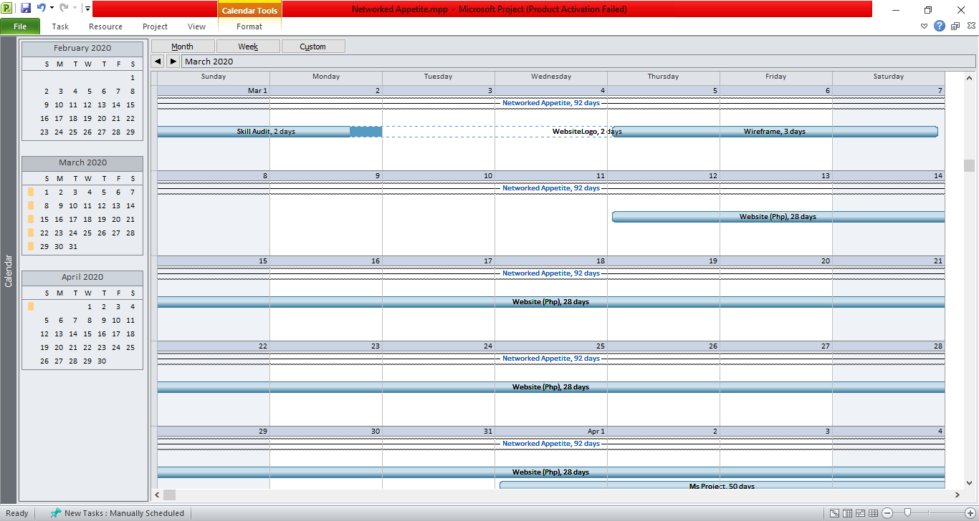

April

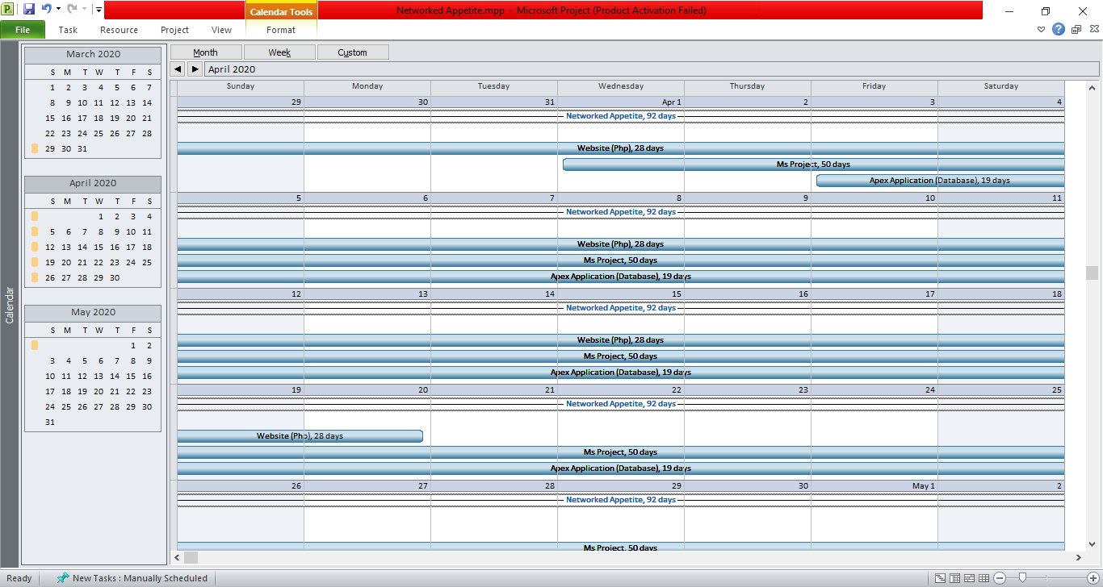

May

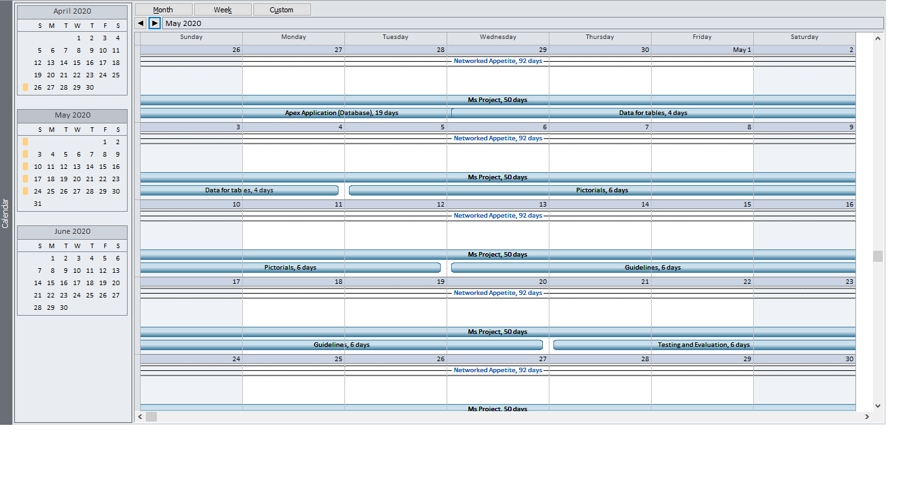

June

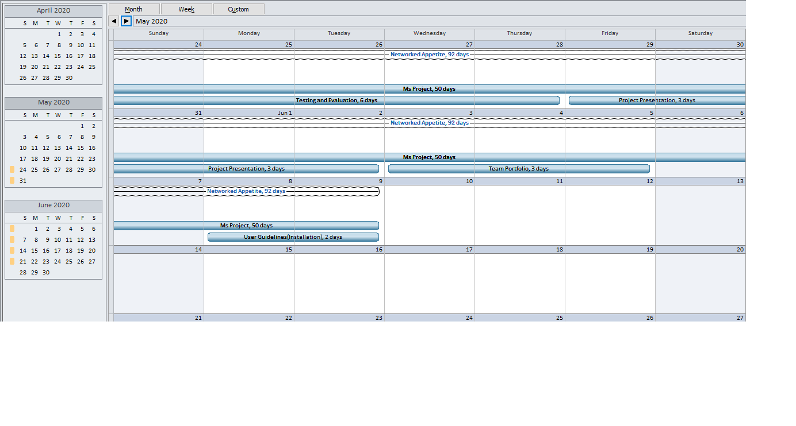

Network Diagram:

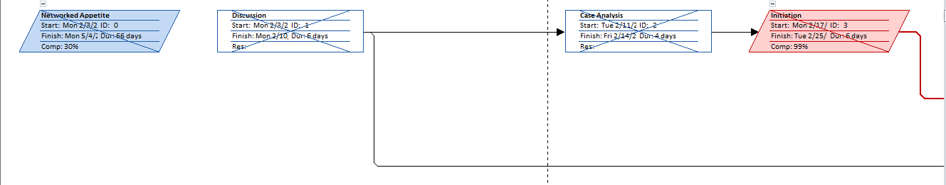

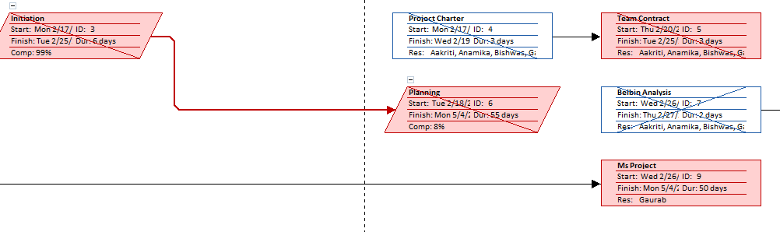

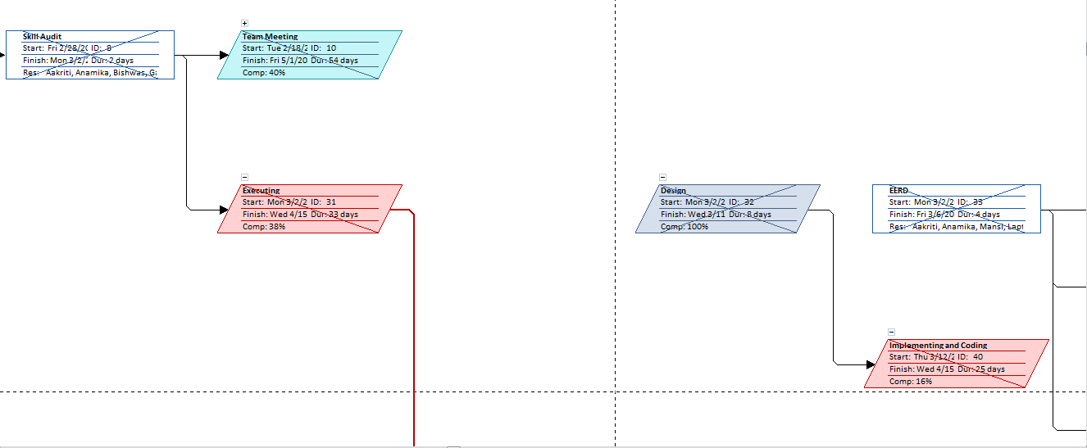

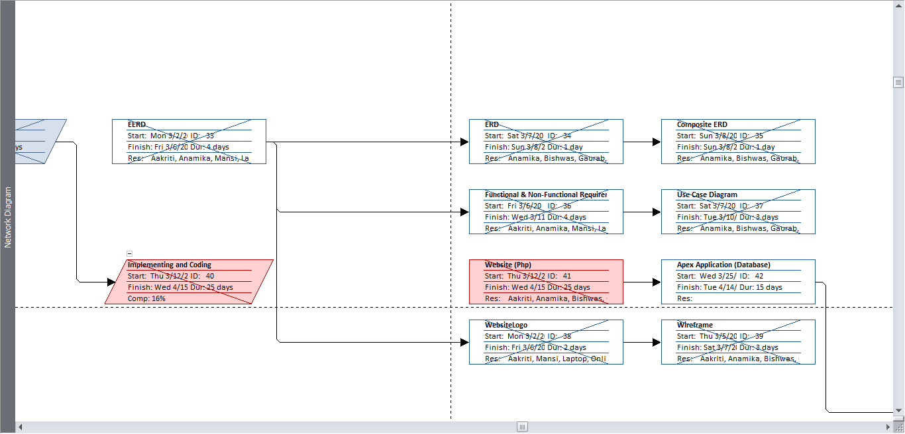

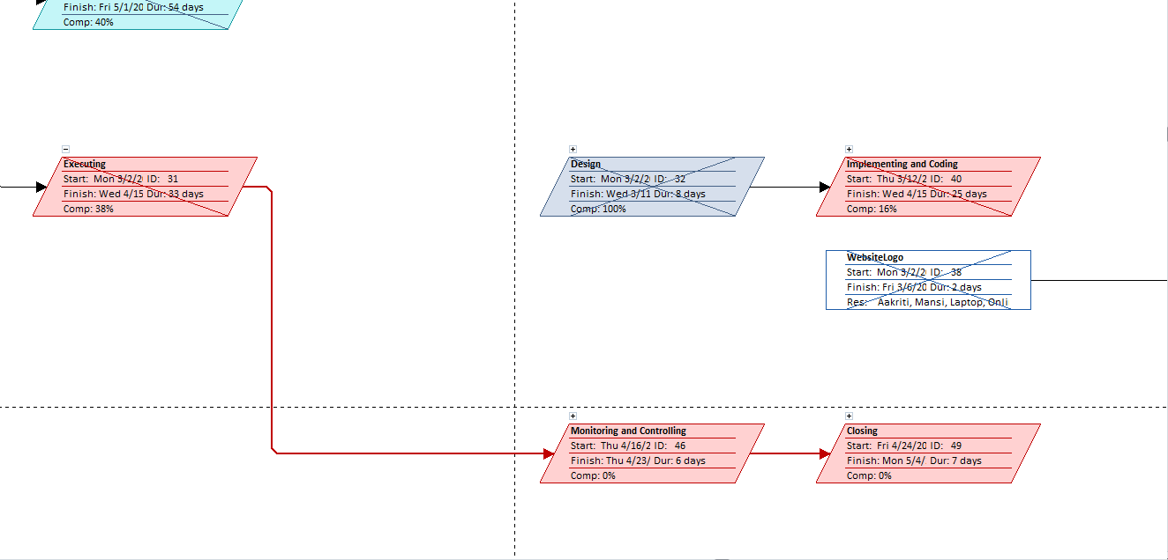

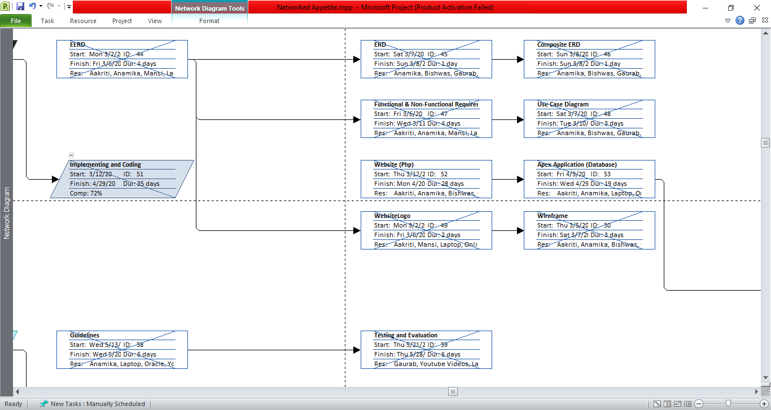

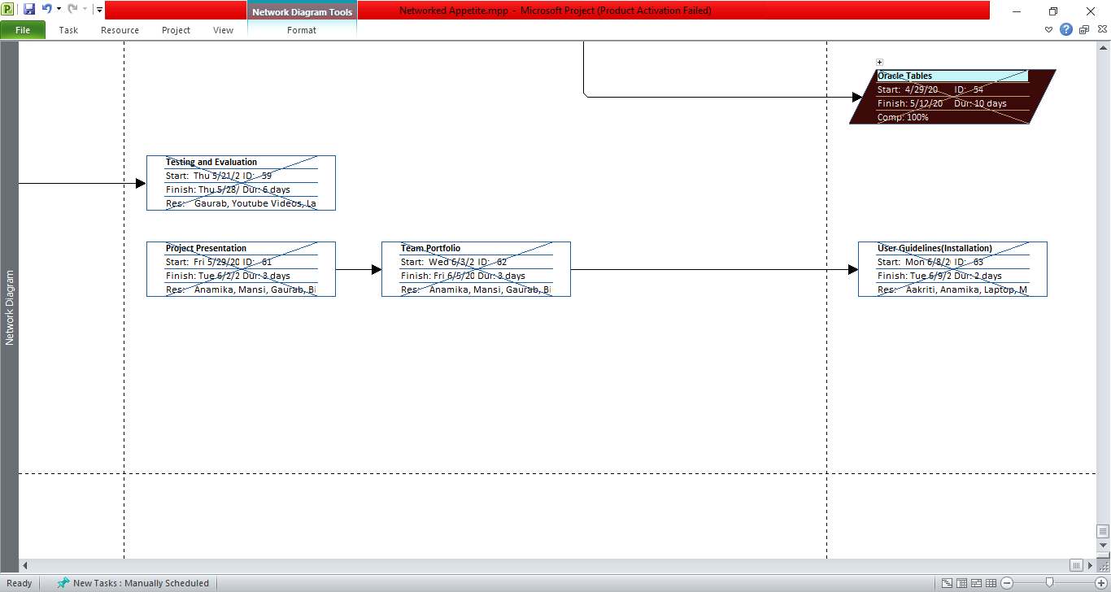

Change Working Time

Exceptions:

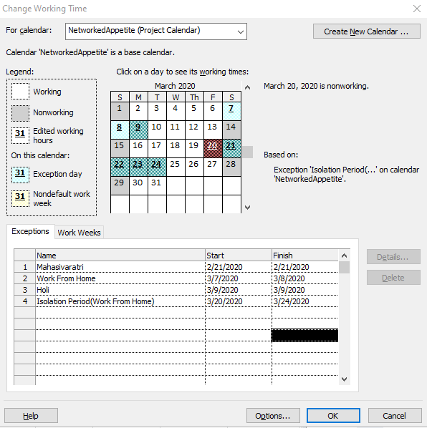

Work Sheets:

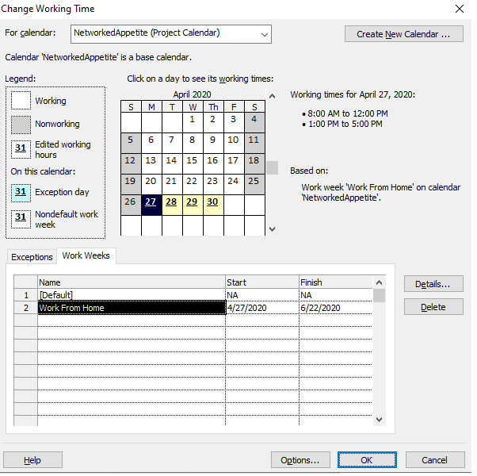

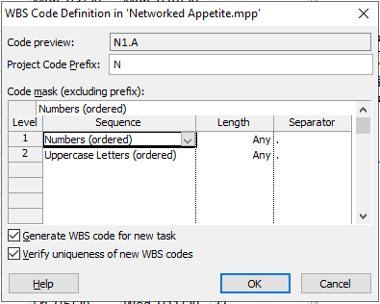Work Breakdown Structure (WBS):

Communication tool

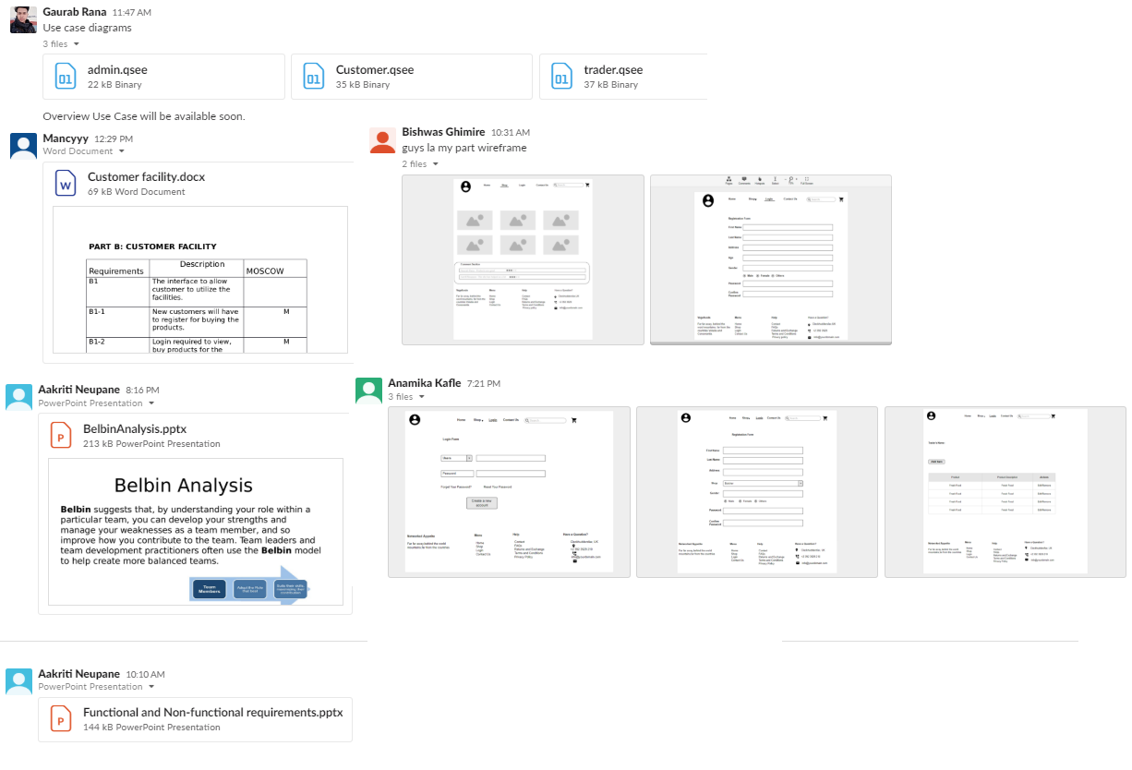

Weekly Meeting Time Selection Using Poll In Slack

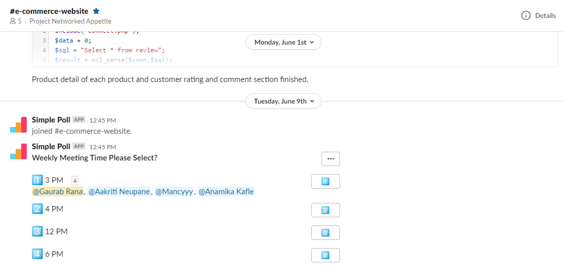

Team Meeting:

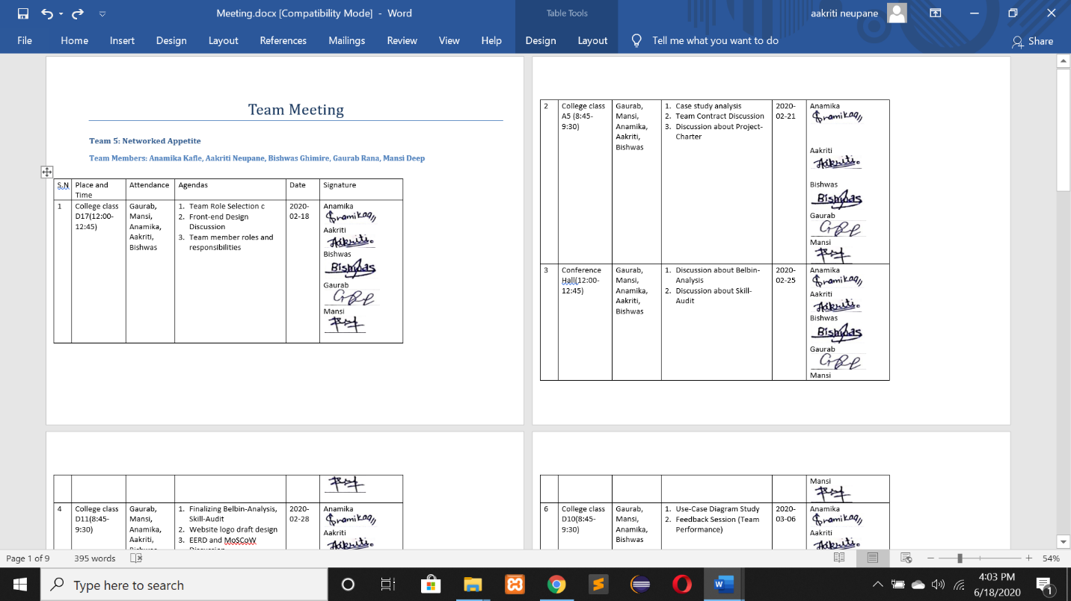

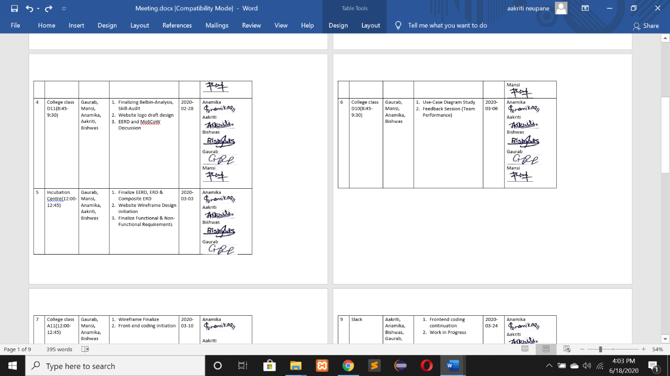

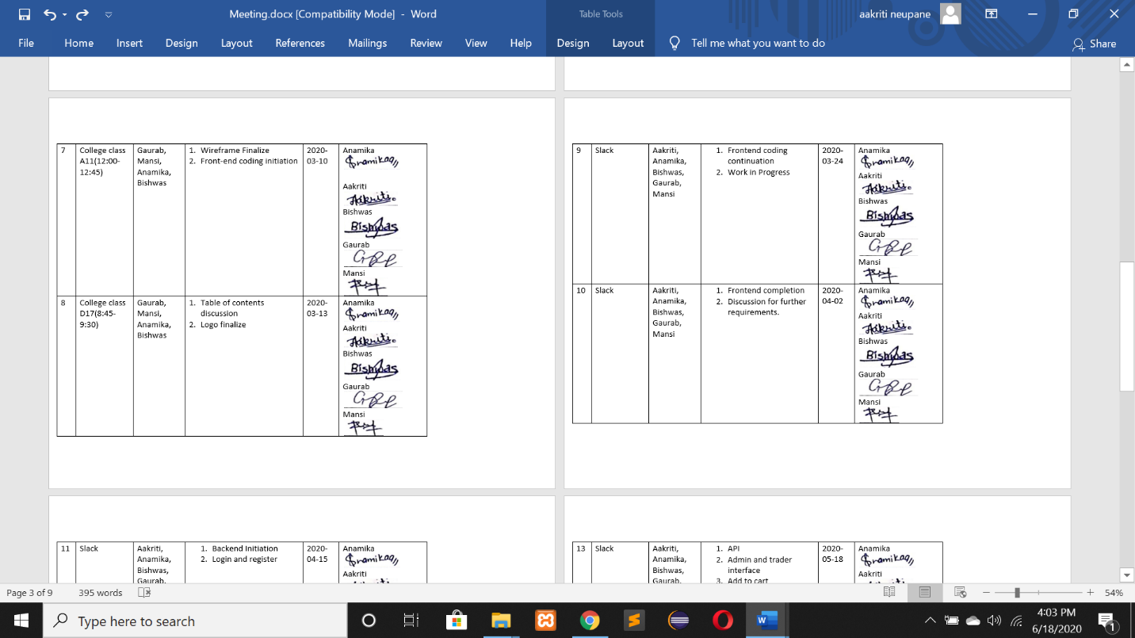

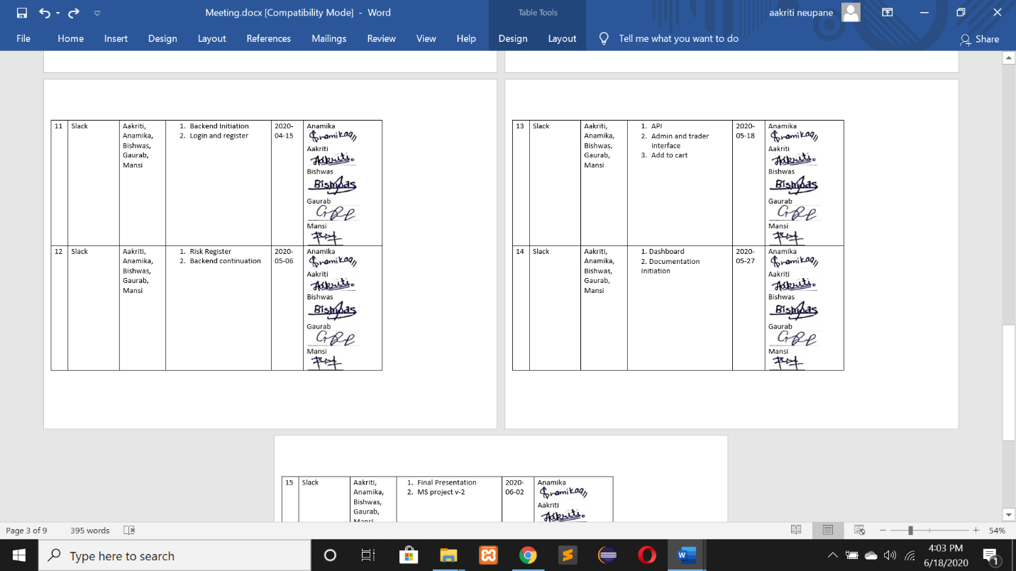

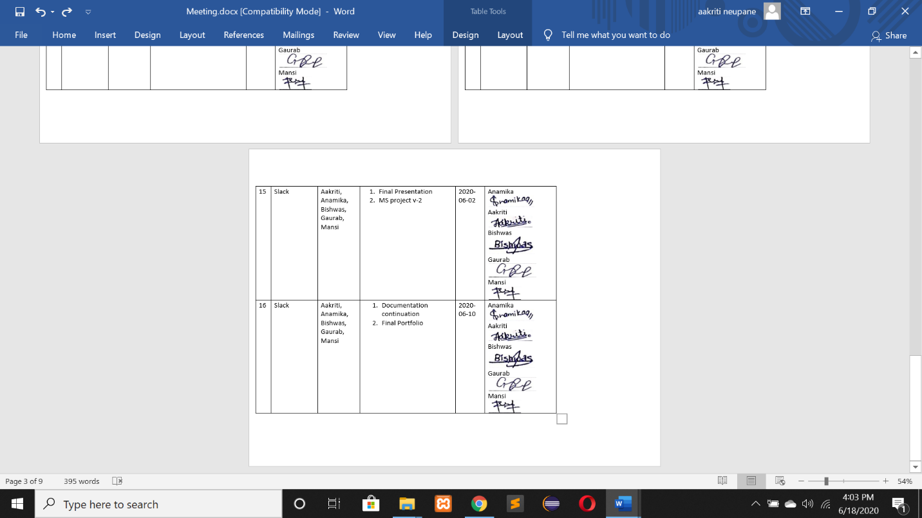

2. Product Designing

ERD

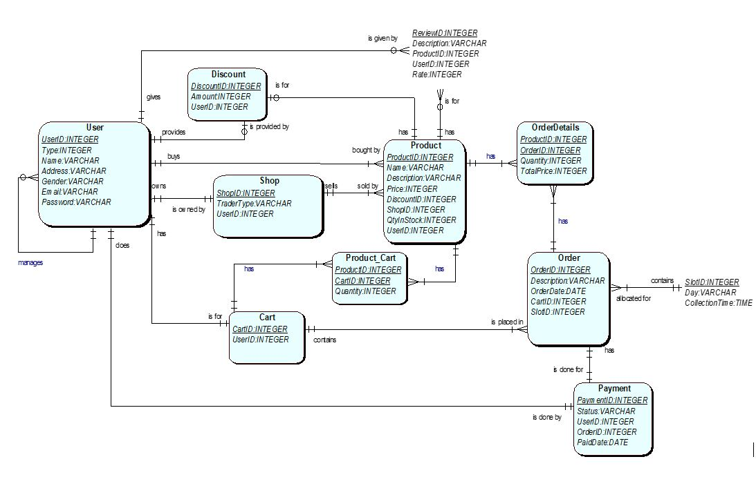

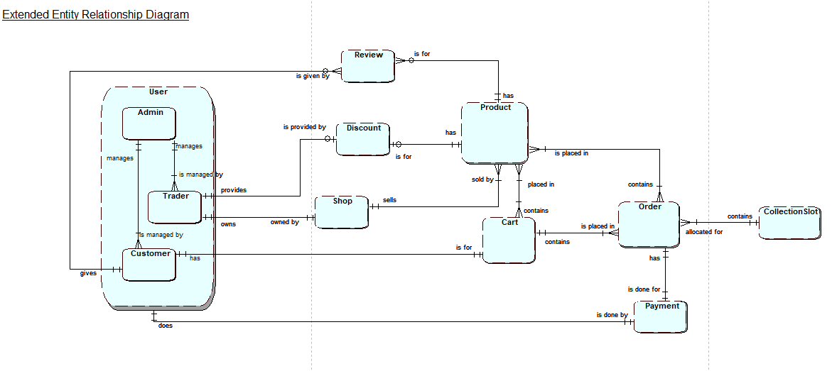



Logical Table

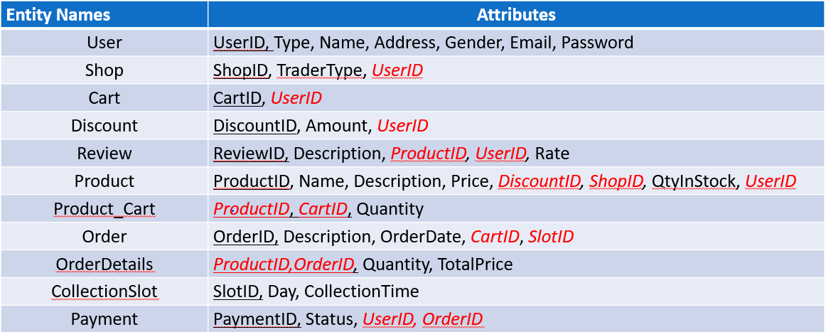

B. Use Case

Overview



Customer



Trader



Admin

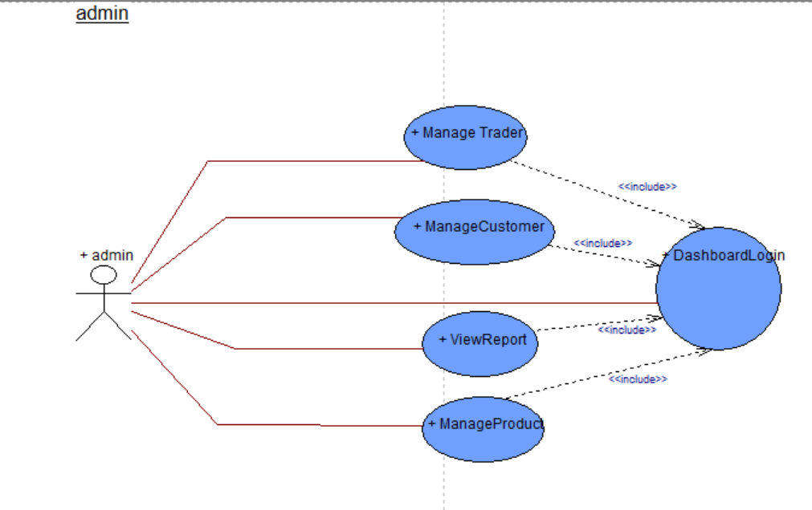

**C. Functional and Non-Functional**

**Functional**

**Part A: PRODUCTS**

|  |  |  |
| --- | --- | --- |
| Requirements | Description | MoSCoW |
| **A1** | **The interface to allow customer to view and buy products** |  |
| A1-1 | Items will be displayed with at least title, short description and a suitable thumbnail image. | M |
| A1-2 | Users will be able to display items by category | M |
| A1-3 | Users will be able to be use open text search for items | S |
| A1-4 | Users will be able to sort/search items based on multiple search criteria. | C |
| A1-5 | Products will be applied with discounts. | S |
| **A2** | **The interface allow user to add products to cart** |  |
| A2-1 | User can add items to cart with or without logging in. | M |
| A2-2 | Users should be able to remove individual item or all items from cart. | C |
| **A3** | **The interface allows customer to give reviews about product** |  |
| A3-1 | Customer can view reviews and give reviews about product | M |
| A3-2 | Customer can give reply to other customer’s reviews. | W |
| **A4** | **The interface allows customers to specify collection slots** |  |
| A4-1 | Customer can select specific collection slots time after payment | M |
| A4-2 | Customer can select collection slot available only after 24 hours of order placed. | M |
| A4-3 | Orders are limited to 20 per collection slot. | M |
| **A5** | **The interface allows customer to use online payment system.** |  |
| A5-1 | Payment for product is done using PayPal. | M |
| A5-2 | Payment invoice goes to customer, admin and respective traders. | S |

**Part B: CUSTOMER FACILITY**

|  |  |  |
| --- | --- | --- |
| Requirements | Description | MoSCoW |
| **B1** | **The interface to allow customer to utilize the facilities.** |  |
| B1-1 | Customers will be able to add products to cart for further processing. | M |
| B1-2 | Customers have access to search products. | M |
| B1-3 | Customers can edit item quantity to buy products. | S |
| B1-4 | PayPal is the only option for customers buying the products. | M |
| B1-5 | Customers can also view best deals for coming new products. | M |
| **B2** | **The interface allow customer to register as a verified user.** |  |
| B2-1 | Customers will have to register for buying the products. | M |
| B2-2 | Customer will have to complete a form to register. | M |
| B2-3 | Register form fields will have password length check and encryption, and collect username, address, email, age, and password. | C |
| B2-4 | Email Verification is required to verify user. | S |
| B2-5 | Customers are able to manage and update accounts. | S |
| **B3** | **The interface to allow customers to login** |  |
| B3-1 | Email address and password required to login. | M |
| B3-2 | Login required for buying products. | M |
| B3-3 | Customer can reset password using email verification. | S |

**Part C: TRADER FACILITY**

|  |  |  |
| --- | --- | --- |
| Requirements | Description | MoSCoW |
| **C1** | **The interface to allow traders to manage the products.** |  |
| C1-1 | Traders will be able to manage products and its related information. | S |
| C1-2 | Traders will be able to run daily, weekly and monthly report ordered in a number of ways: alphabetically, by total number of orders per product, by total income per product. | S |
| C1-3 | Traders will be able to login their respective ID and view their details. | S |
| C1-4 | Traders will be able to view and update the details of their respective accounts. | S |
| C1-5 | Traders will be sent email verification link in order to proceed to the site. | C |
| C1-6 | Traders will be able to provide discount to the customers. | C |

**Part D: ADMIN FACILITY**

|  |  |  |
| --- | --- | --- |
| Requirement | Description | MoSCoW |
| **D1** | **A facility to allow authenticated admin users to manage the activities presented by the system.** |  |
| D1-1 | An active admin link will be provided once an admin user has logged in. | S |
| D1-2 | The admin page will display all activities and can access any trader account. | S |
| D1-3 | Clicking the update link will show a form pre-populated with all editable details. Submitting the form will update the chosen item and display the updated item. | S |
| D1-4 | Clicking the delete link will remove the chosen item and update the displayed catalogue of items. | S |
| **D2** | **A facility to allow admin to track activity of products and traders.** |  |
| D2-1 | Admin will keep the uniqueness of each product of traders in check. | M |
| D2-2 | A dashboard will be shown with overview of reports, sales, activities of customer and traders. | S |
| D2-3 | Admin will facilitate traders with daily report on goods and stocks, weekly report on finance and monthly report on their product sales. | M |

**Part E: Web Interface**

|  |  |  |
| --- | --- | --- |
| Requirements | Description | MoSCoW |
| **E1** | **Web interface for website design** |  |
| E1-1 | The site will be viewable on mobile as well as desktop devices and viewable on the most popular browsers. | M |
| E1-2 | The site will have good reflection of heritages of the area | C |
| E1-3 | The system will support a maximum of 10 shops in the first instance. | S |
| E1-4 | Traders will be able to manage products and do CRUD operations via web interface. | M |

**NON-FUNCTIONAL REQUIREMENTS**

The website will comply with the following non-functional requirements.

|  |  |  |
| --- | --- | --- |
| Requirements | Description | MoSCoW |
| F1-1 | HTML /CSS template suited to requirements. | M |
| F2-2 | Template applied consistently throughout the site. | S |
| F3-3 | Site built for maintainability: Files organized, comments added, HTML using includes bespoke functions. | S |
| F4-4 | Backing up the data. | C |
| F5-5 | Information security. | C |
| F6-6 | The website shall be secure from hackers. | M |

D. Logo Design:



E. Wireframe

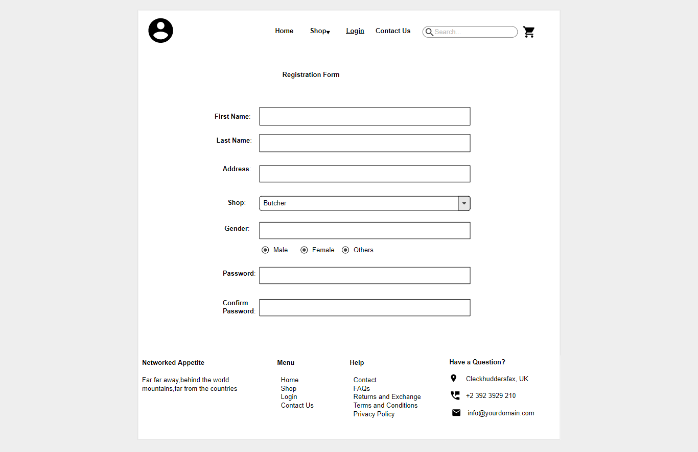

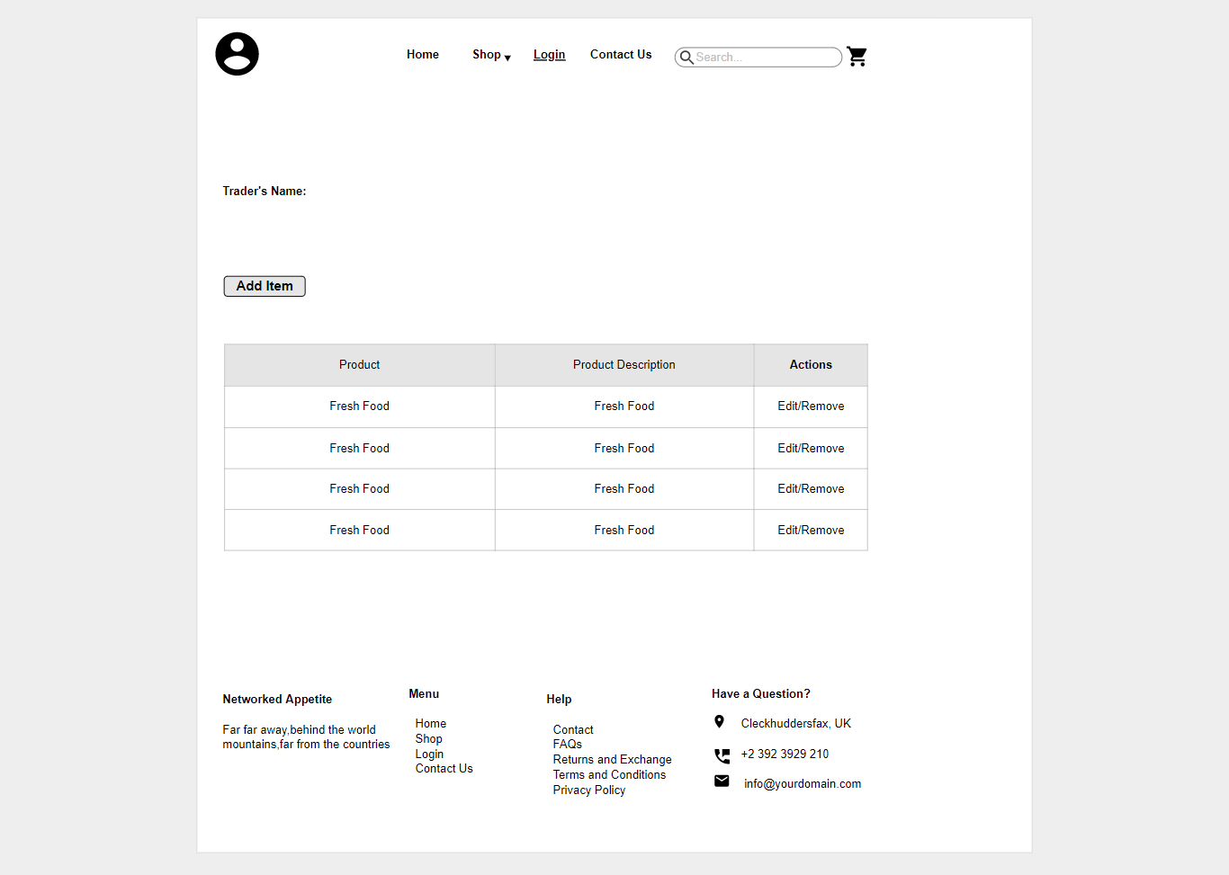

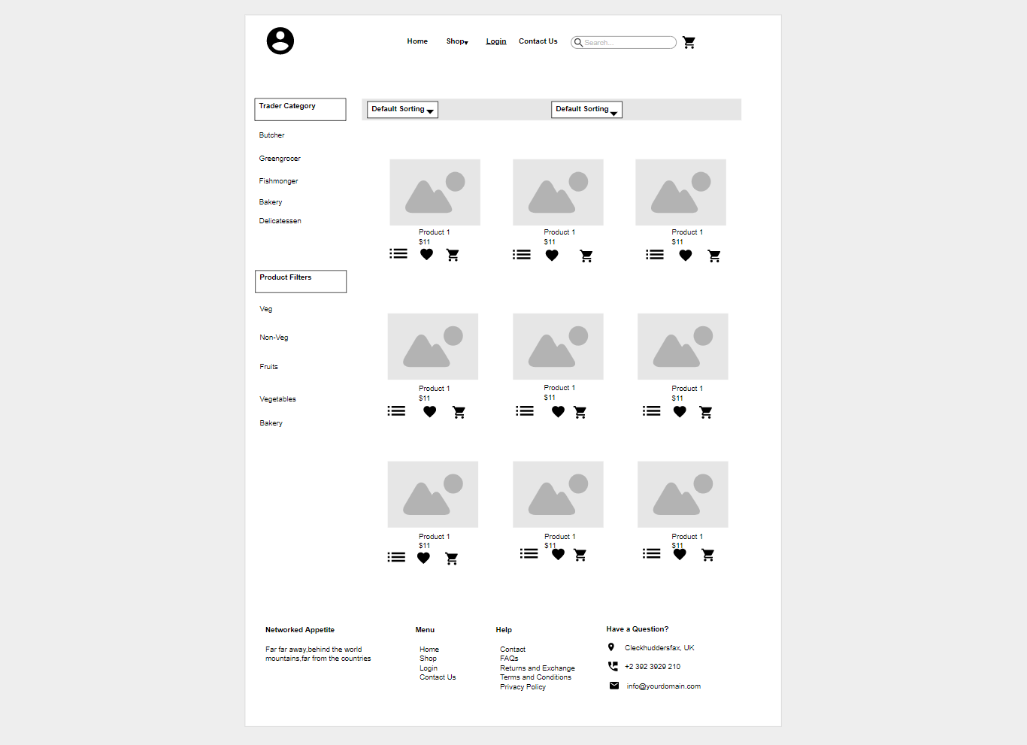

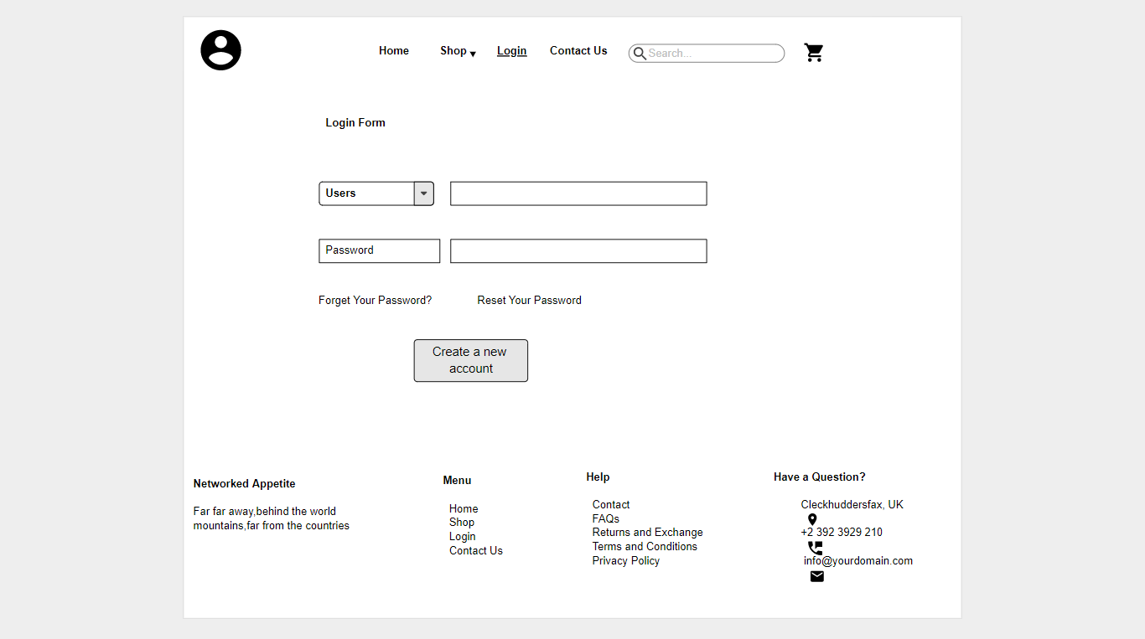

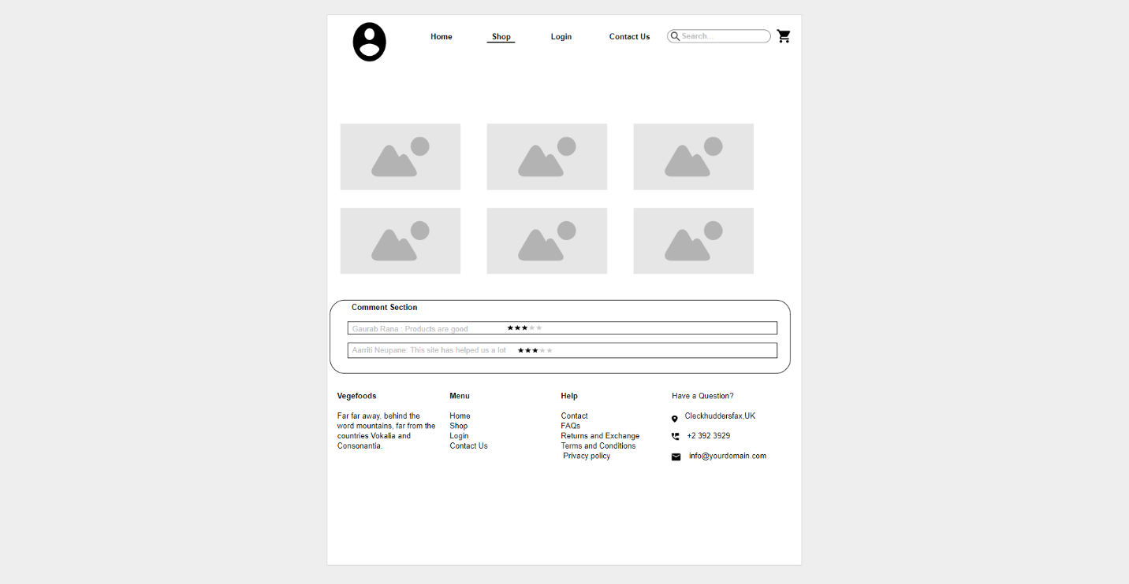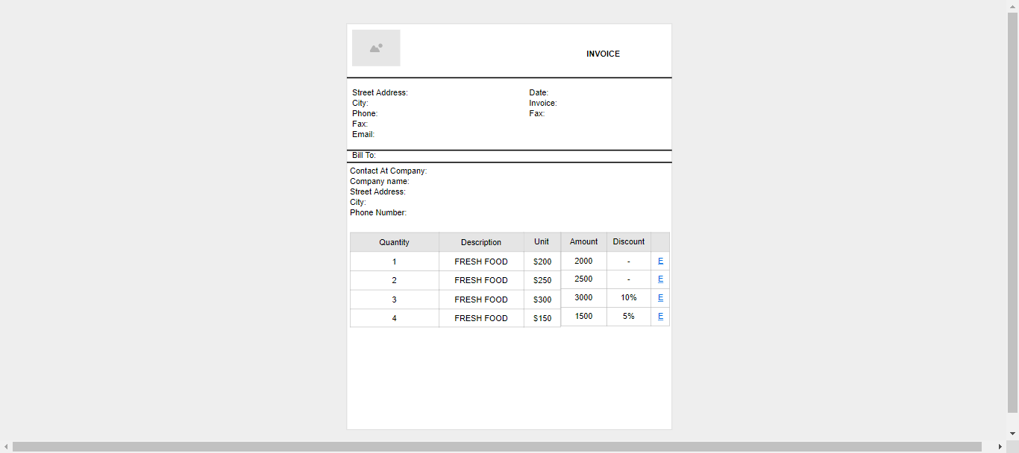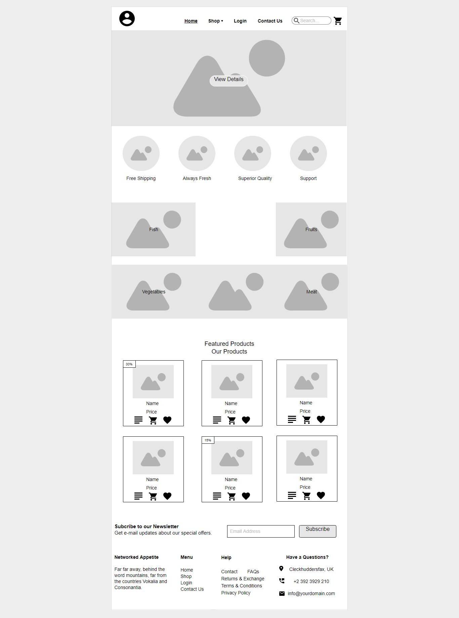

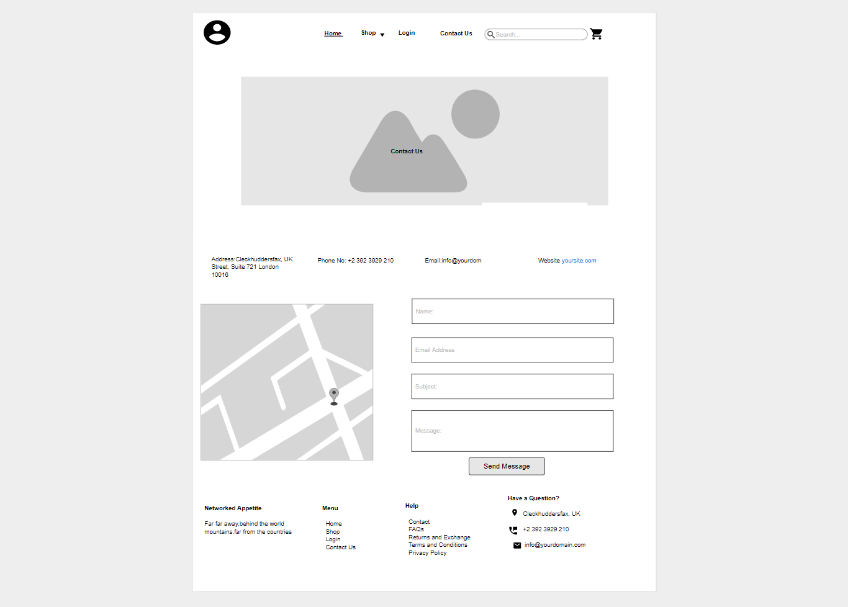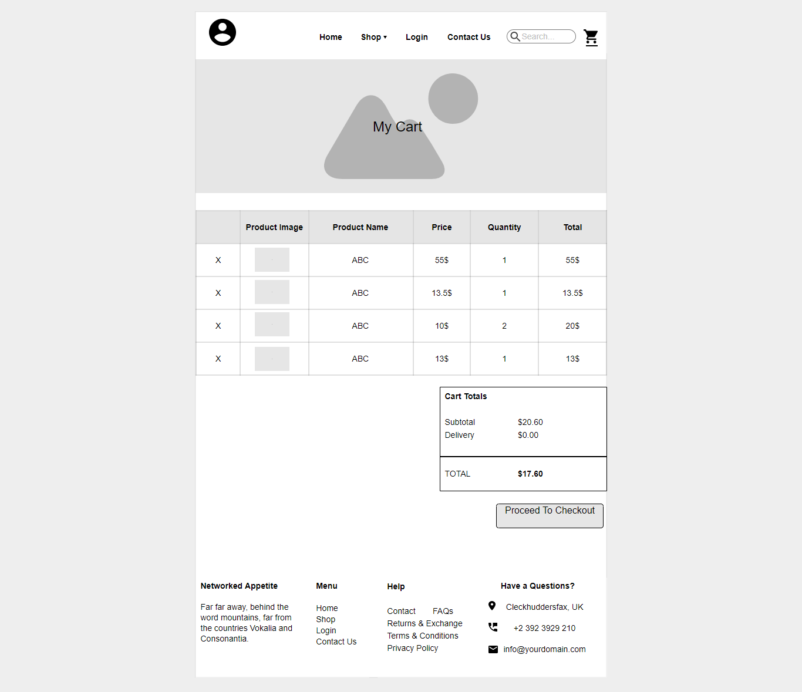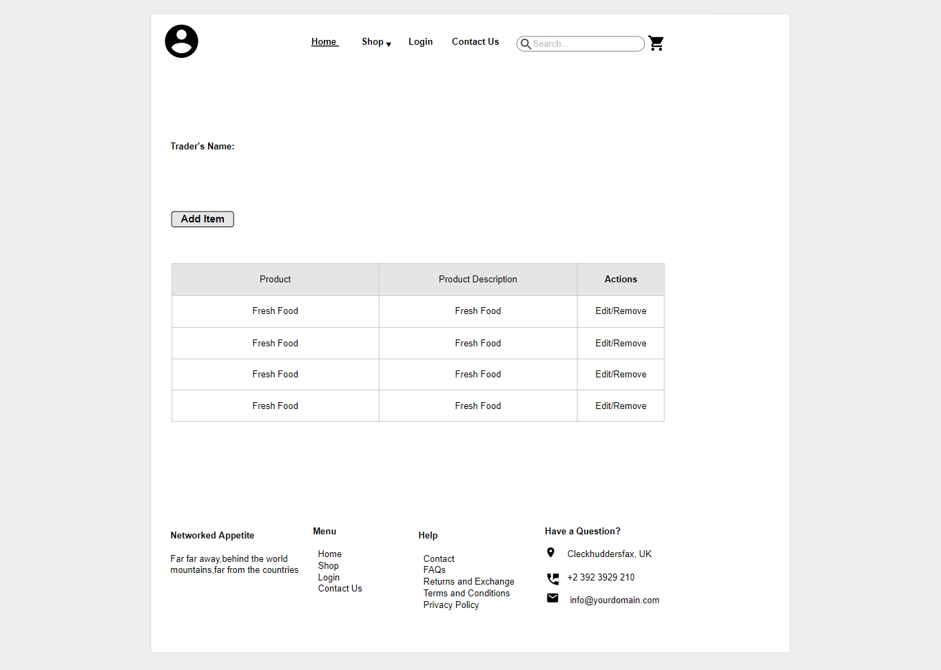

3. Product development

a. Screenshots:

We need to register as a trader for product development.

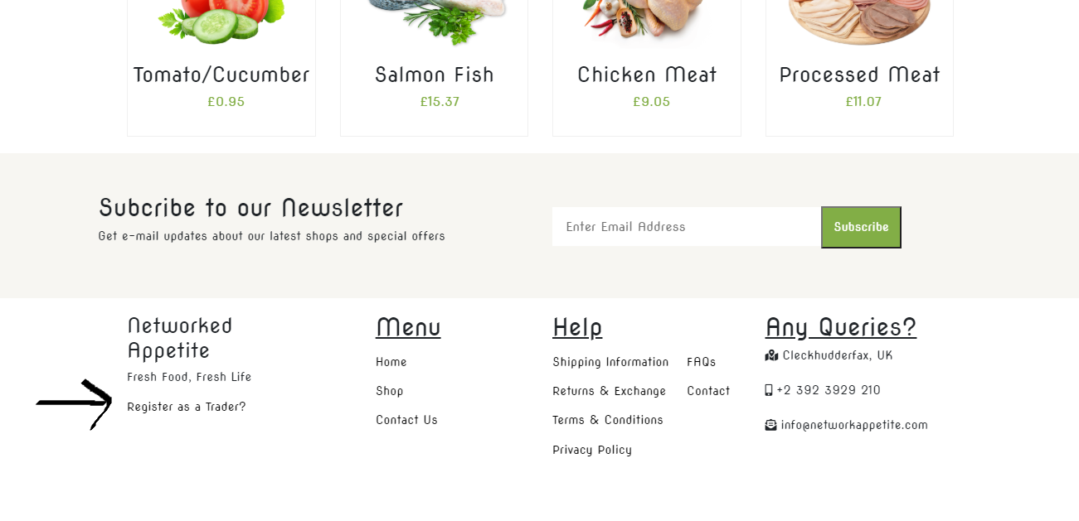

Registration Page of a trader

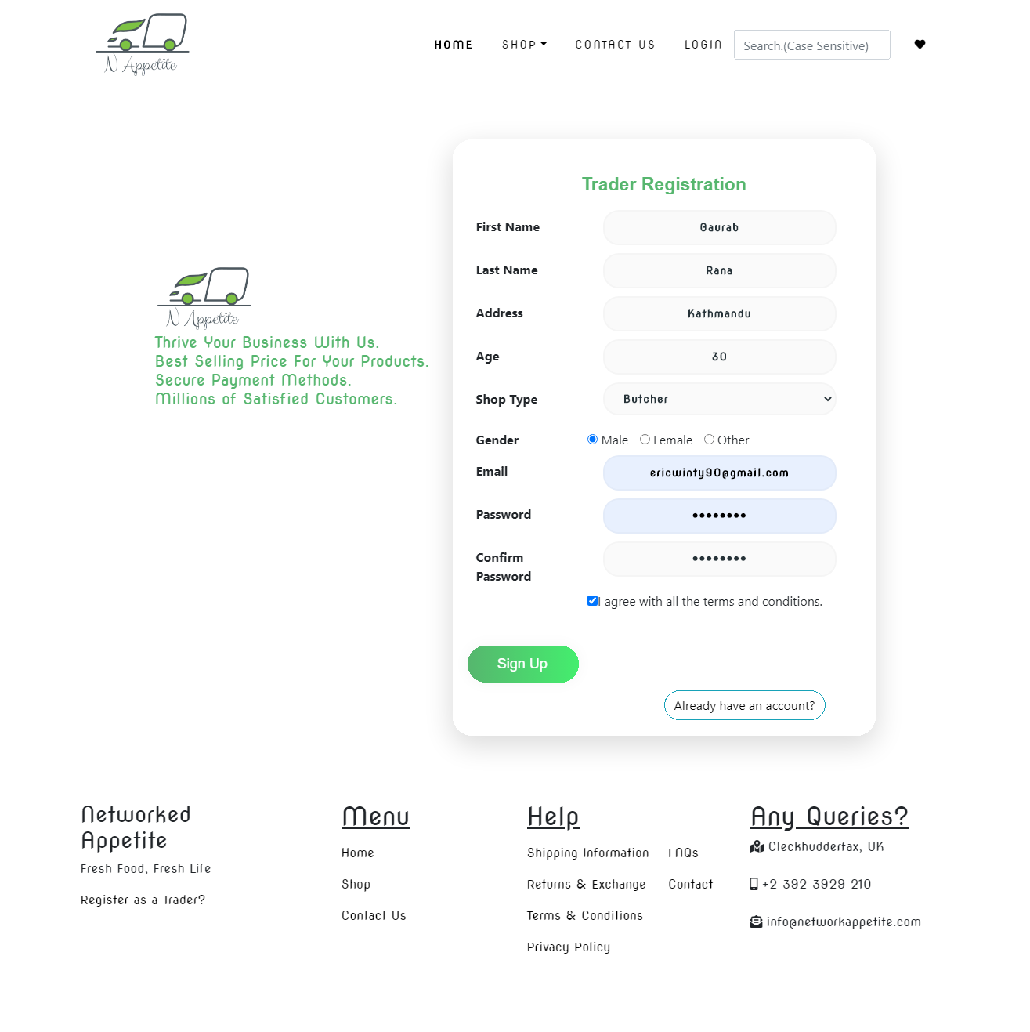

Email Verification after you register your account

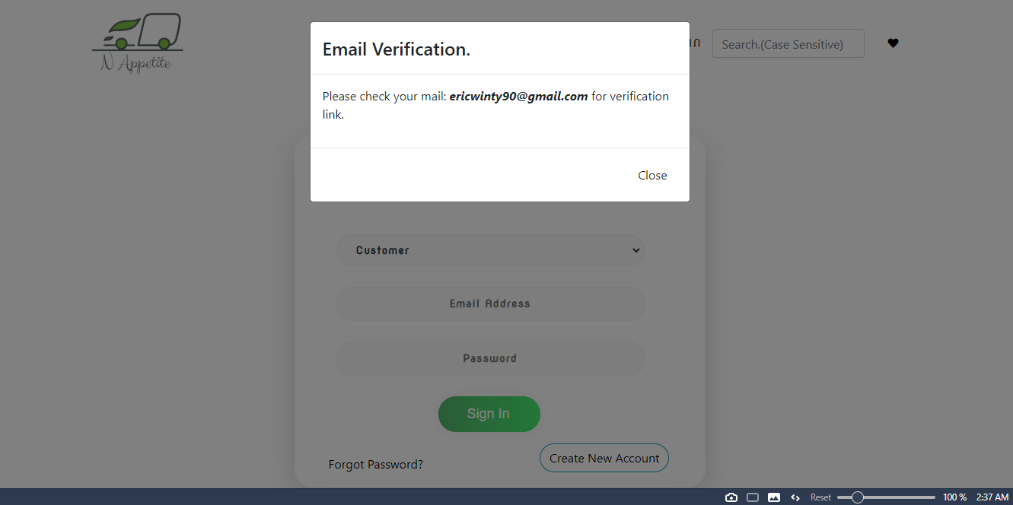

Email you get after you register to verify your account by activating account

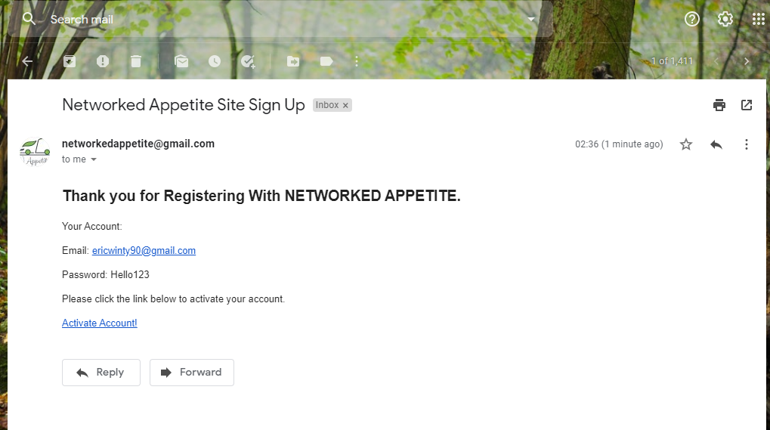

You get this pop-up message after successful activation.

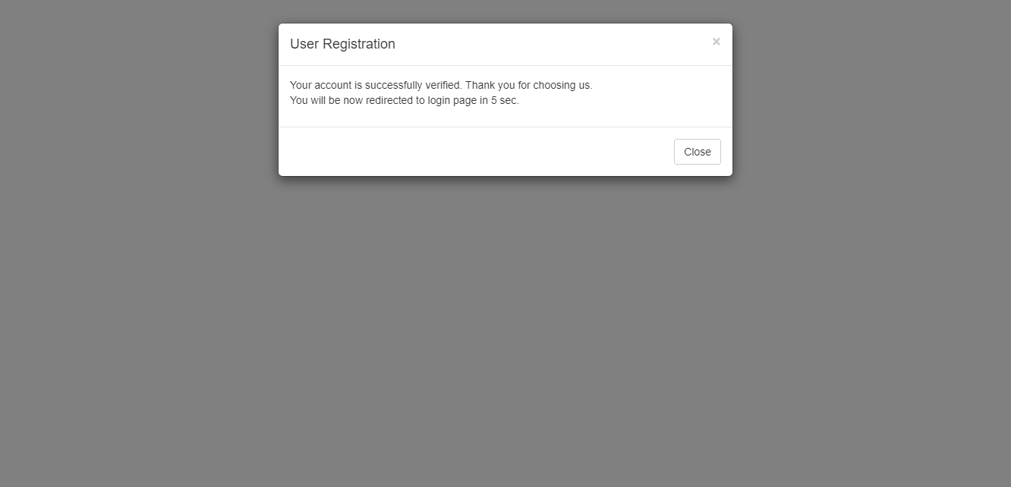

You can add, delete or update the product you login.

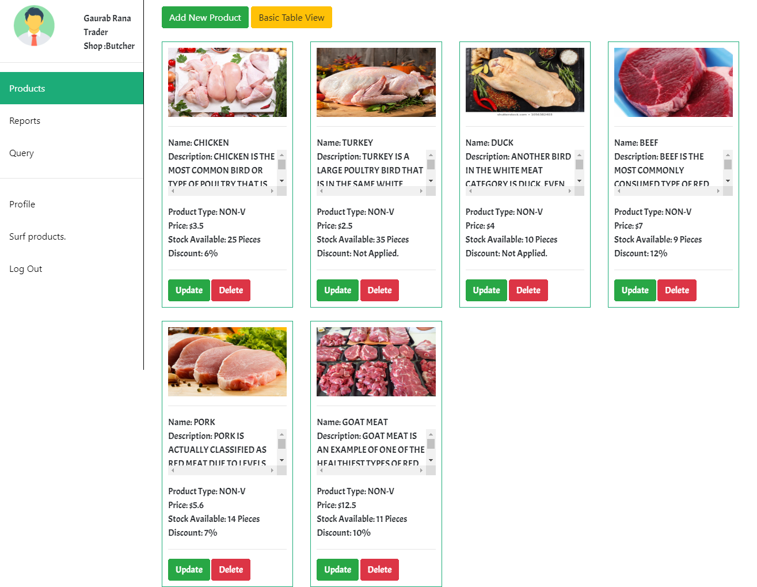

Products of Shop Type: Bakery

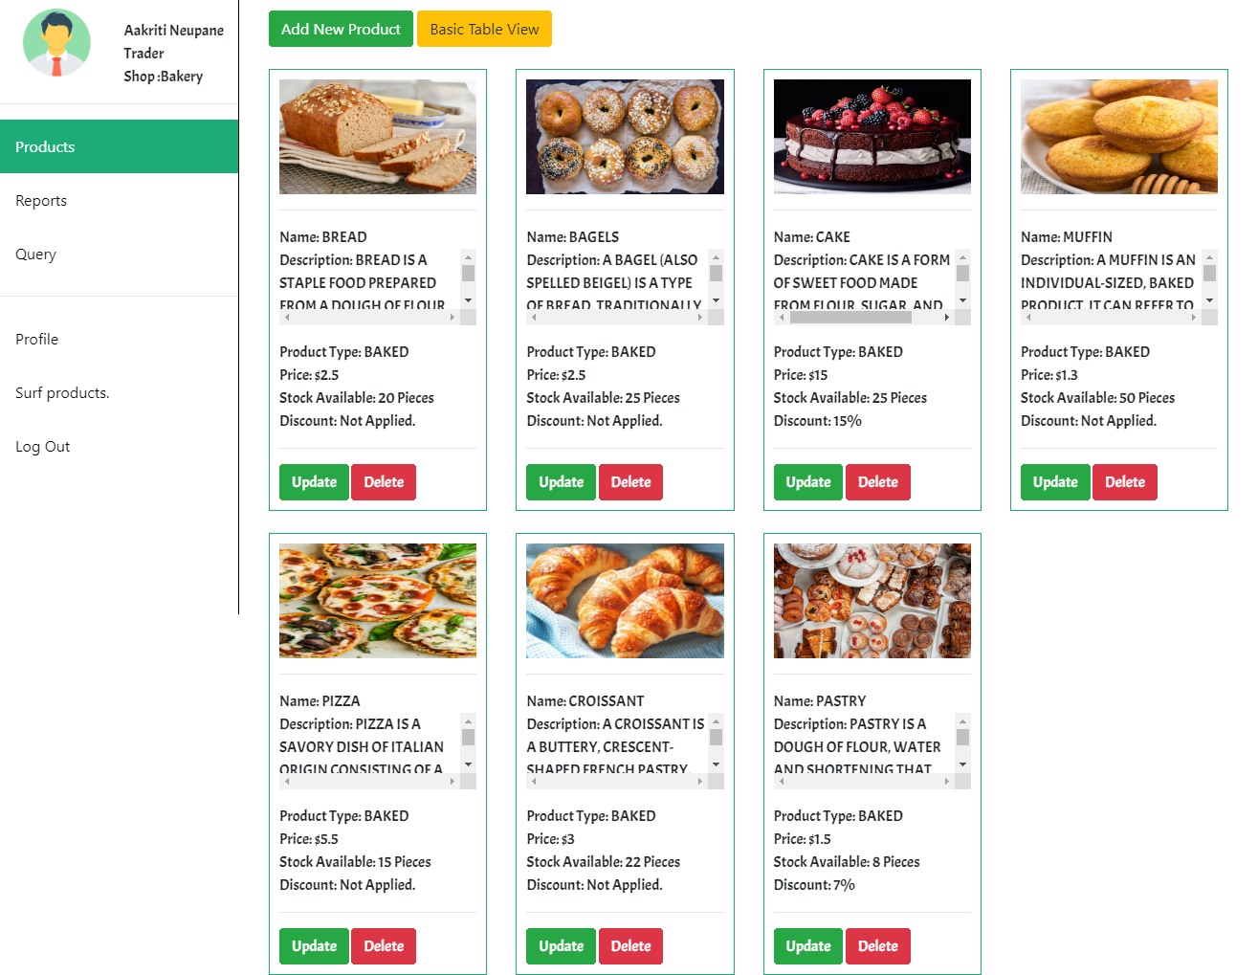

Products of shop type Delicatessen

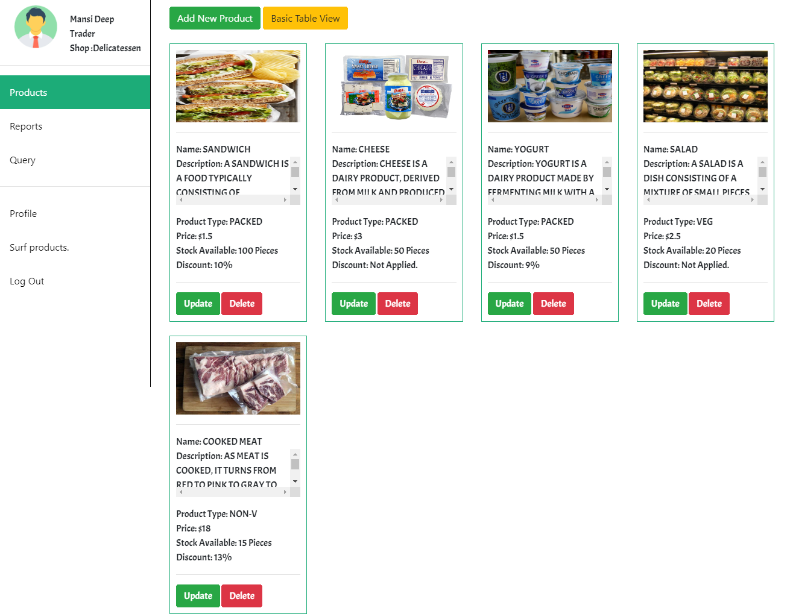

Basic table view of products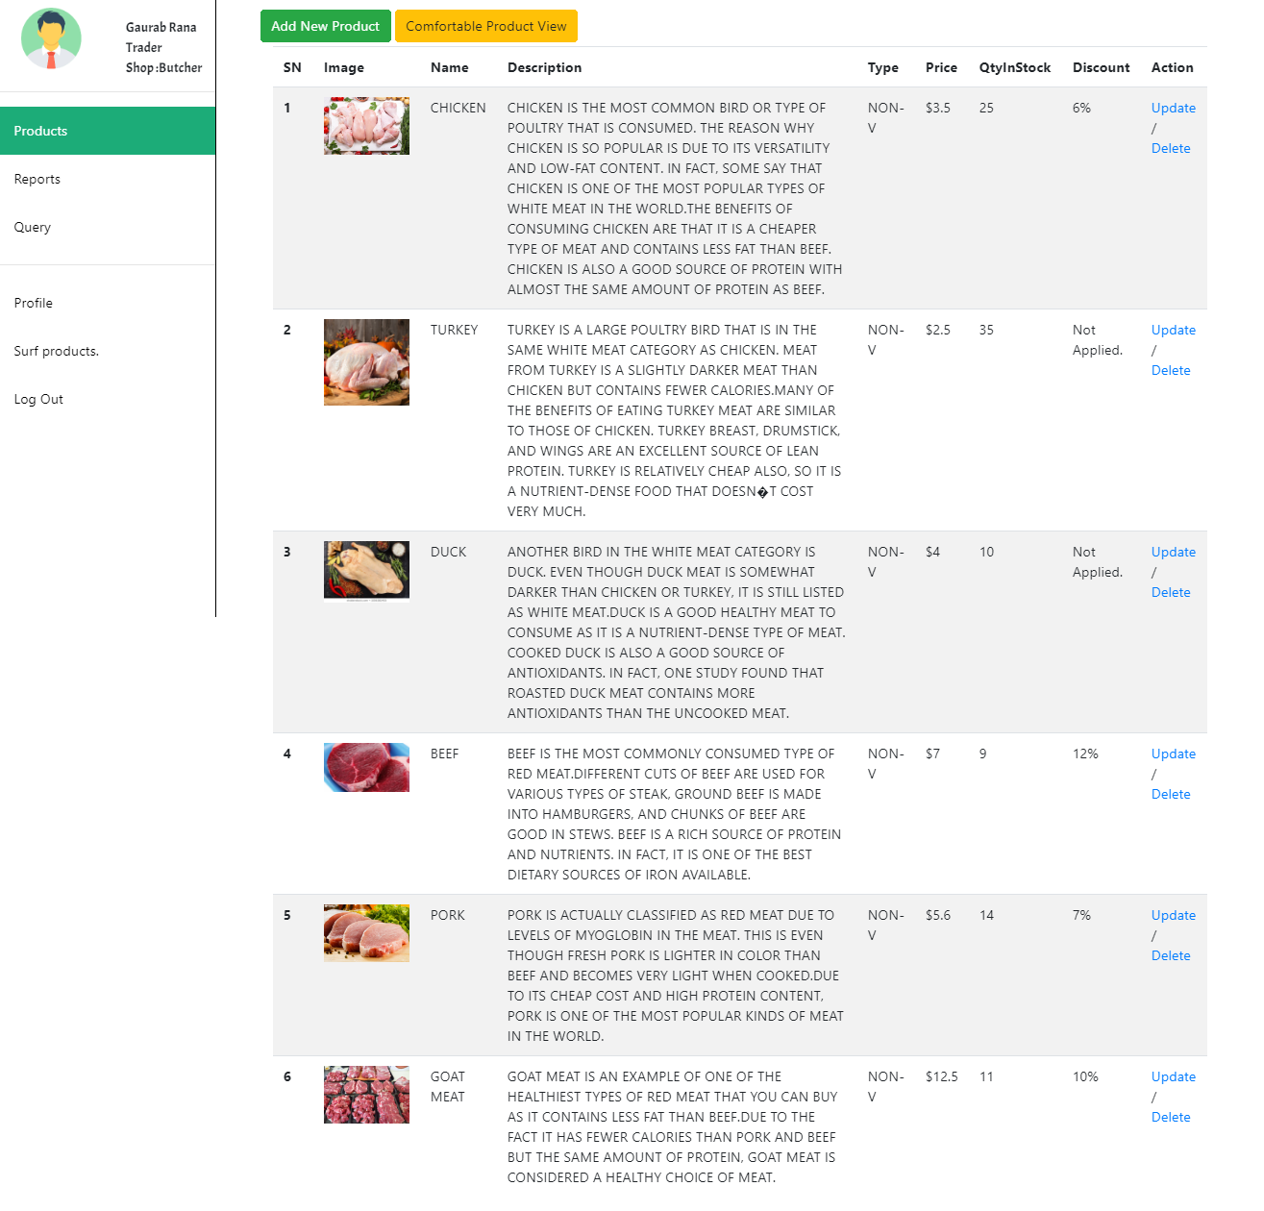

Adding a product

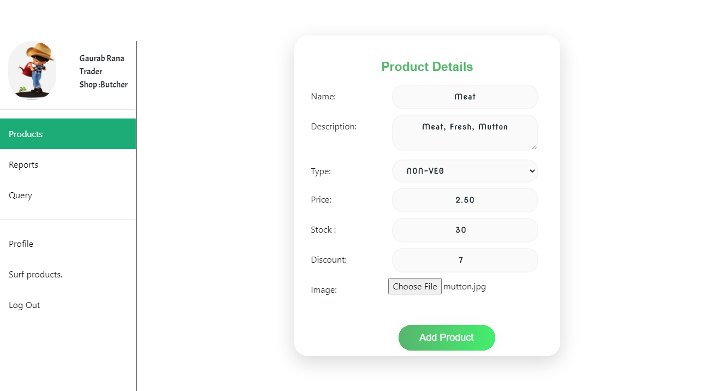

Product page after adding item

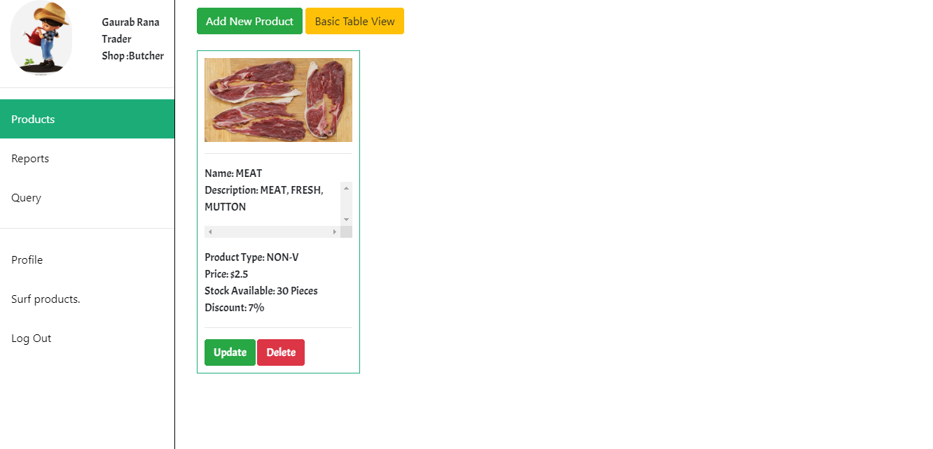

Products page after deleting item

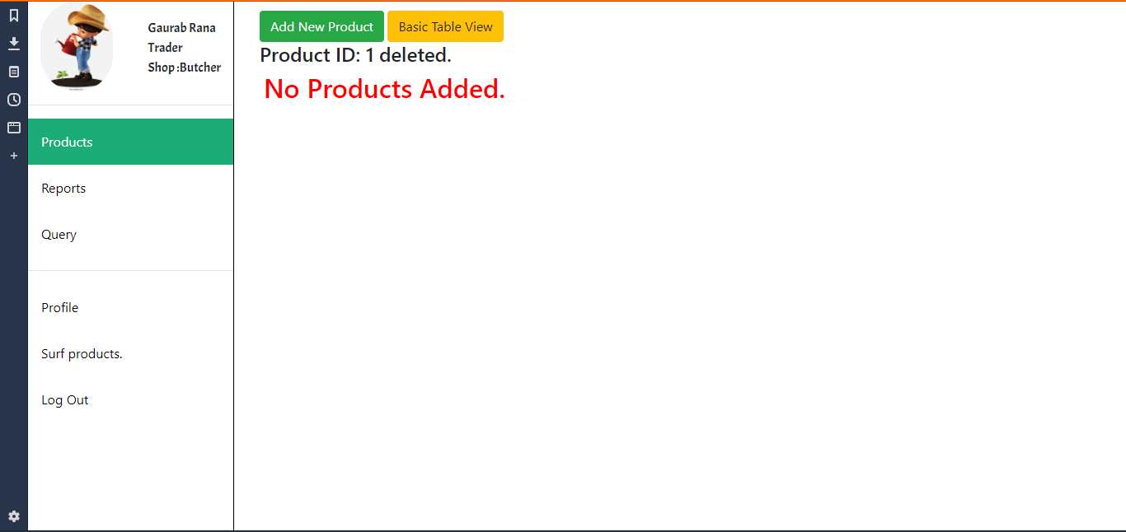

One can change the profile information

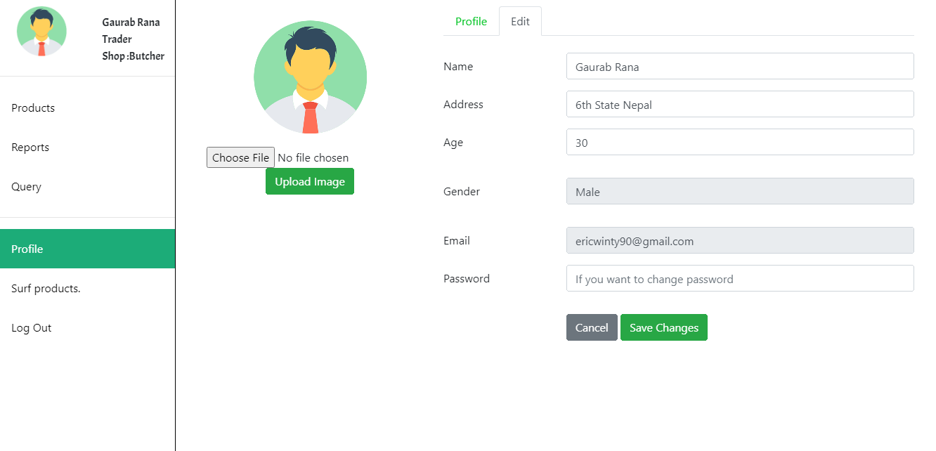

User Profile

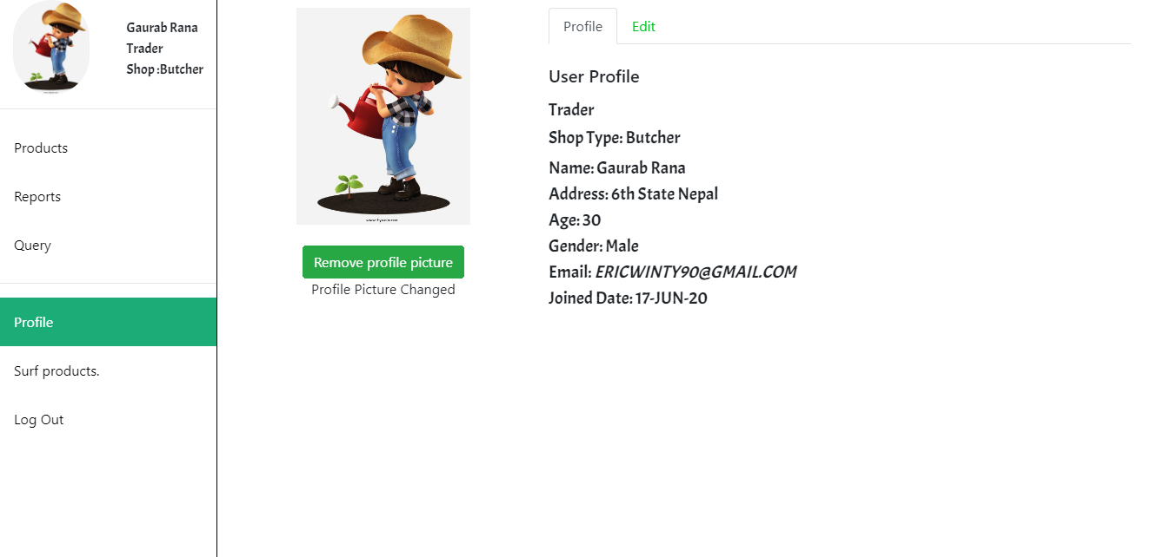

B. Homepage

This is the homepage of the website.



Customer

Registration-

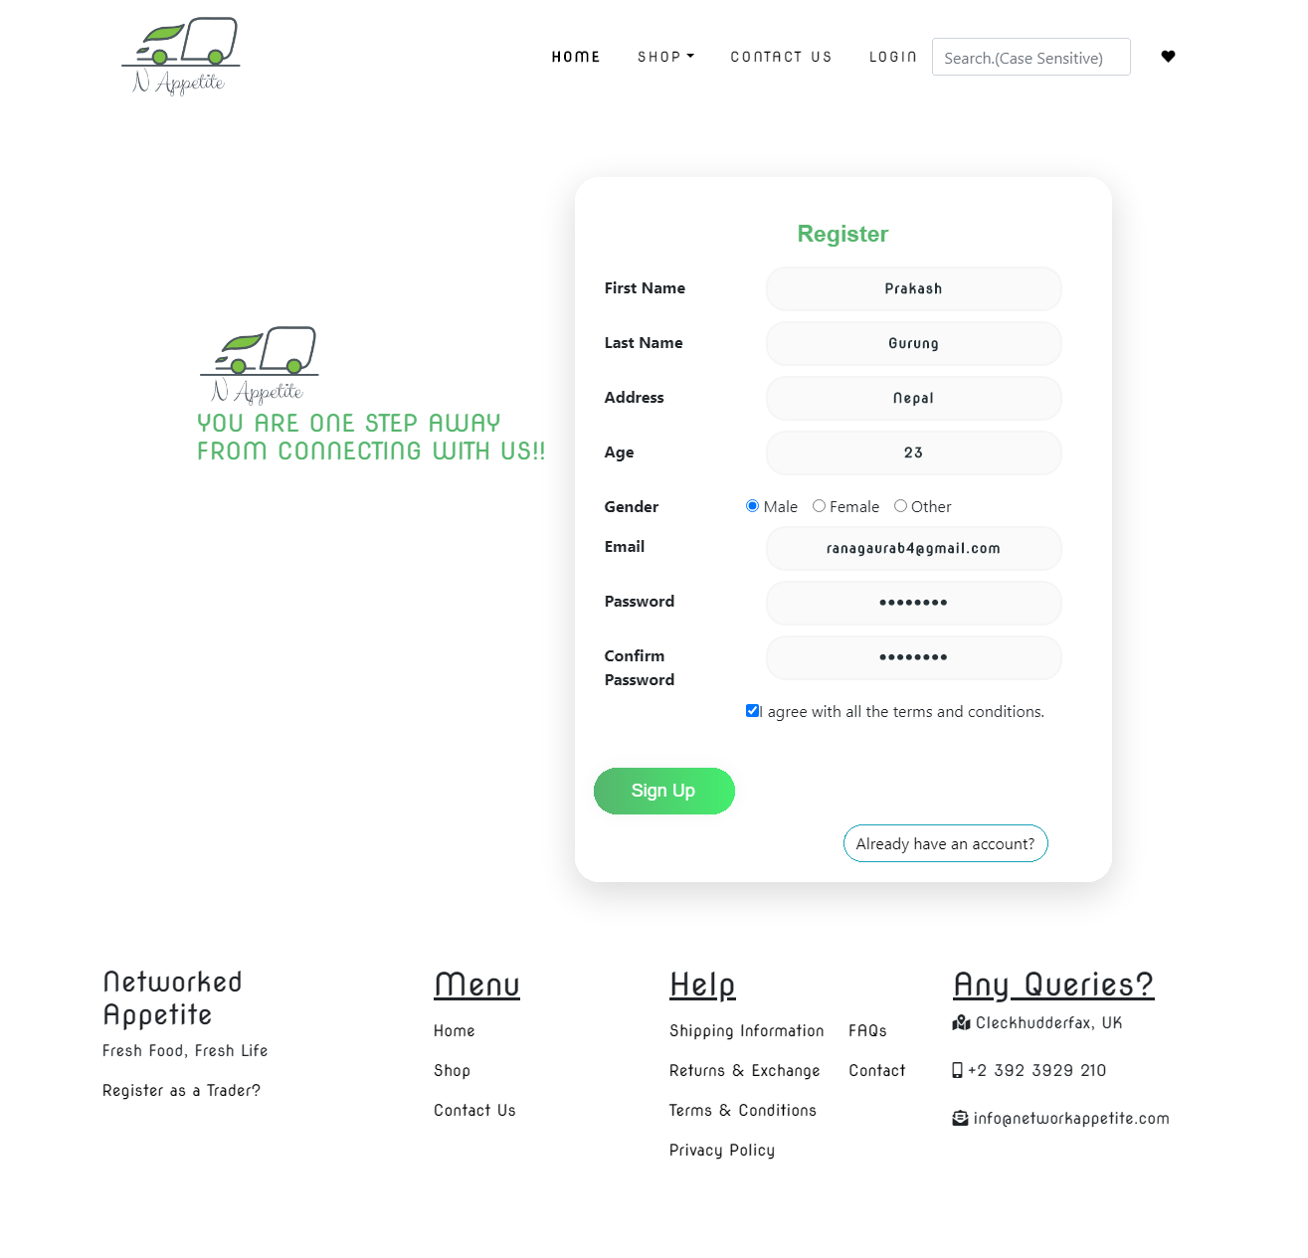

Login

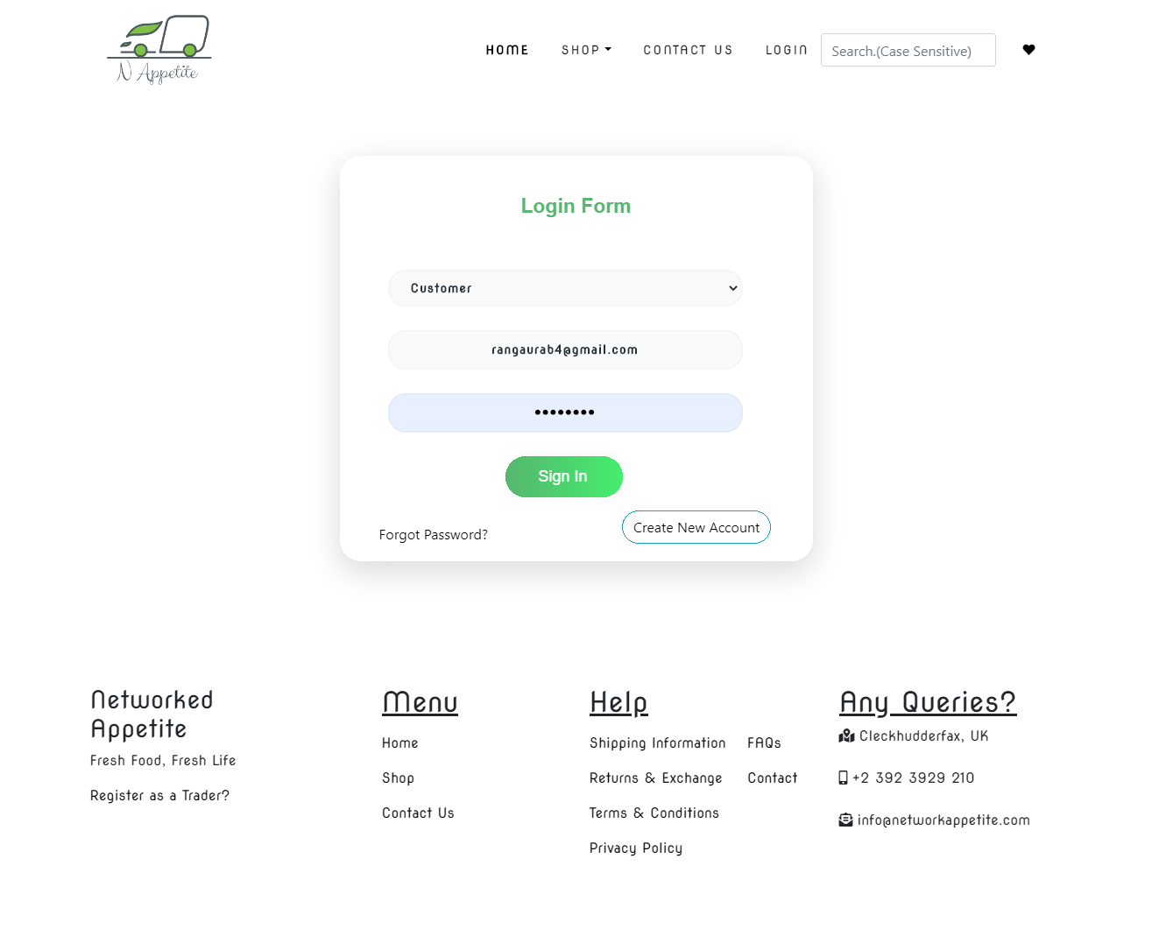

Email Verification

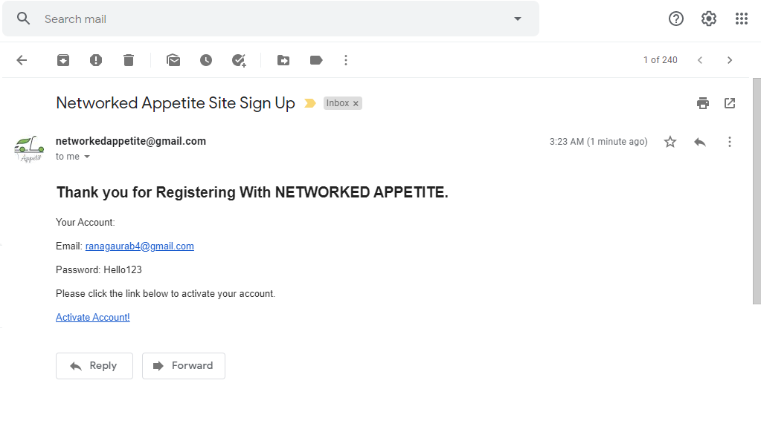

Activating account

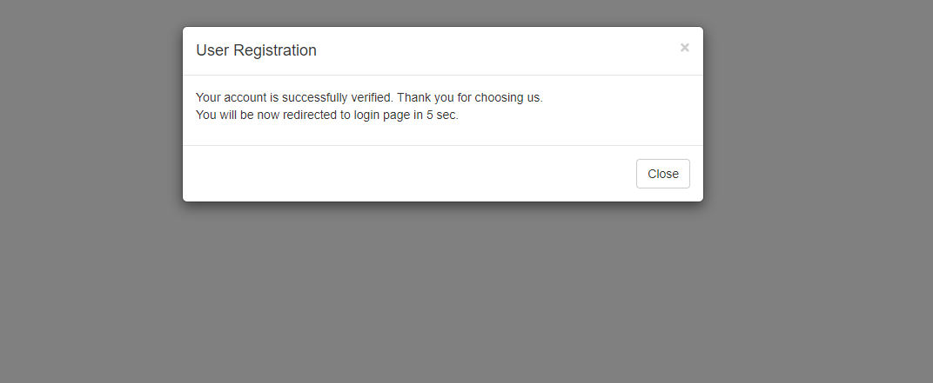

You get redirected to shop after you login as a customer

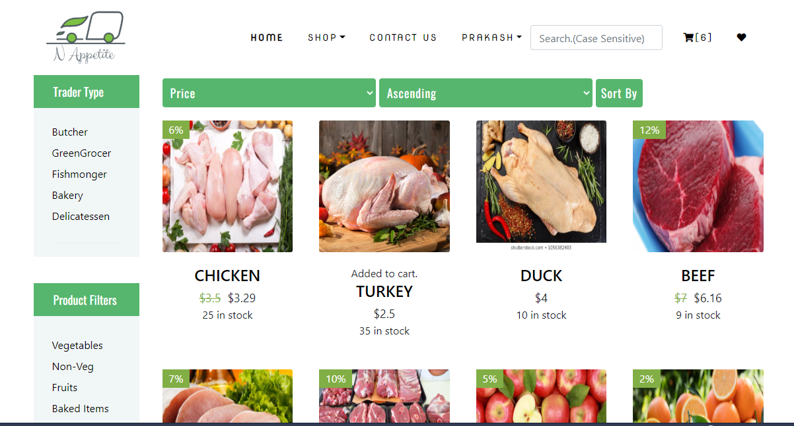

You can choose the item you want from any type.

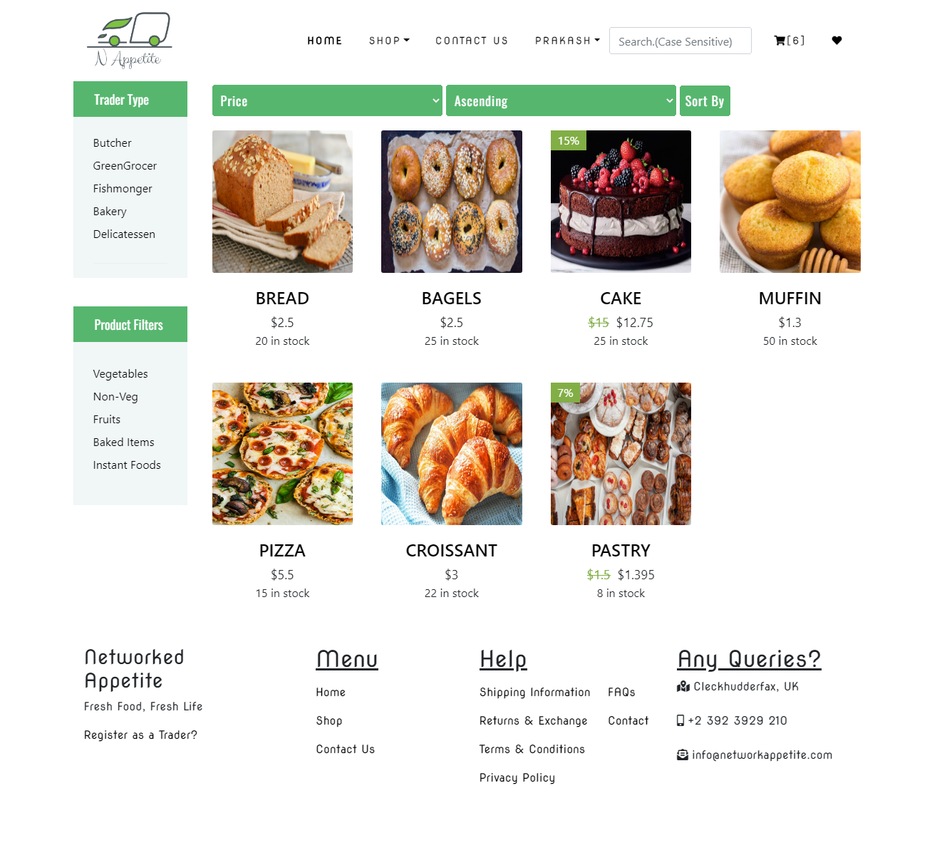

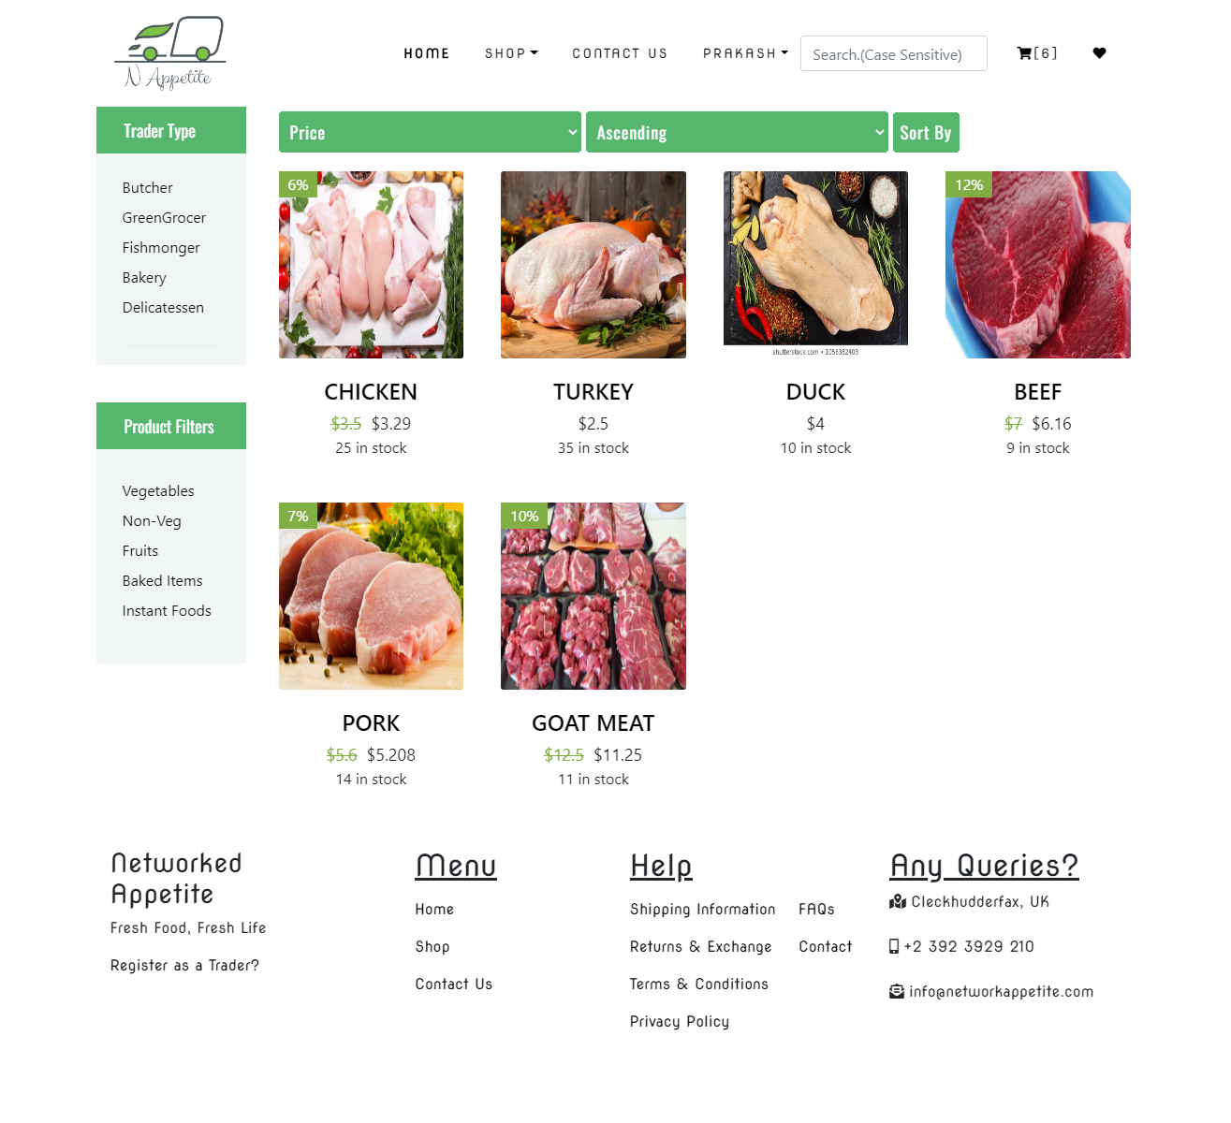

My cart

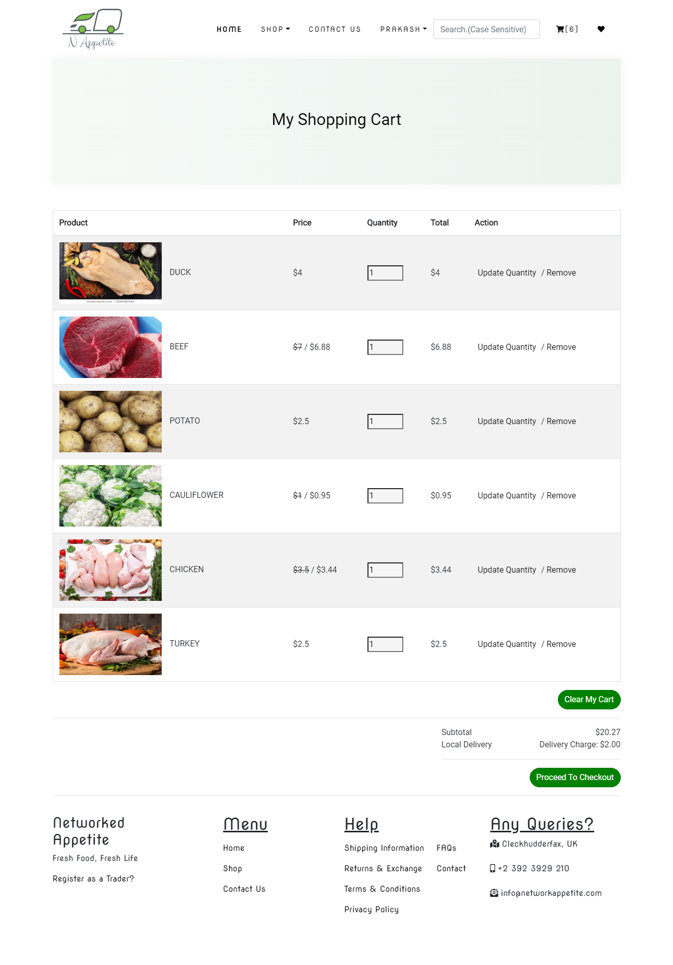

Shipping Details

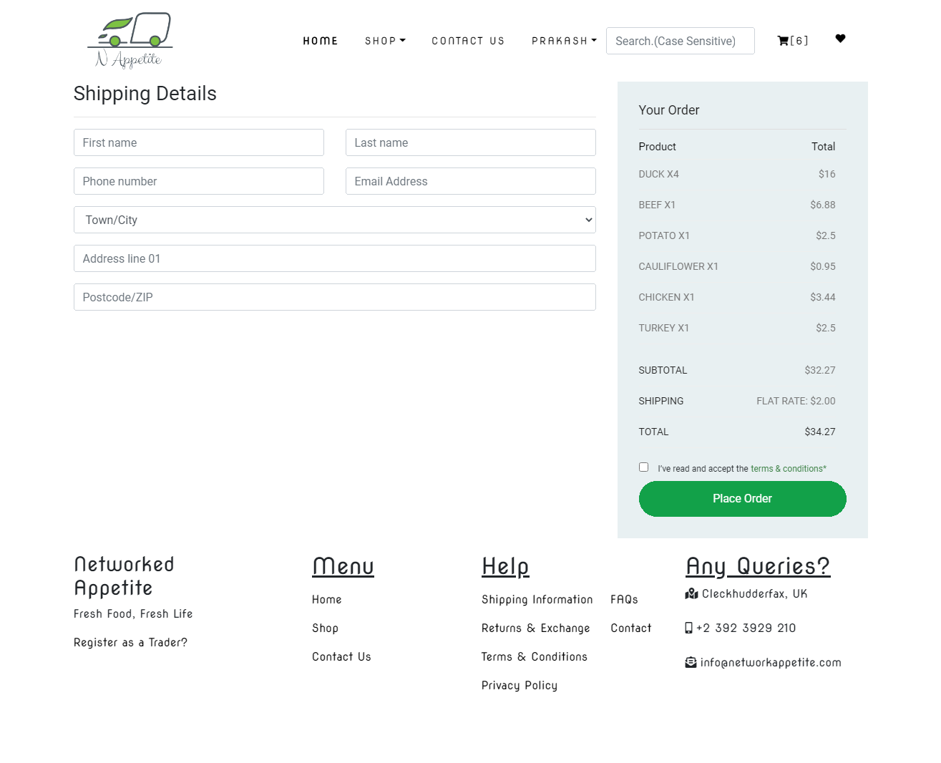

Order Confirmed Email: Customer gets email when an order is confirmed.

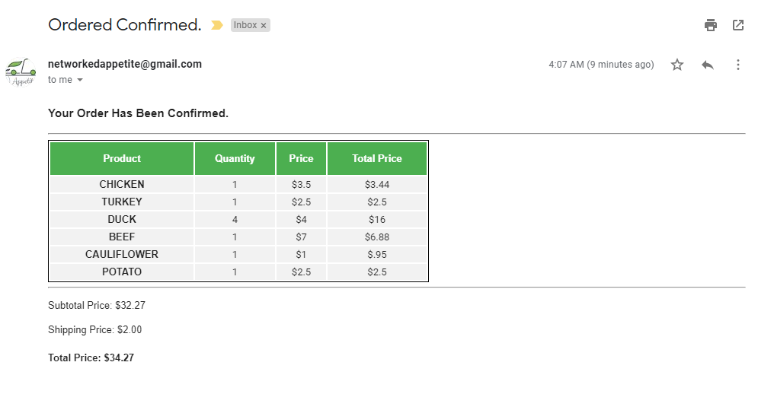

Payment with PayPal

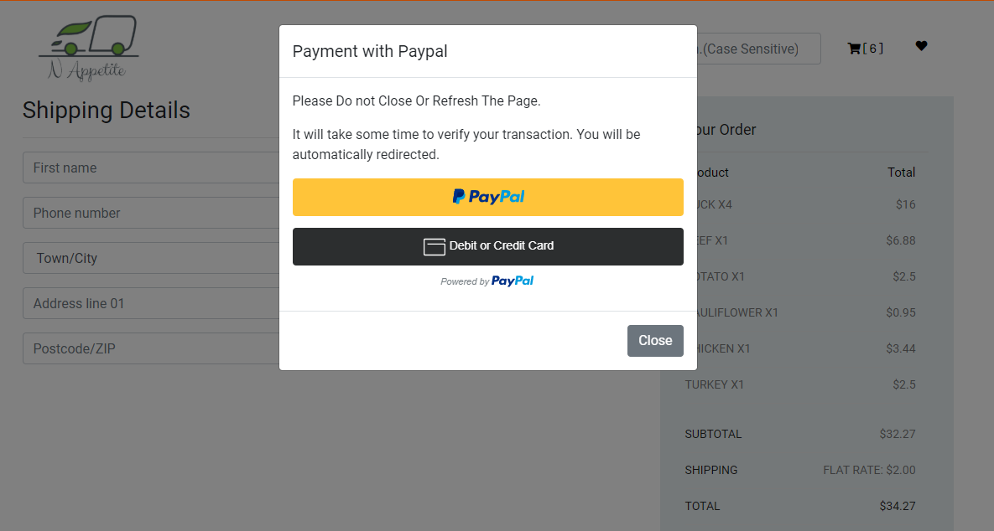

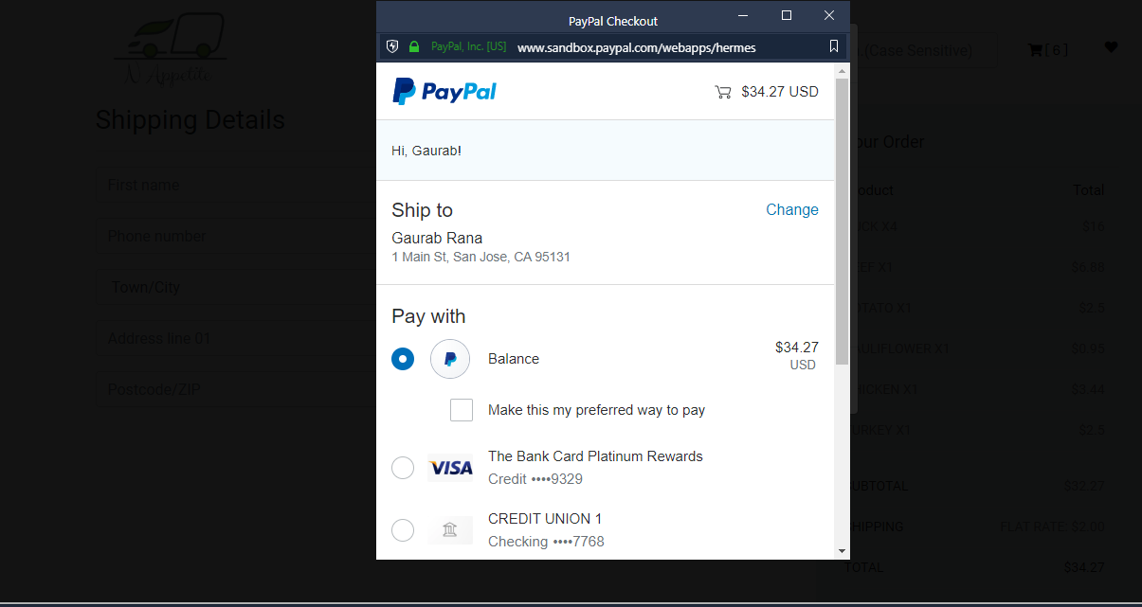

User can view their orders at this section their profile.

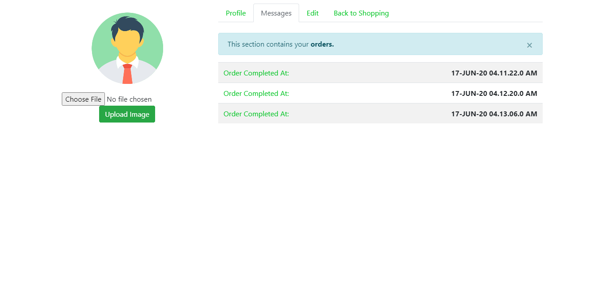

Customer product Invoice

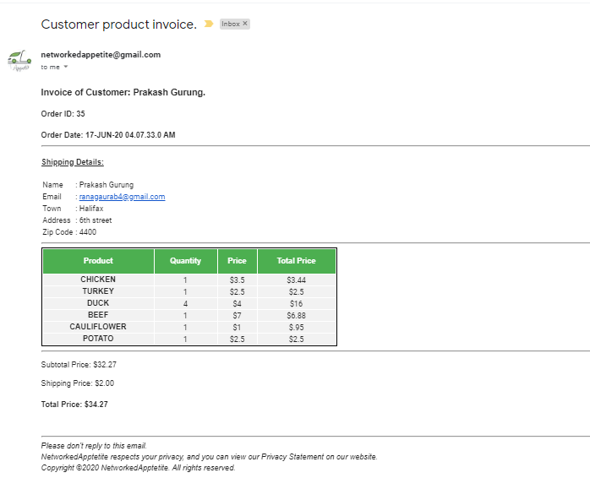

Ordered Products and shipping detail as well as collection slot choice.

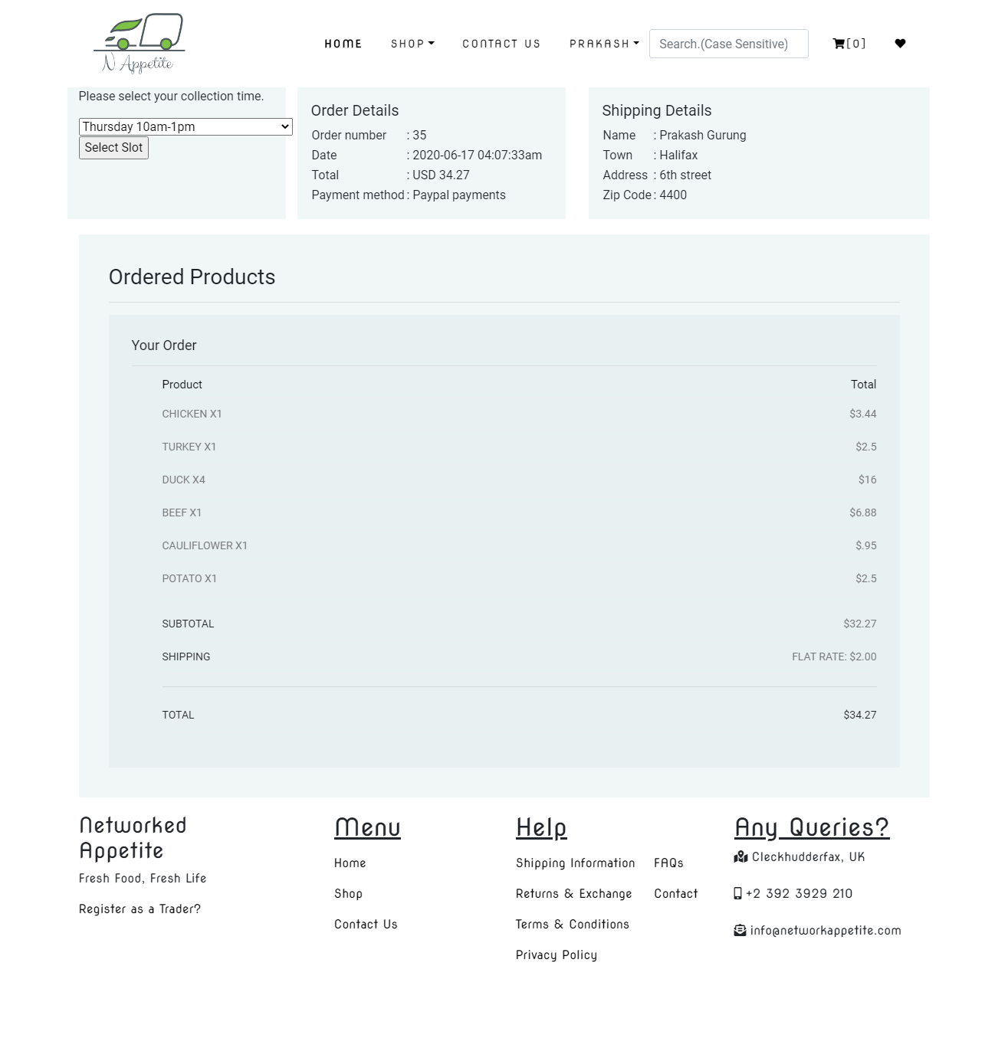

Review and Rating

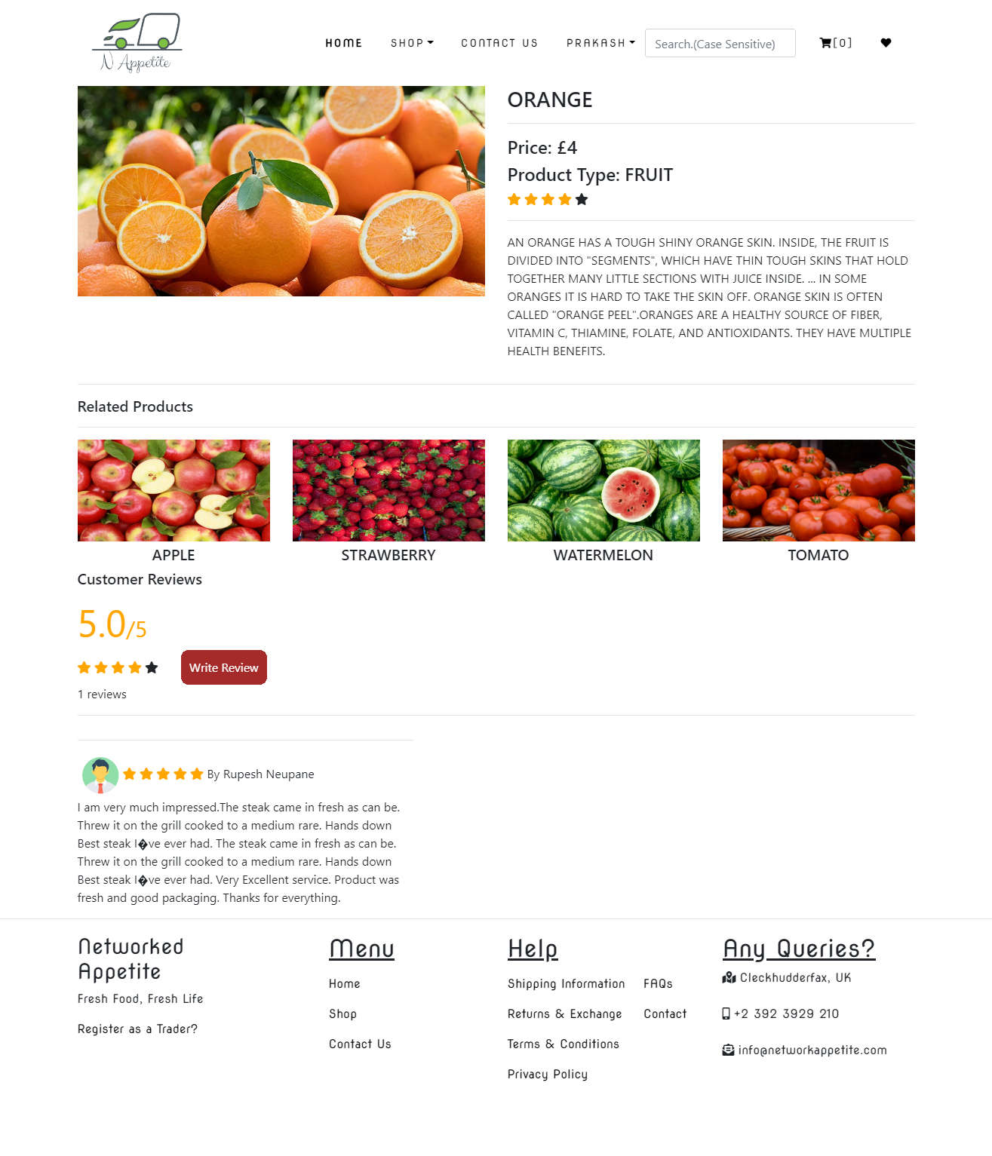

Customer can give review by clicking on write review button



Early Testing Phase

Error when logging in without registration.

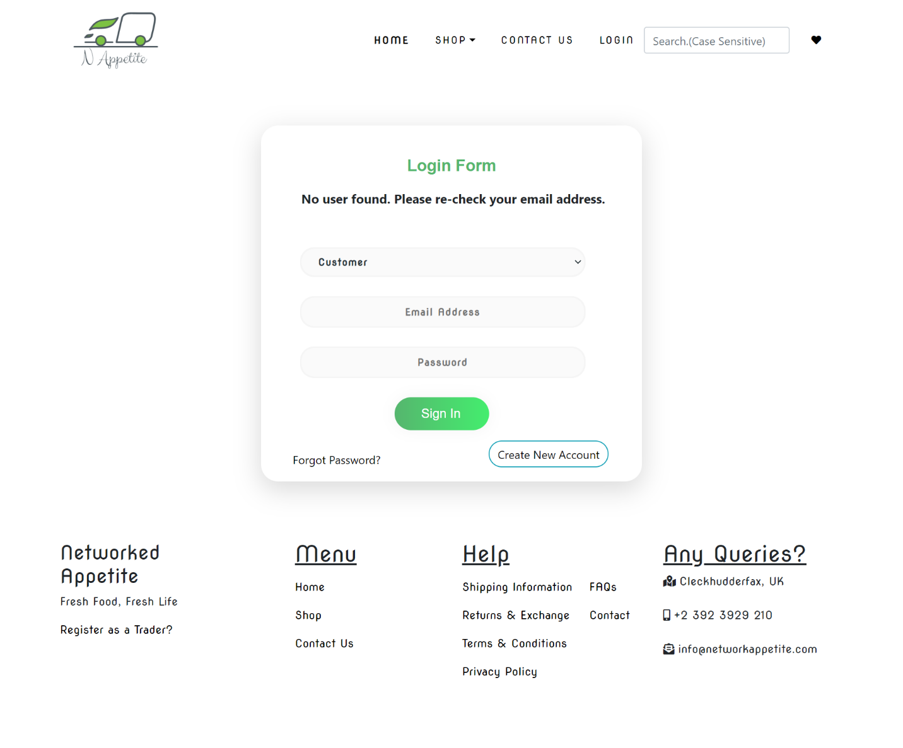

When confirmed password doesn’t match with password, it shows error saying confirmed password does not match. Please re-check.

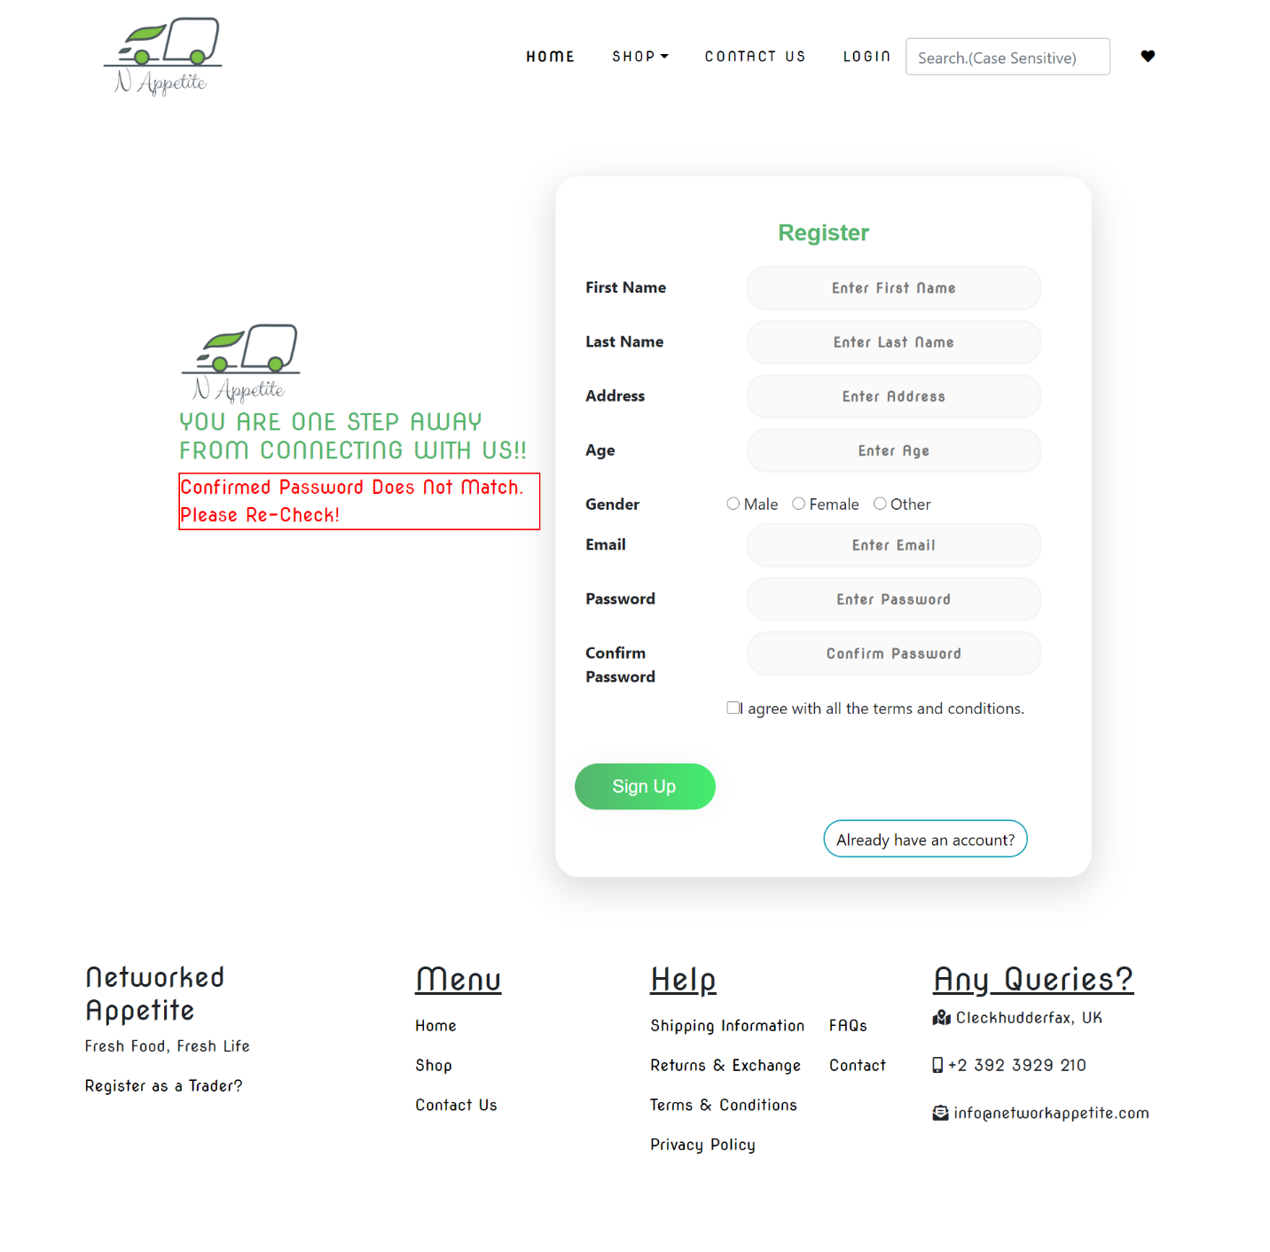

When the user hasn’t verified their account. It shows error when logging in.

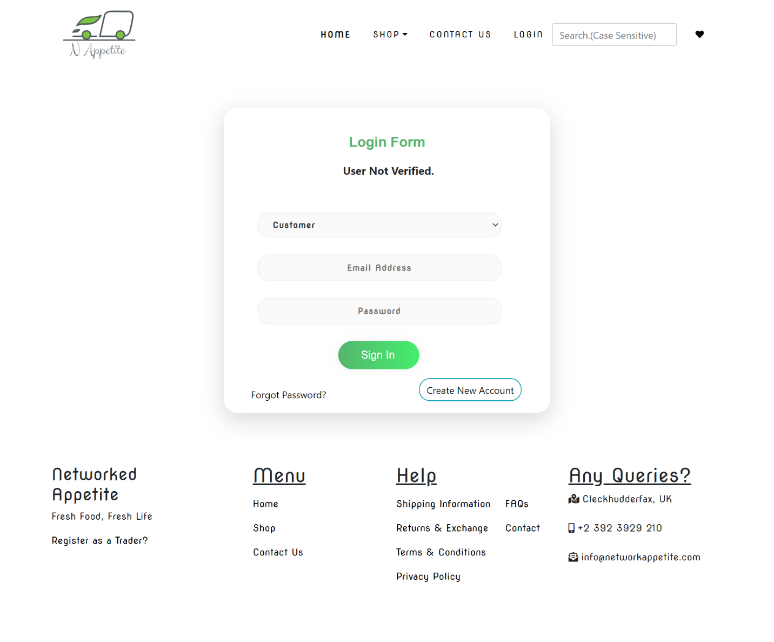

When password doesn’t contain at least 1 number and 1 capital letter, it shows an error.

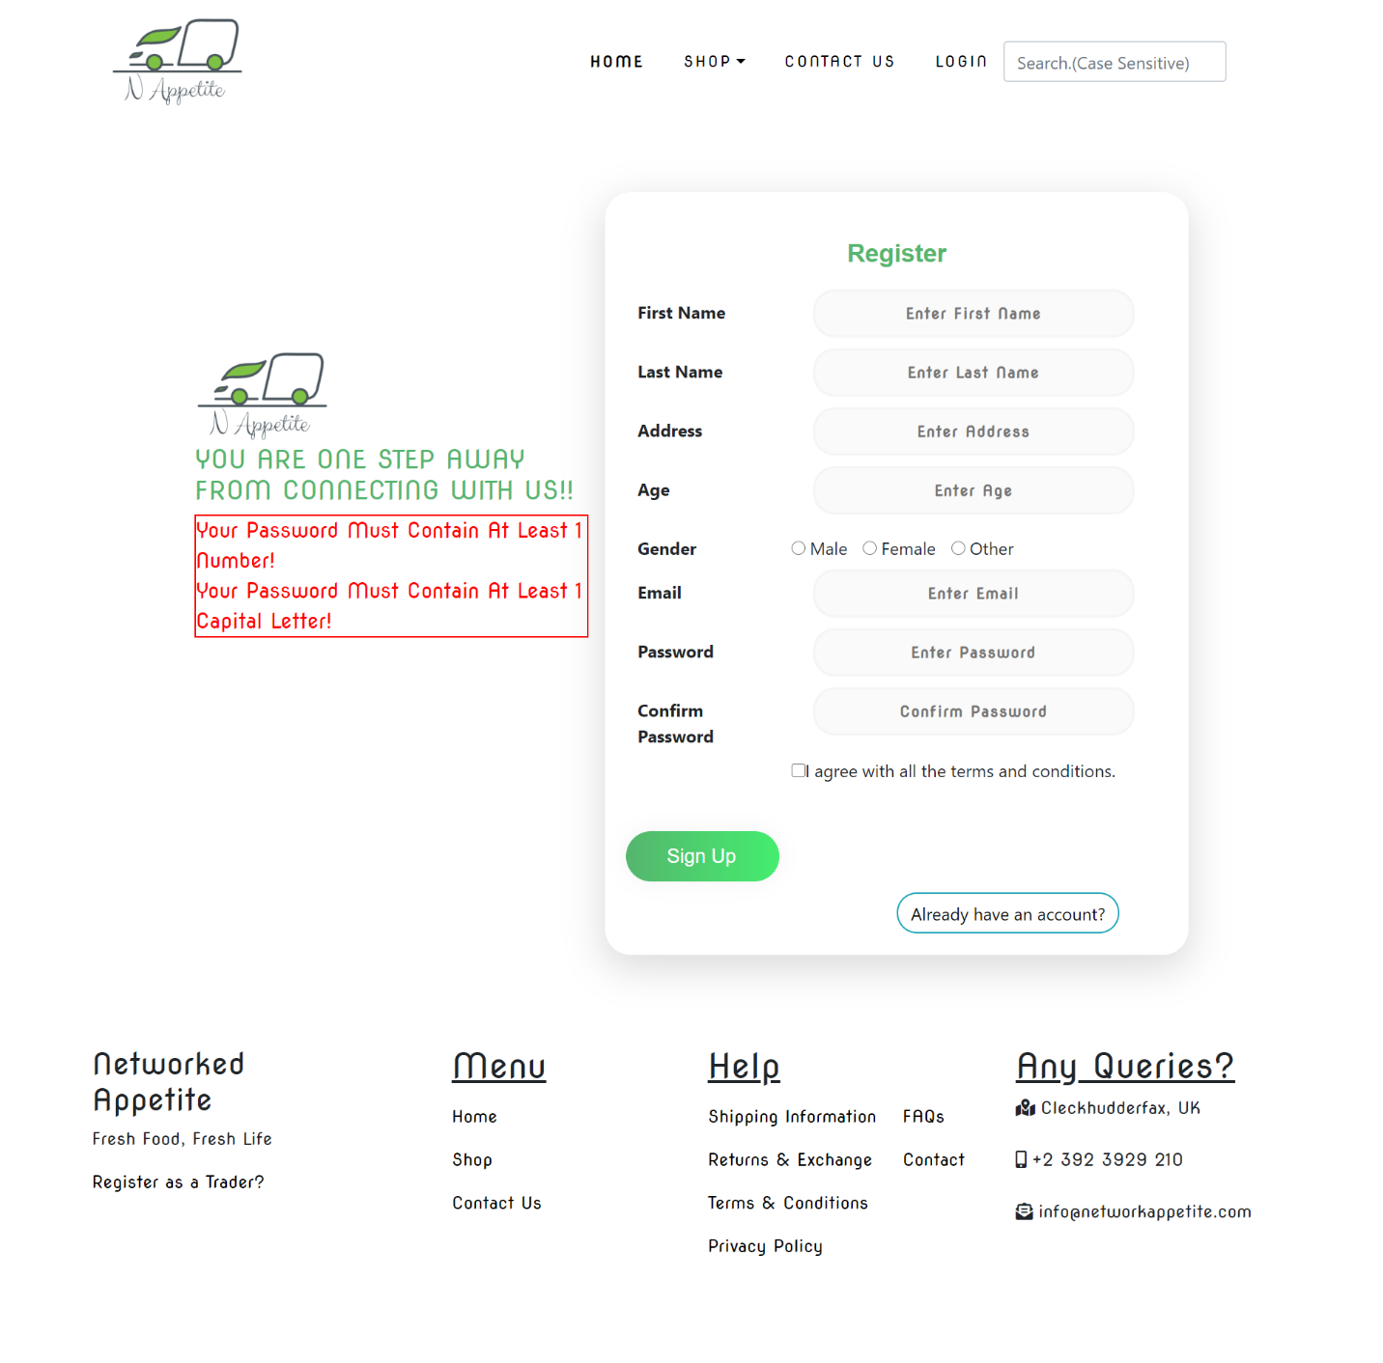

Trader (Php)

We can register from same email once after it is registered. It shows that email already registered

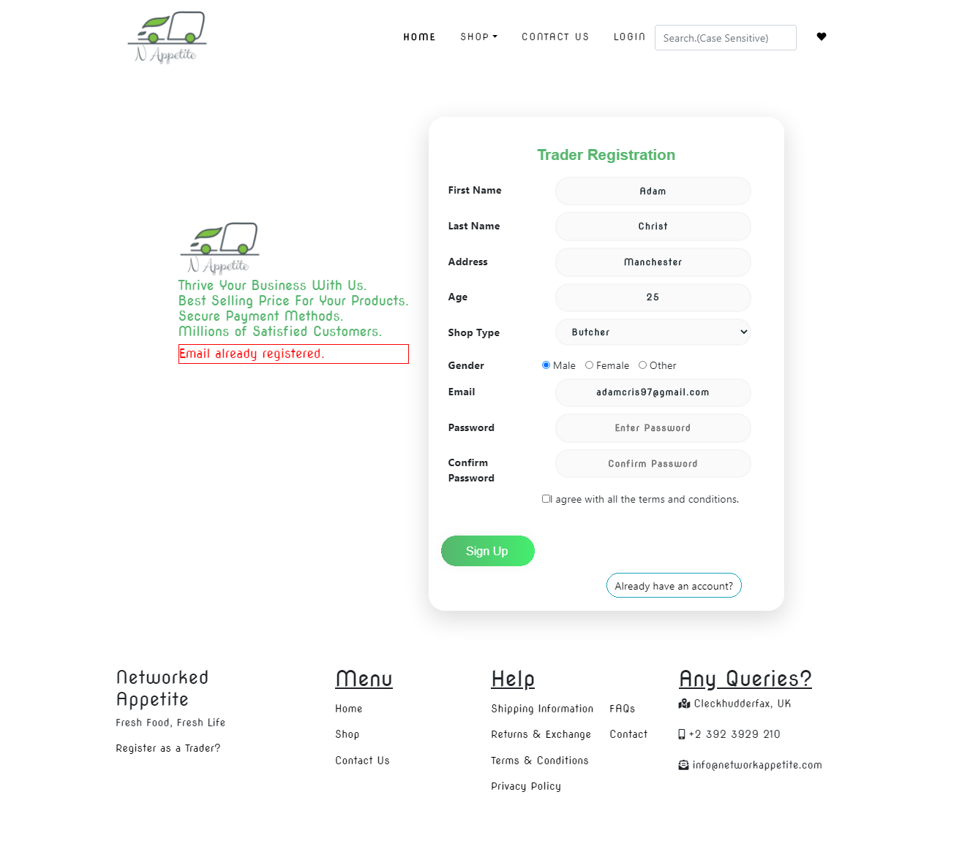

Email and shop type already registered

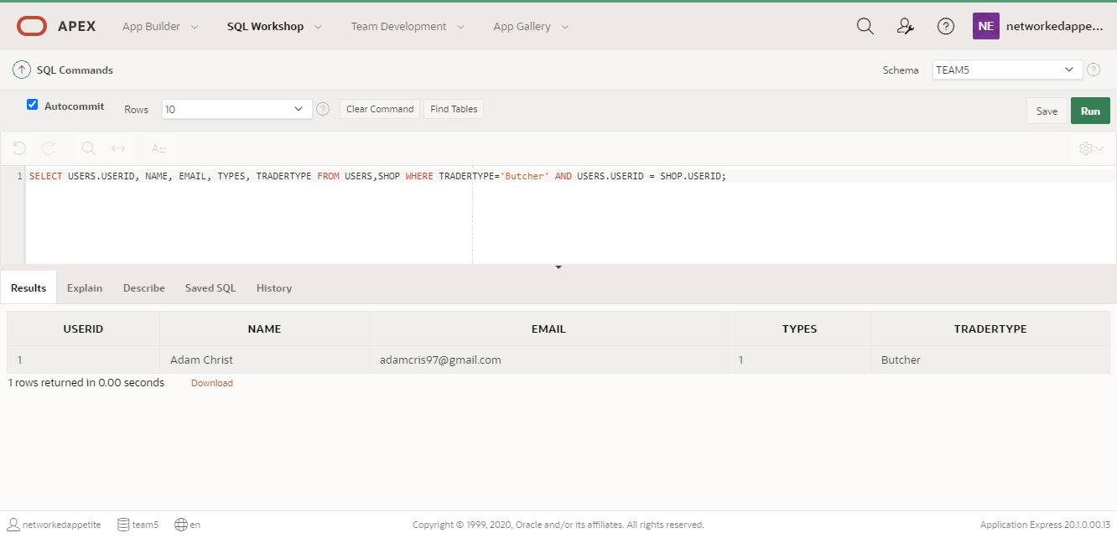

When confirmed password doesn’t match with password, it shows error saying confirmed password does not match. Please re-check.

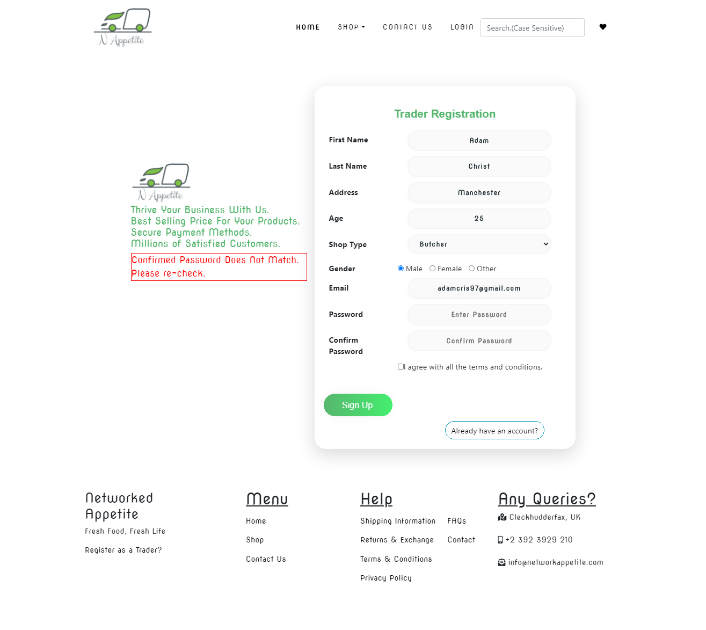

Similarly, with the password when it doesn’t contain at least 1 capital letter and lowercase letter.

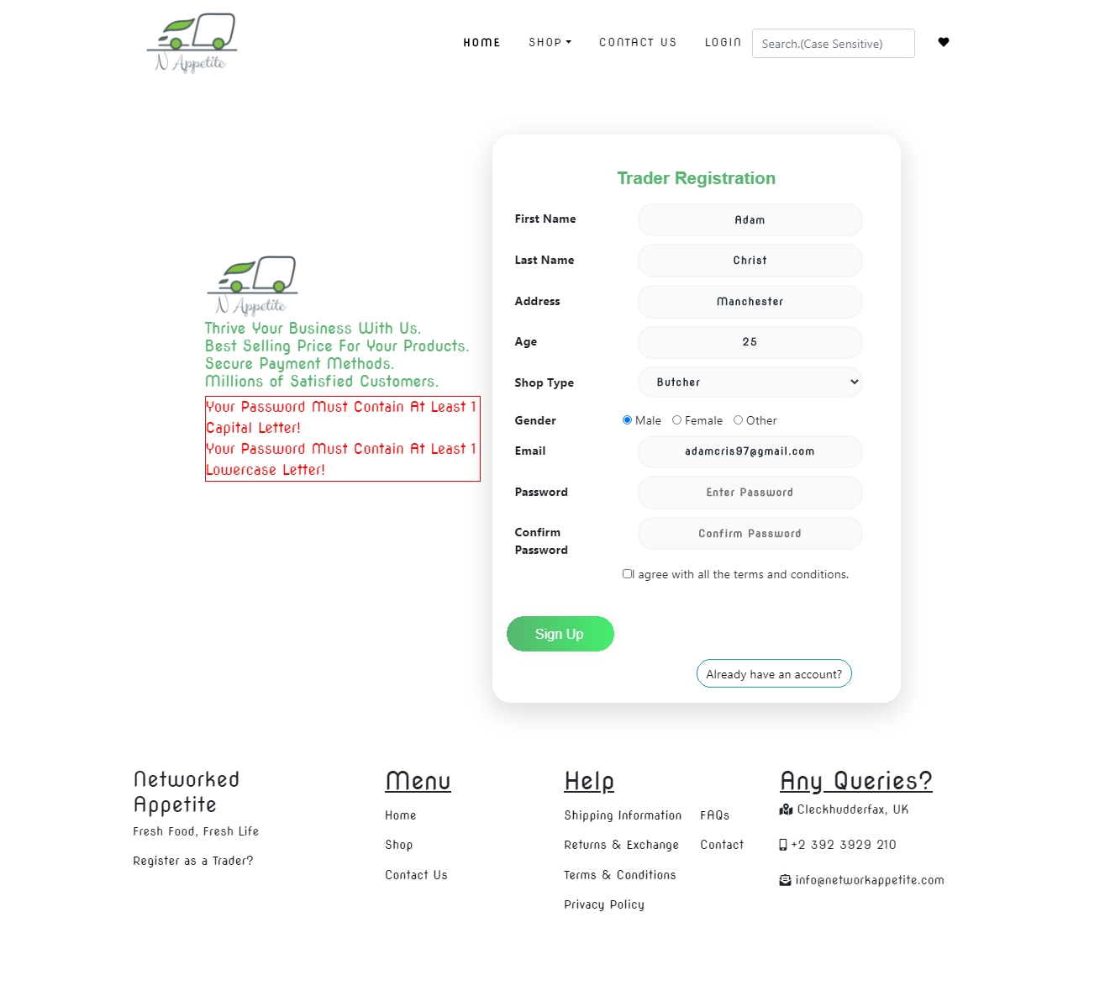

Shows error when the shop type already exists

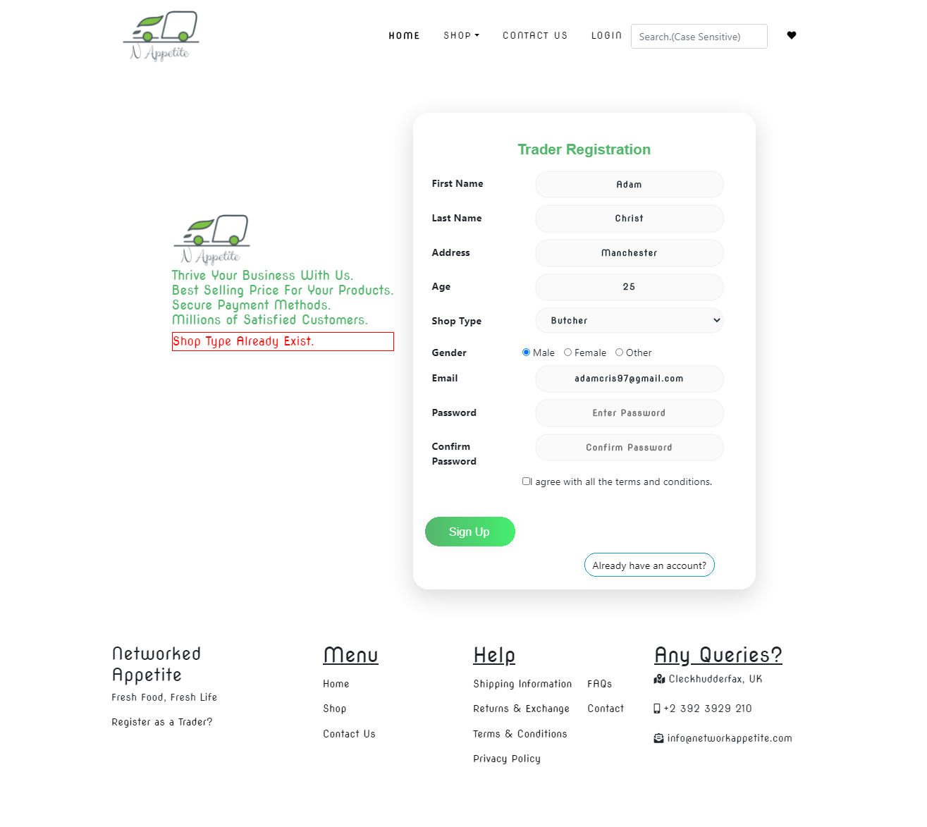

# TESTING

Admin Interface Testing (ORACLE APEX)

Table of Content

1. Sign In

1. Admin sign in with empty username and password
2. Admin sign in with invalid password
3. Admin sign in with correct credentials

2. Trader

1. View basic detail of each trader
2. View Shop Details and products of each trader
3. View each trader dashboard
4. View daily report
5. View weekly finances
6. View monthly sales

3. Customer

1. View each customer details
2. View payment made by each customer
3. View reviews and ratings given by each customer

4. Dashboard

1. View Admin Dashboard

5. Logout

1. Admin is logged out of the admin page.

# Sign In

1. Admin sign in with empty username and password

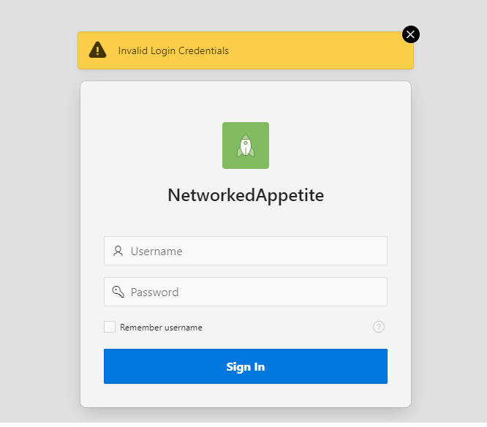

If admin tries to log in with empty username and password then an error message is displayed “Invalid Login Credentials”.

1. Admin Sign In With Invalid Password



If admin tries to log in with wrong password then an error message is displayed ’Invalid Login Credentials’

1. Admin login with valid credentials

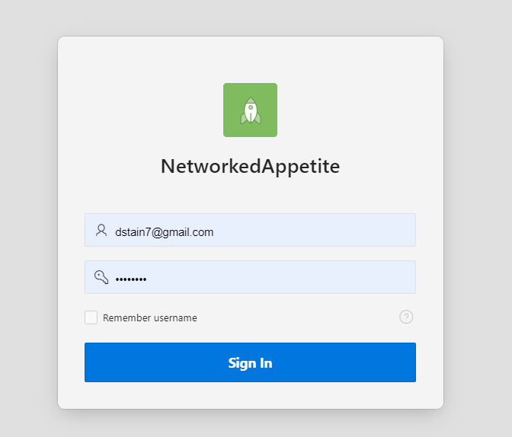

If admin log in with valid credentials then admin gains access to the admin homepage.

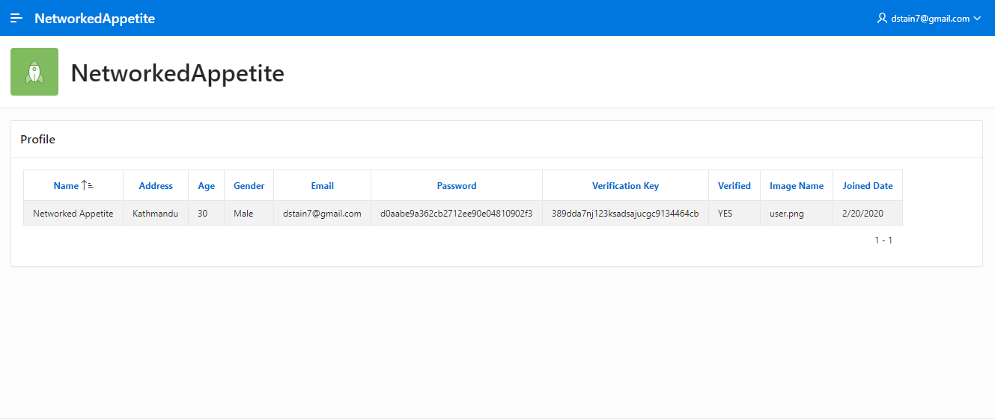

# Trader

1. View Basic Details of each trader

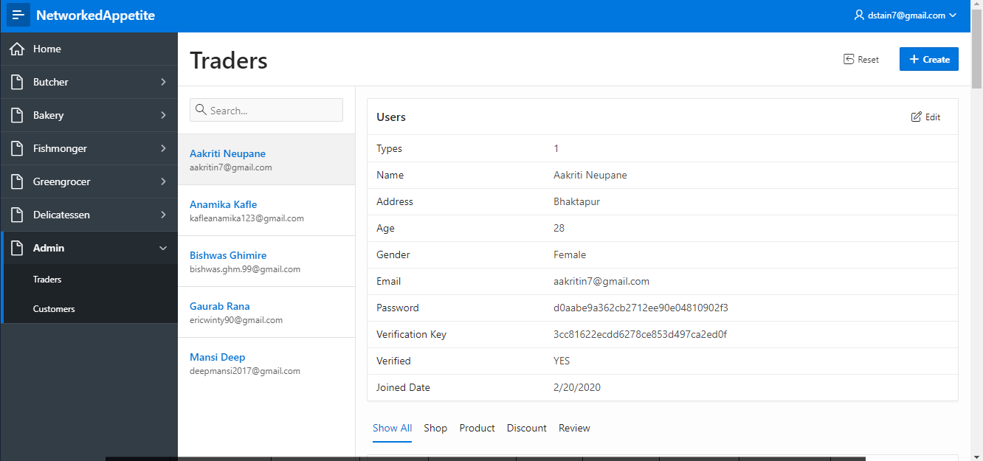

Admin can view details of each trader. Clicking on any trader name will give detail of their profile, shop detail, products sold, discounts given to product and reviews given to their products.

1. View Shop Type and Product sold by each trader

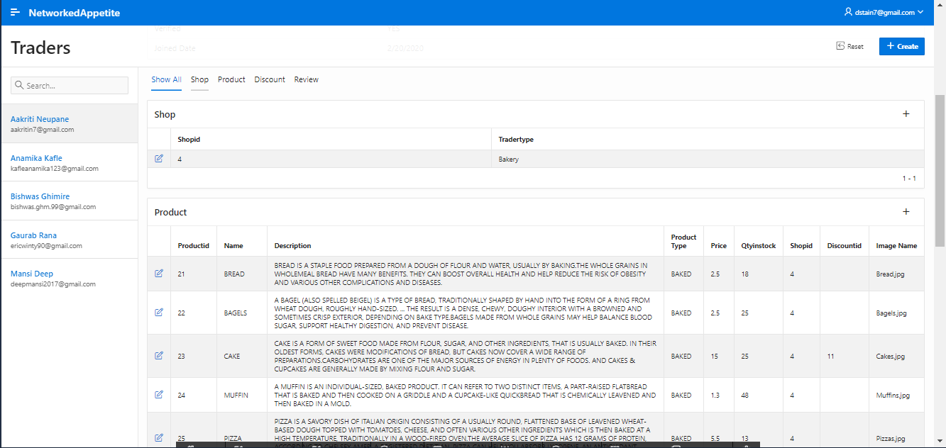

Admin can view detail of trader shop and products they sell.

1. View Dashboard

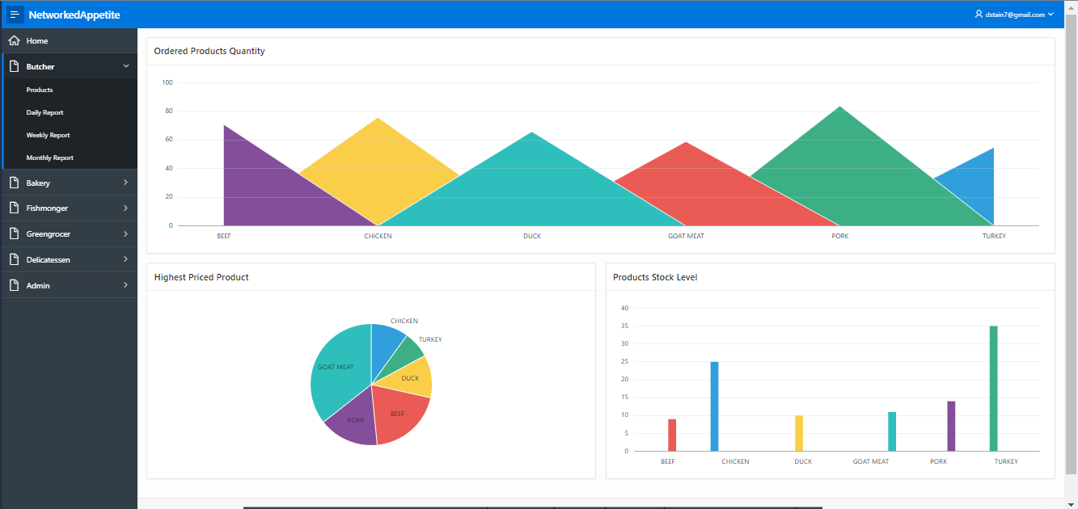

Admin can view dashboard of each trader. The first chart shows the most ordered product of the trader. Pie Chart shows Highest Priced Product and bar graph shows Product Stock Level.

1. View Daily Report

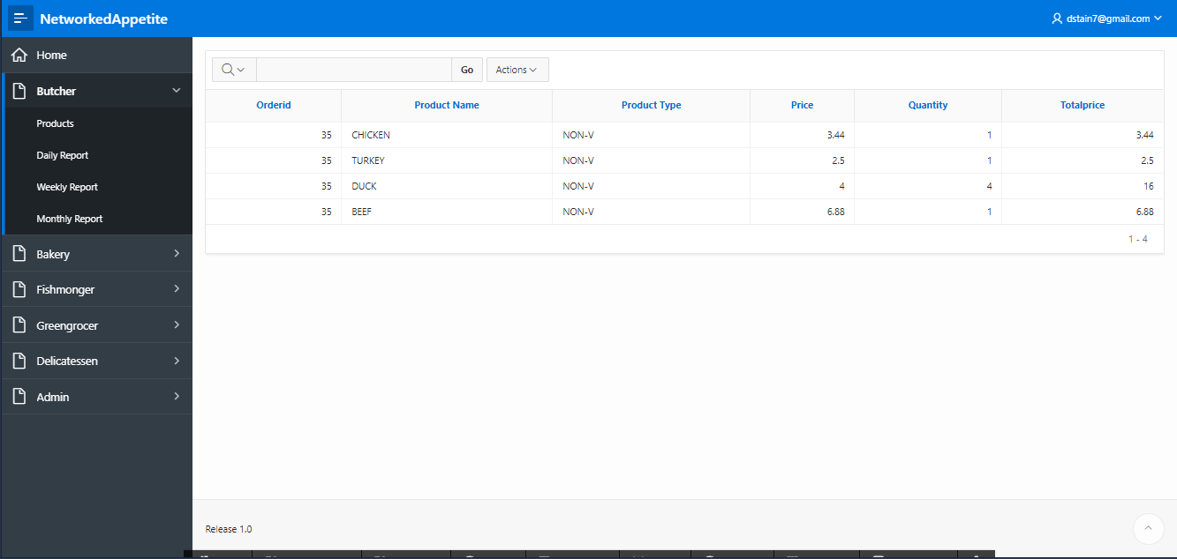

Admin can view Daily Report of each trader.

1. View Weekly Finances

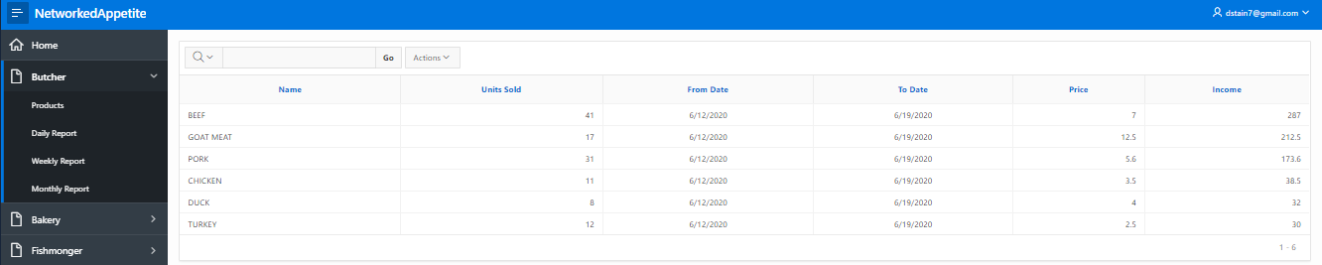

Admin can view weekly finance report of each trader

1. View Monthly Sales

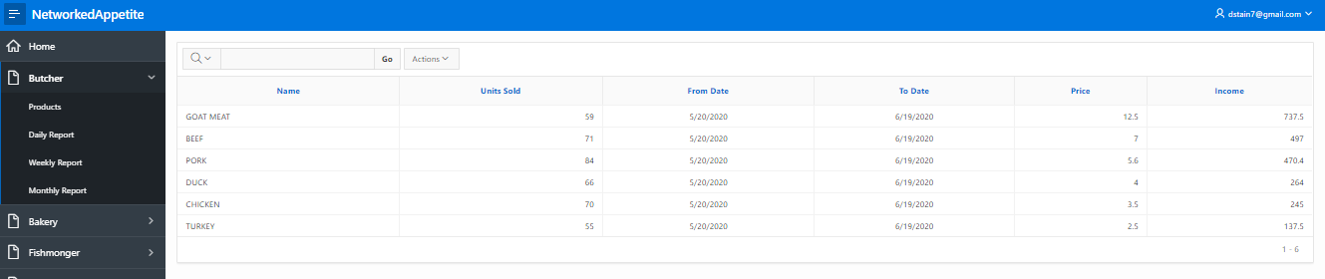

Admin can view monthly sales of each trader.

# Customer

1. View Customer Details

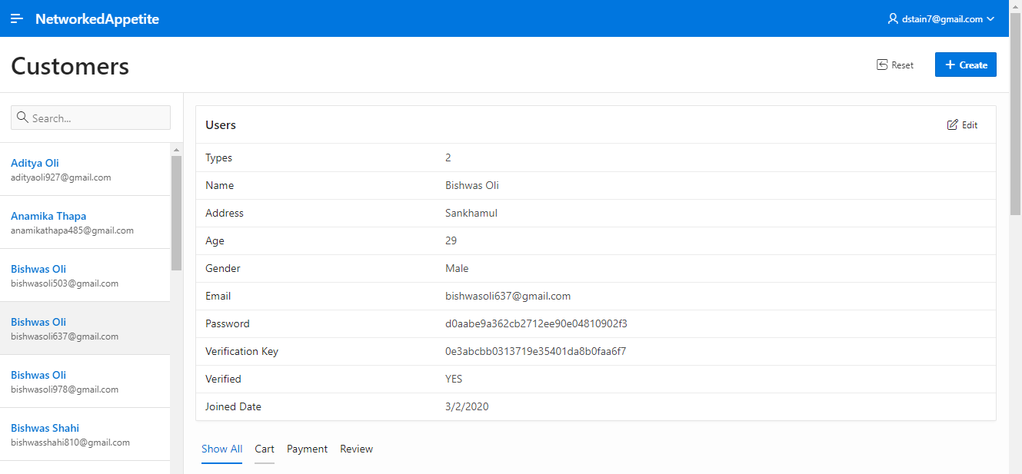

Admin can view all the details of each customer.

1. View Payment Made by Each Customer

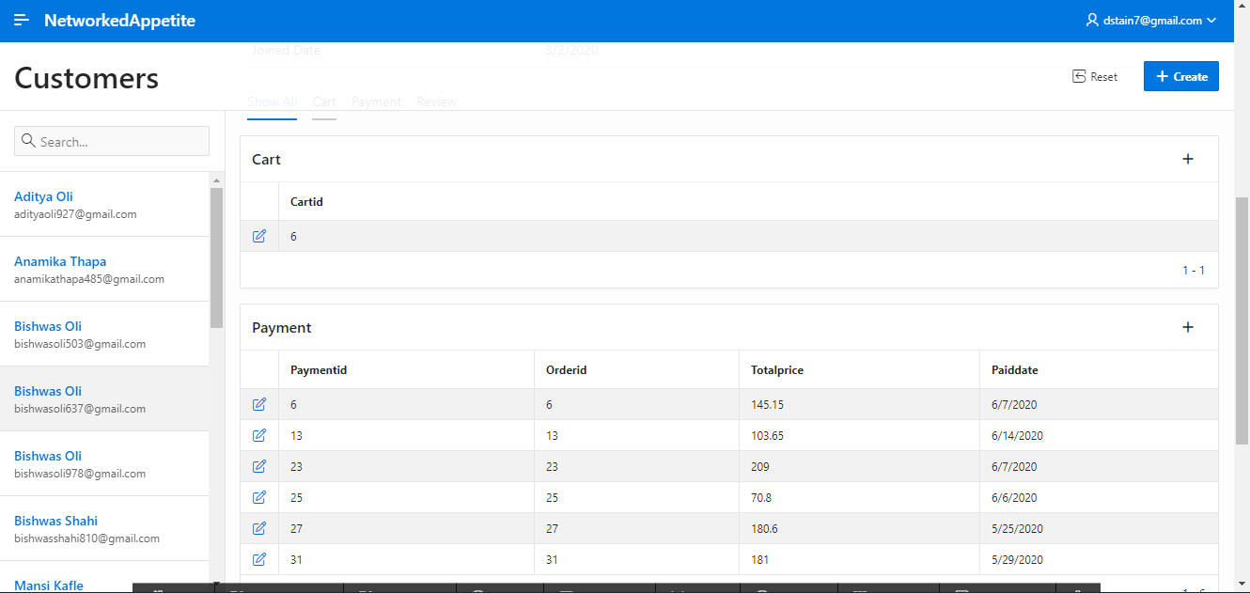

Admin can view all the payment details of each customer.

1. View Reviews And Rating Given By Customer

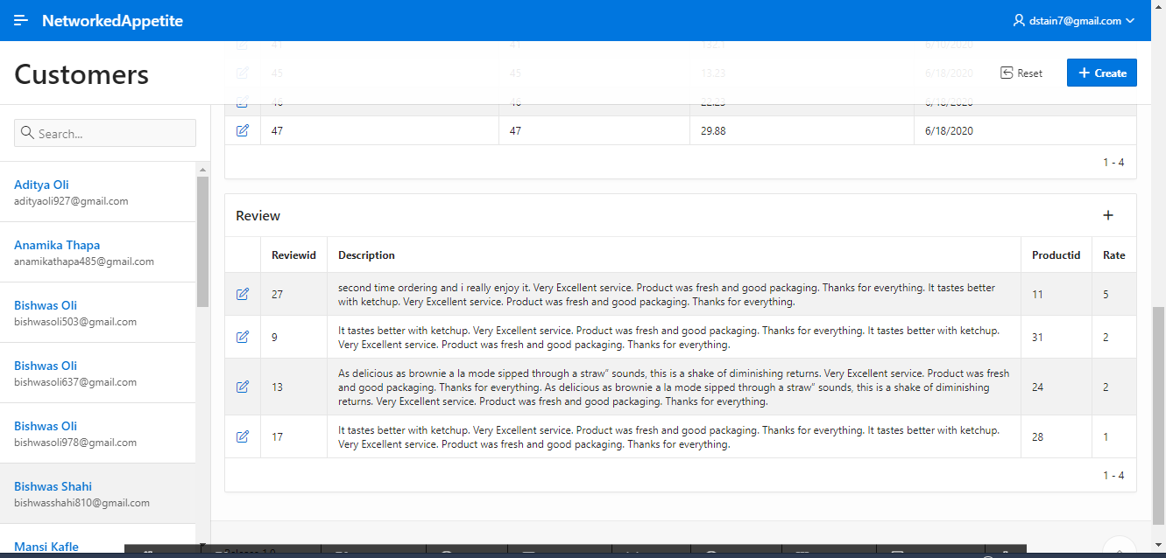

Admin can view all the reviews and ratings given by the customer.

# DASHBOARD

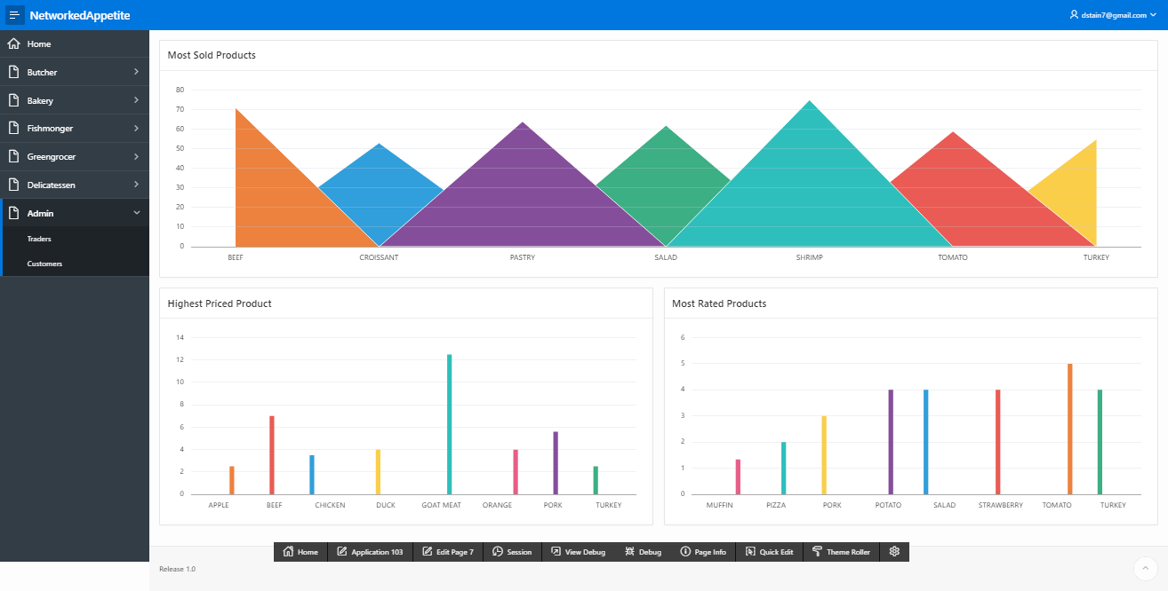

Admin also have access to overall dashboard where information like most sold product, most rated product, highest priced product are shown.

# Logout

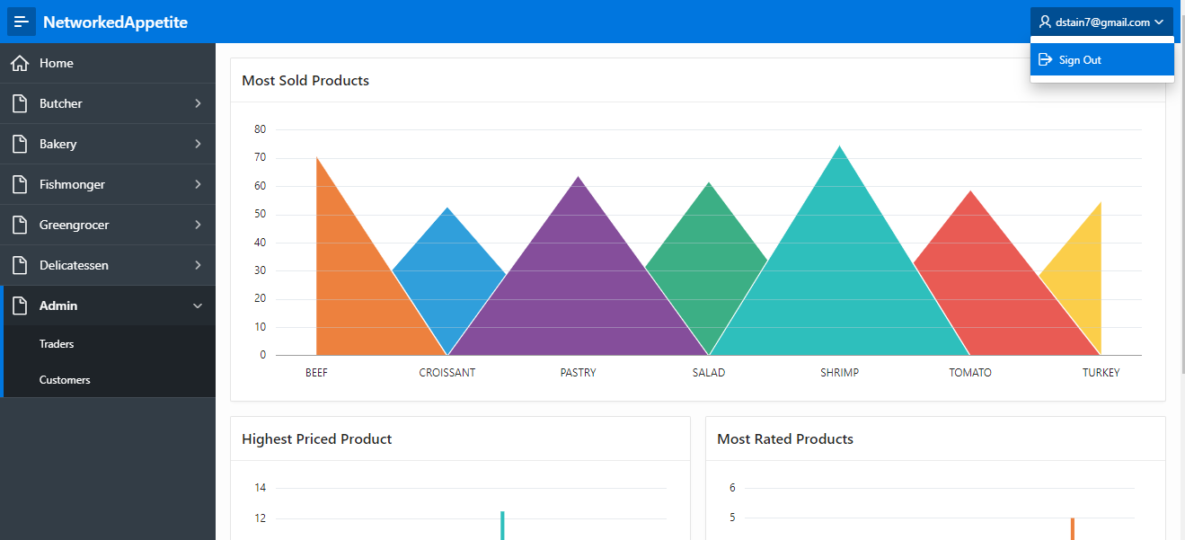

Admin can logout the dashboard from Sign Out button at the top right side of the page.

Trader Interface Testing (ORACLE APEX)

Table of Content

1. Sign In

1. Sign in with empty username and password
2. Sign in with invalid password
3. Sign in with correct credentials

2. Products

1. View Products Details
2. View Product Discount

3. Dashboard

1. View Dashboard

4. Report

1. View Daily Report
2. View Weekly Finances
3. View Monthly Sales

5. Reviews

1. View Reviews and Ratings

6. Access

1. View Dashboard / Reports of other traders
2. View Dashboard of Admin

7. Logout

1. Logout of the trader from dashboard page

# Sign In

1. Trader sign in with empty username and password



If trader tries to log in with empty username and password then an error message is displayed “Invalid Login Credentials”.

1. Sign In With Invalid Password



If trader tries to log in with wrong password then an error message is displayed ’Invalid Login Credentials’

1. Trader login with valid credentials(logged in with one of the trader account)

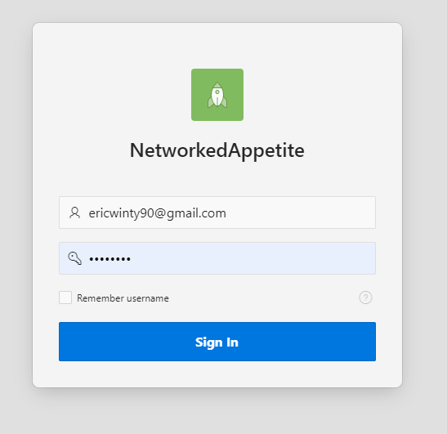

If trader log in with valid credentials then trader gains access to the Trader homepage. The homepage shows detail of the trader.

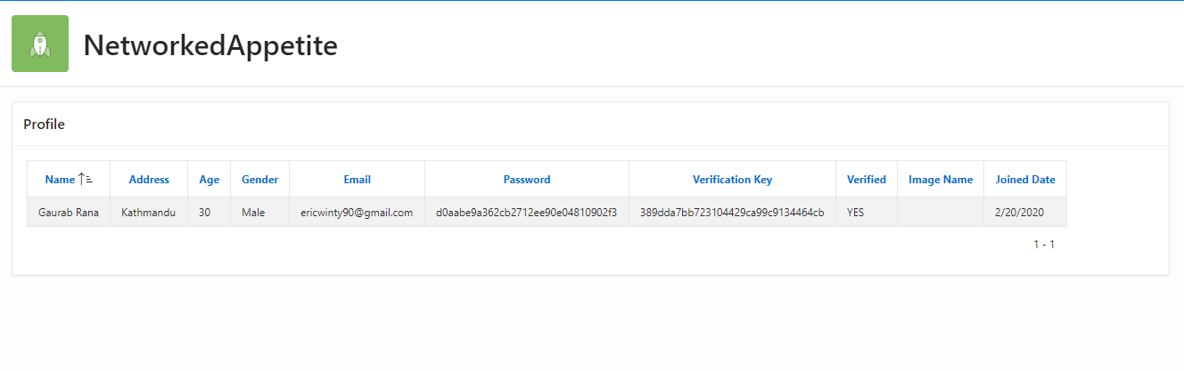

# Products

1. View Products Details

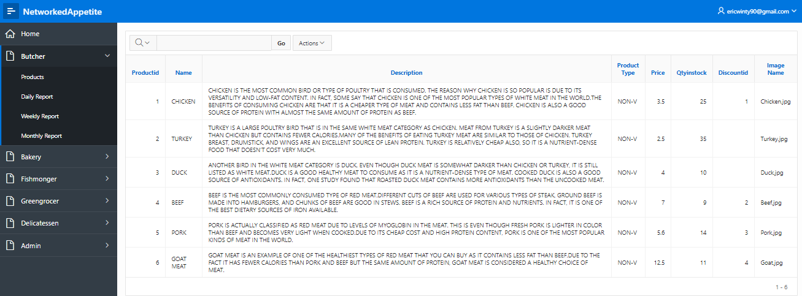

Trader can view details of each of their product.

1. View Product Discount

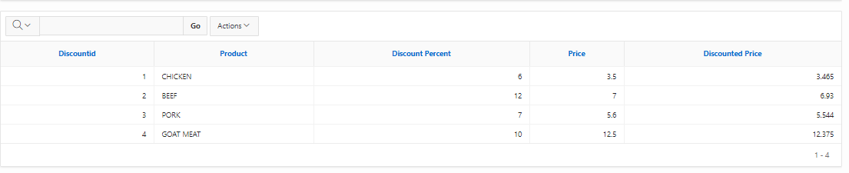

Trader can see what products they have given discount and price after discount.

# DASHBOARD



Trader can view their overall dashboard. The first chart shows the most ordered product of the trader. Pie Chart shows Highest Priced Product and bar graph shows Product Stock Level.

# REPORTS

1. Daily Order Report

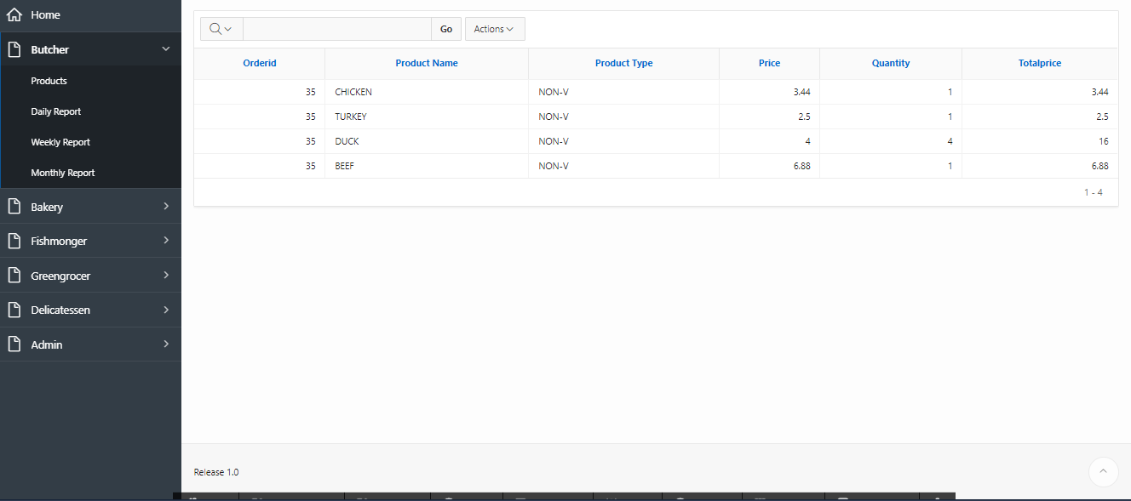

Trader can view their daily order reports.

1. View Weekly Finances

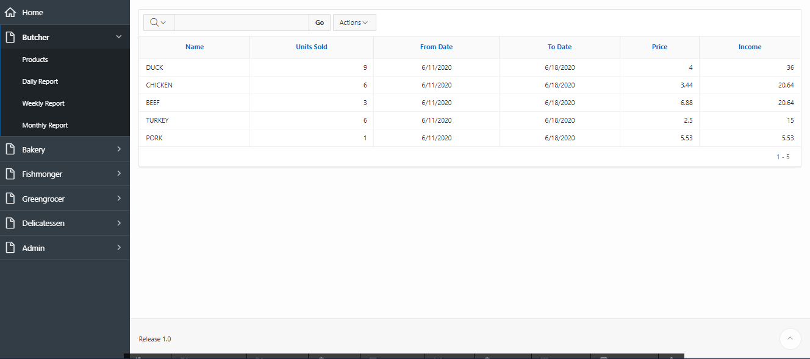

Trader can view their weekly finance report.

1. View Monthly Sales

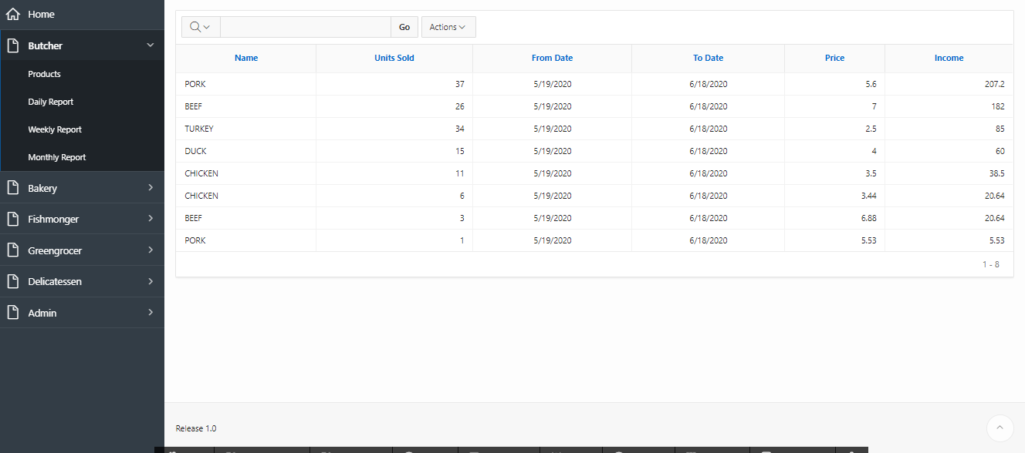

Traders can view their monthly sales report.

# Reviews

1. View Reviews And Rating Given By Customer

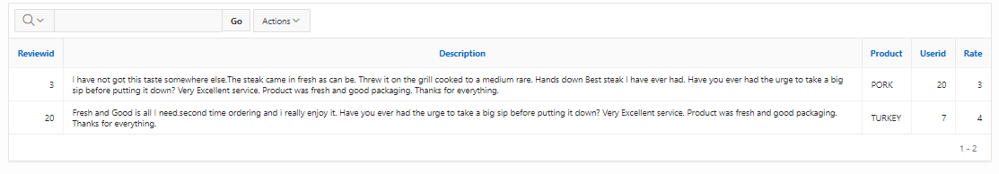

Traders can view the reviews and ratings given to their products.

# ACCESS

1. View Dashboard / Reports Of Other Traders

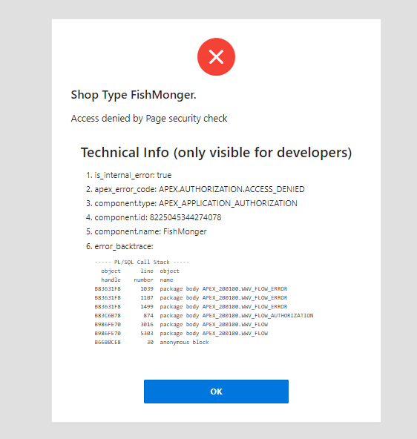

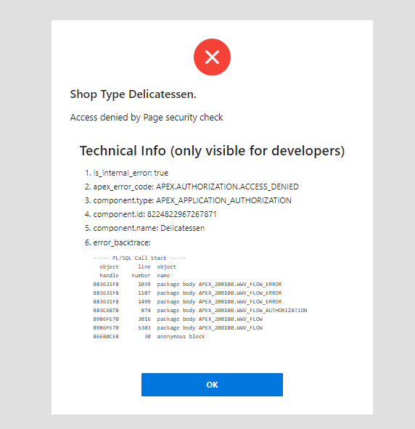

Traders are not given access to reports of other traders. If any trader tries to access those pages, they will be blocked along with the error message. Here we have tested trader butcher trying to access page of fishmonger and delicatessen.

1. View Admin Dashboard

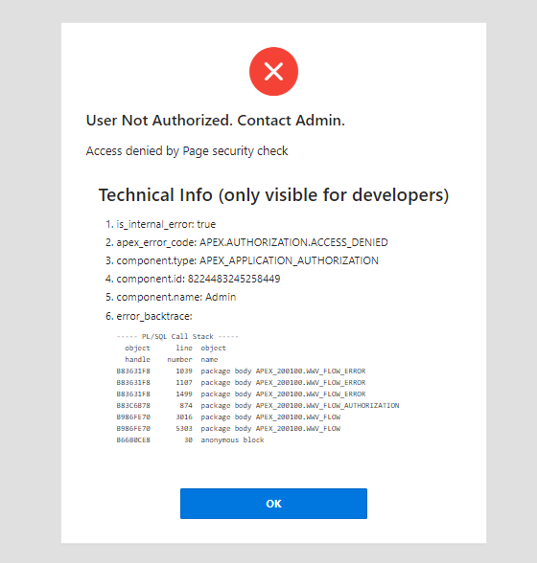

Traders are not allowed to access admin dashboard either. Trying to access will give error and access is denied as shown in picture above. Here we have tested butcher trader trying to access admin dashboard.

# Logout

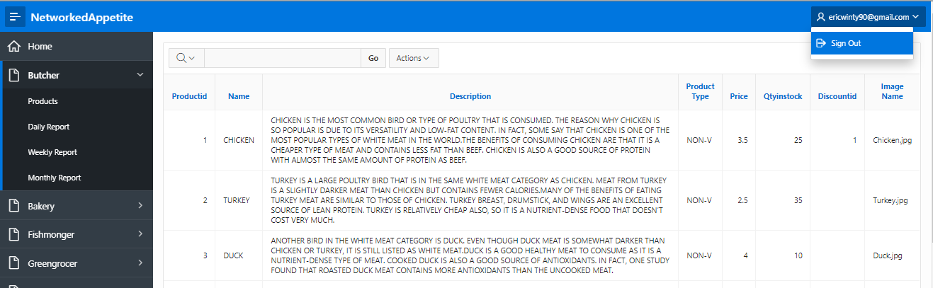

Traders can logout from the page using Sign Out button at the top right side of the page.

Trader Interface Testing (PHP)

Table of Content

1. Register

1. Register with password and confirm password incorrect
2. Register with invalid password format
3. Register with email that is already registered
4. Register with shop type that is already registered
5. Register with correct credentials

2. Verify

1. Activate account with verification link sent in email of trader

3. Login

1. Login with incorrect email
2. Login with incorrect password
3. Login with correct email and password

4. Reset Password

1. Clicked on reset password link to send email verification for reset password
2. Click on link to reset pass

5. Trader Interface

1. View Products
2. Add Products
3. Update Products
4. Delete Products
5. View Profile
6. Update Profile
7. View Report

6. Logout

1. Logout of the trader from trader page

# Register

1. Register with password and confirm password incorrect



If trader tries to register with unmatched password and confirm password field, then registration fails and an error message is shown.

1. Register with invalid password format



If trader tries to register with incorrect password format, then registration fails and an error message is shown.

//TESTING WITH EMAIL AND TRADER TYPE ALREADY REGISTERED



As shown above we already have email and trader type registered. So trying to register with same email or trader type will result in registration failure with respective error message.

1. Registering with email that is already registered



Registration fails and an error message is displayed.

1. Register with shop type that is already registered



Registration fails and an error message is shown.

1. Register with correct credentials



Registration with correct info and an email is sent to the email of user.



# VERIFY USER

1. Clicked on activate account in email to verify email



Clicking on activate account will redirect trader this page below.



User is verified and redirected to login page. Then trader can login.

# Login

1. Tried logging in with incorrect email

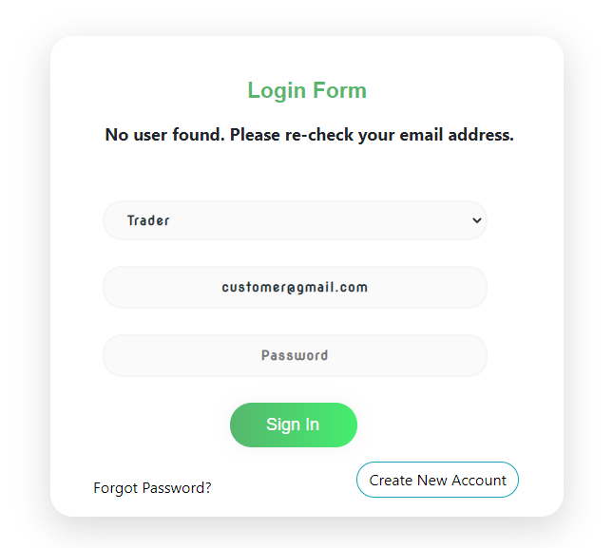

Login fails with an error message ‘no user found’.

2. Tried logging in with incorrect password

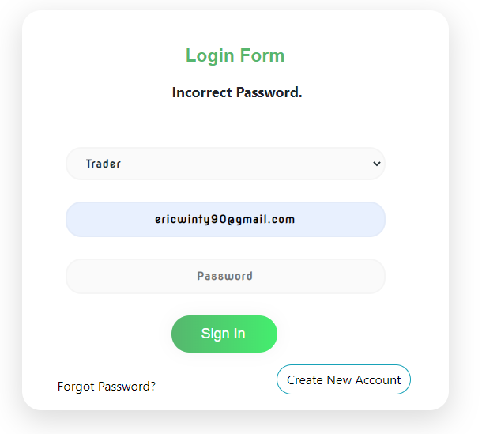

Login fails with an error message ‘Incorrect Password’

3. Tried logging in with correct email and password

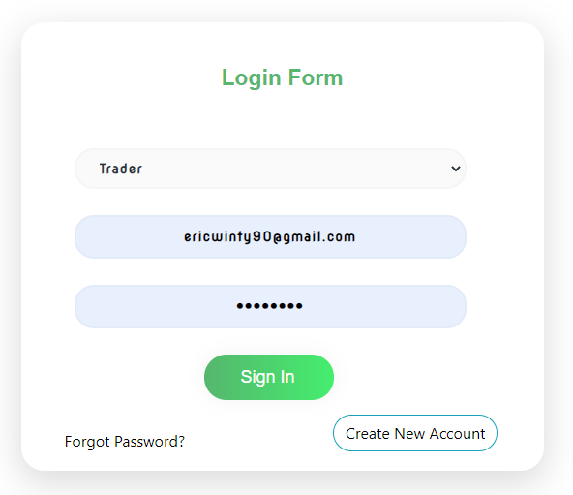

Login is successful and trader is redirected to trader interface.

# Reset Password

1. Clicked on reset password to send email verification link to reset password

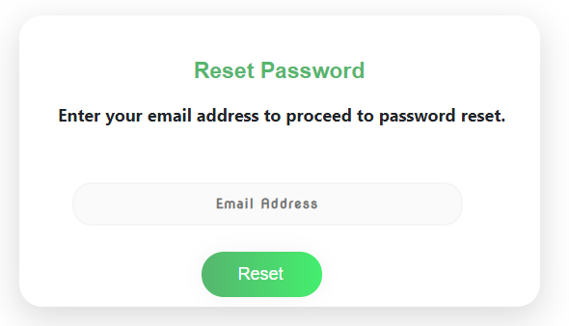

Traders enter their mail and click on reset. An email was sent with verification link.

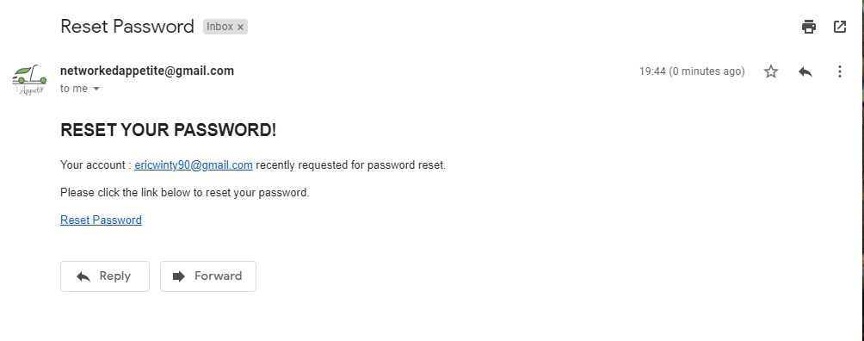

Clicking on reset password took trader to reset page. The page checks password validation as well.

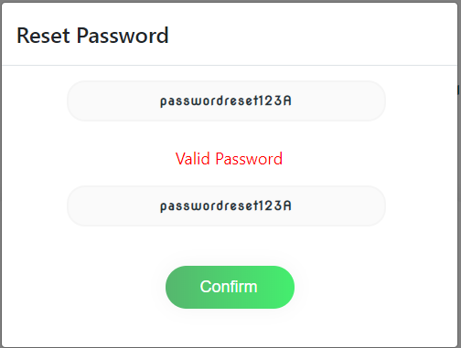

After confirm password was reset trader was redirected to login page with an message.

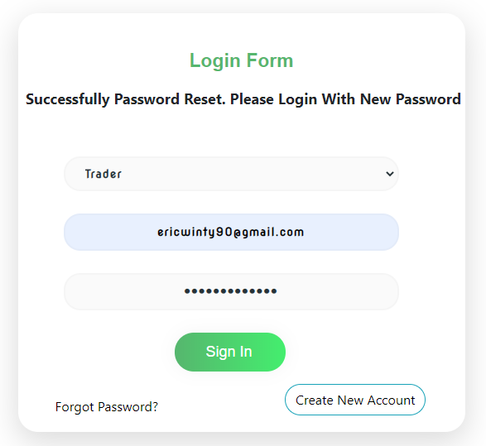

# Trader Interface

1. View Product

This is the trader interface where product list are shown once they are added.

# D:\Project Management\4.Monitoring and Controlling\Testing and Evaluation\Trader (Php)\Trader Product Interface.png

1. Add Product

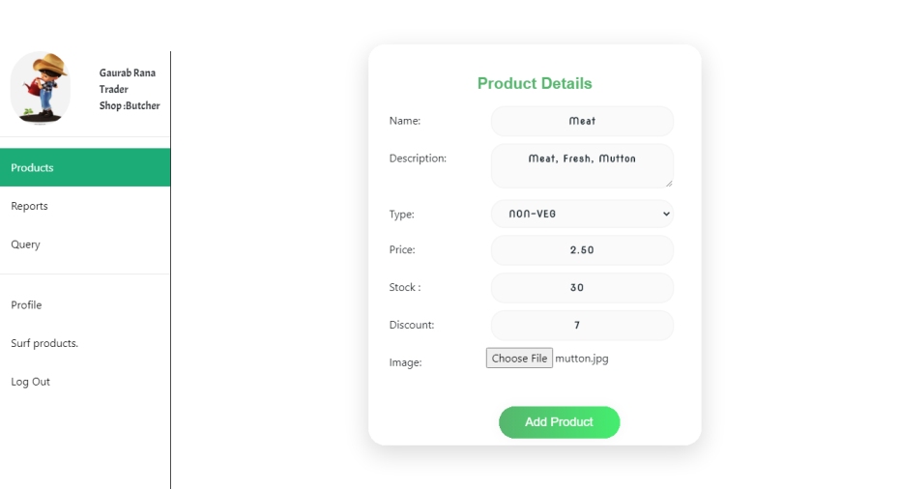

Trader can add product in this manner.

1. Update product

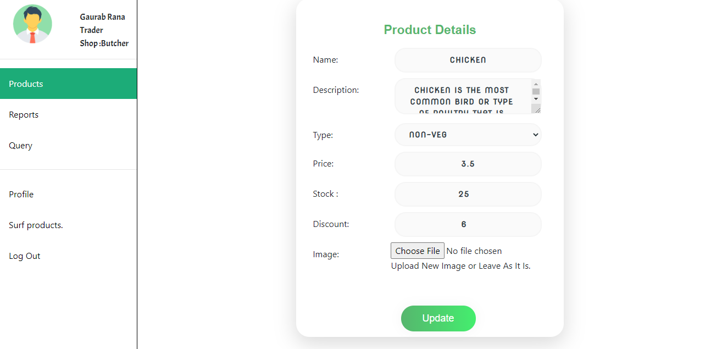

1. Delete Product 

Product deleted successfully

1. View Profile

Profile of trader shown successfully

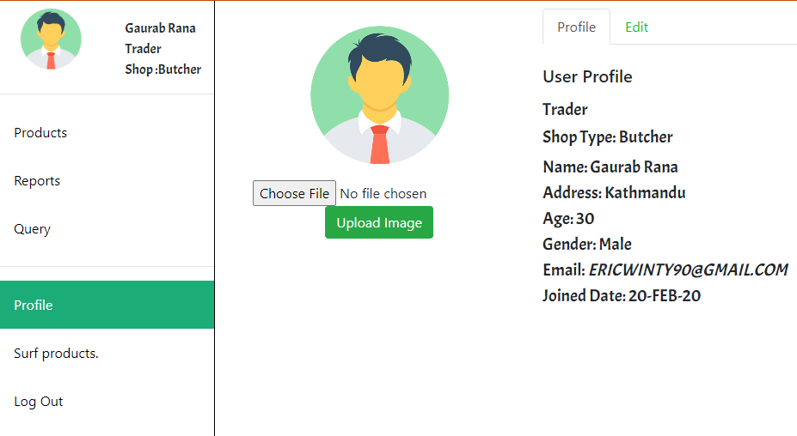

1. Update profile.

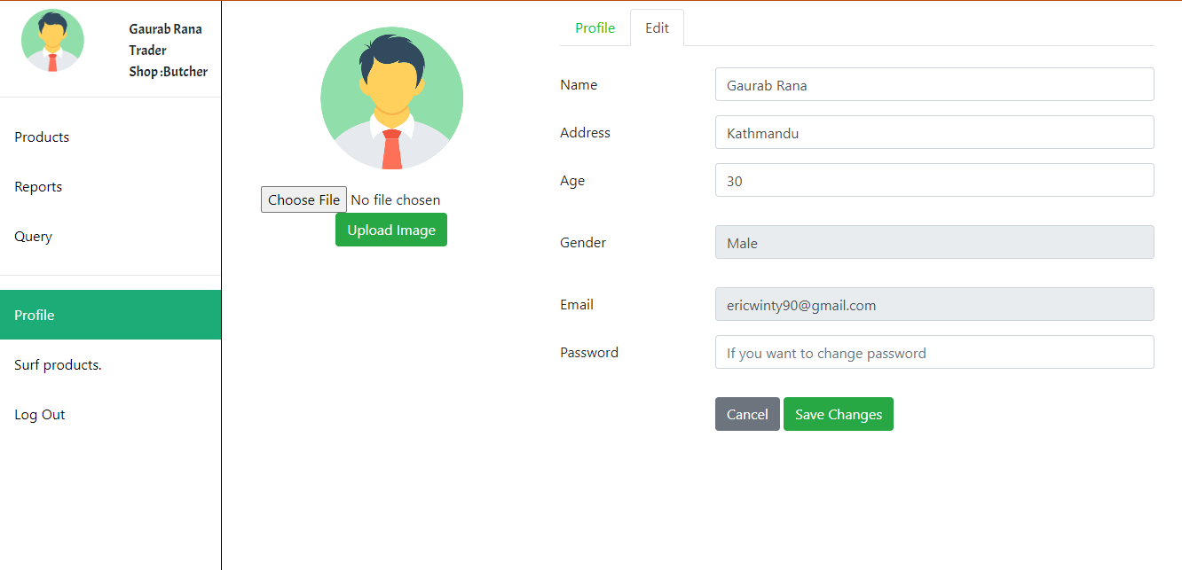

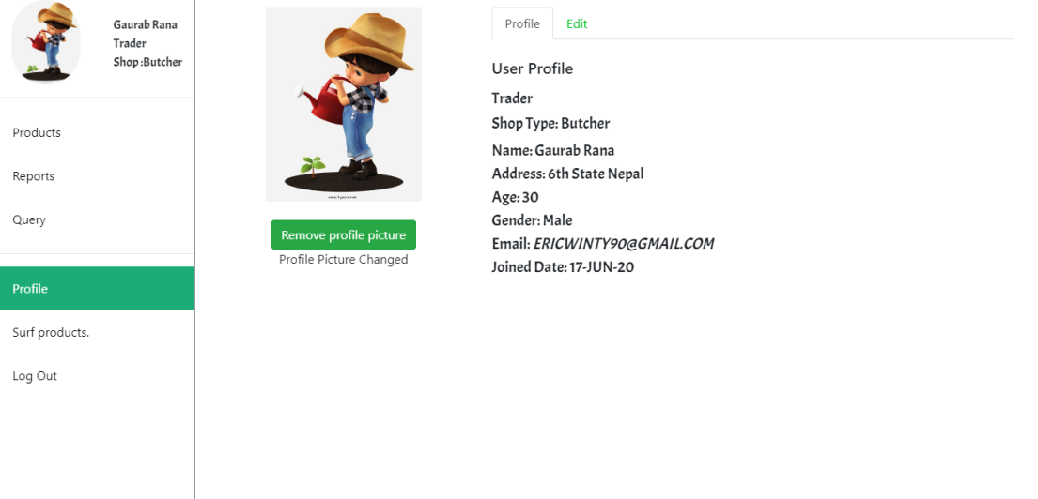

Profile updated successfully

1. View Report

On click reports trader is redirected to oracle application.

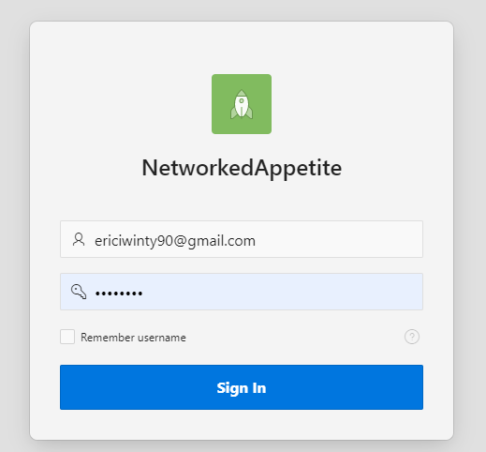

# Logout

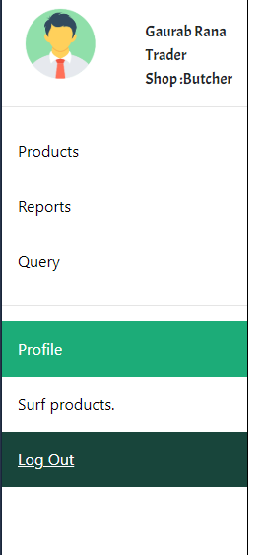

Traders can logout from the page using Log Out button at the bottom of the page.

User Testing

Table of Content

1. Sign Up and Login
2. Sign Up with empty username and password
3. log in with empty username and password
4. Sign Up with incorrect confirmation password
5. login in with invalid password
6. log in with correct credentials
7. Email Verification

2. Products

1. Sorting Product in alphabetical order
2. Add to Cart
3. Removing product from Cart
4. Clear All product from Cart

3. Checkout

1. Shipping through PayPal
2. Logging in PayPal
3. Order Confirmation

4. Logout

User Sign Up

1. User sign up and log in with empty username and password

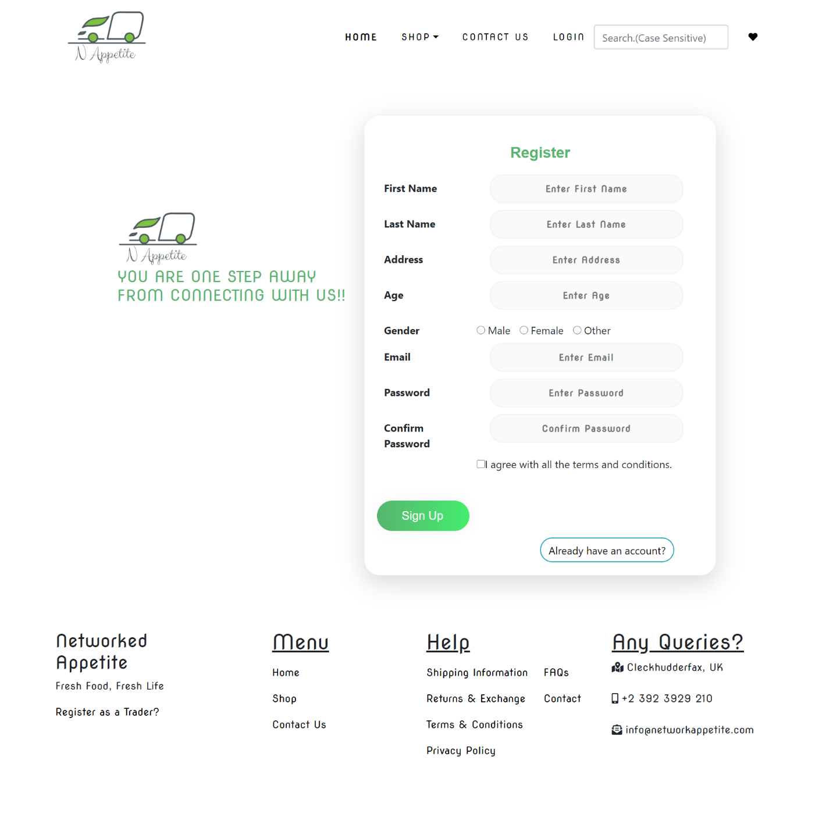

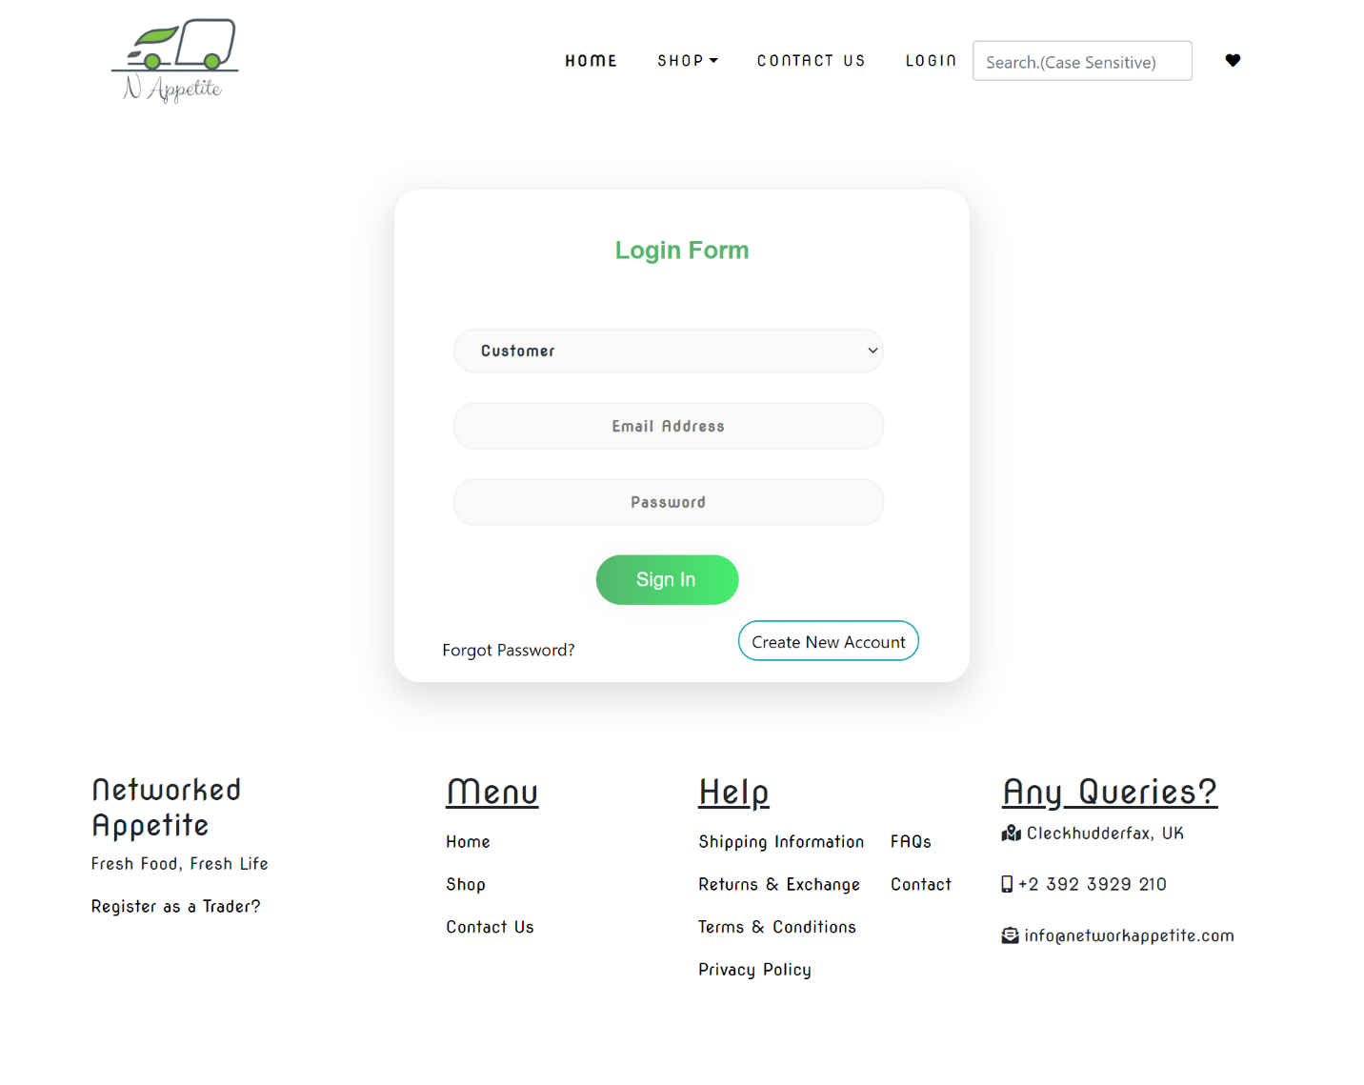

If user tries to log in with empty username and password then an error message is displayed “Invalid Login Credentials”.

1. Sign up and Login With Invalid Password



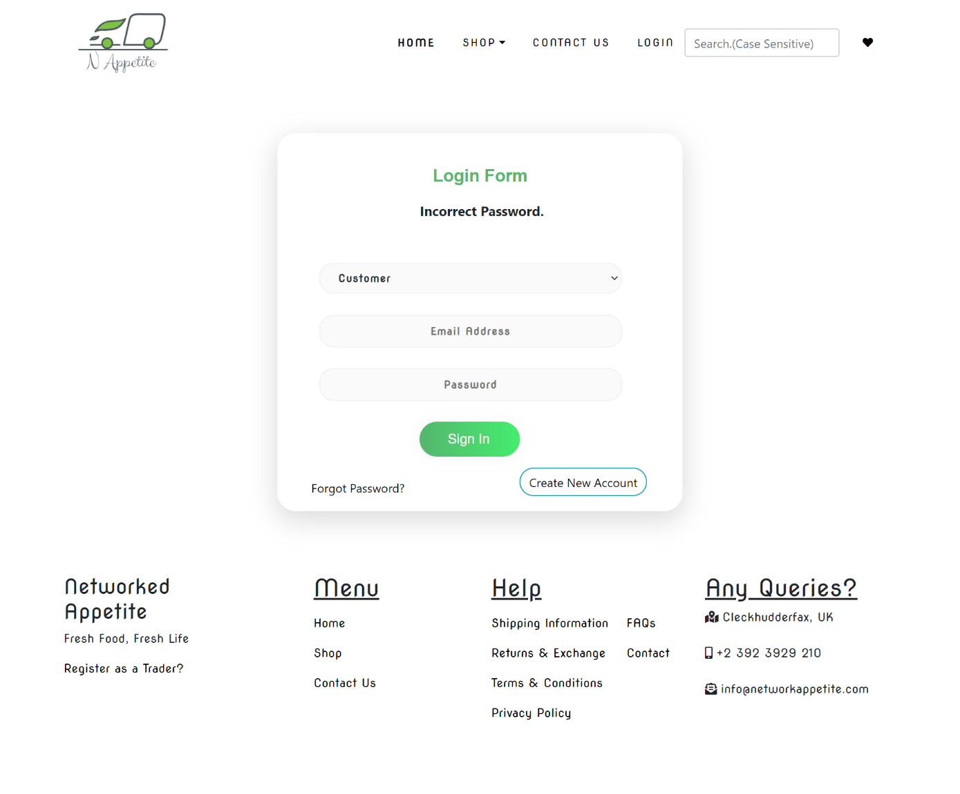

If user tries to log in with wrong password then an error message is displayed ‘Incorrect Password’

Email Verification

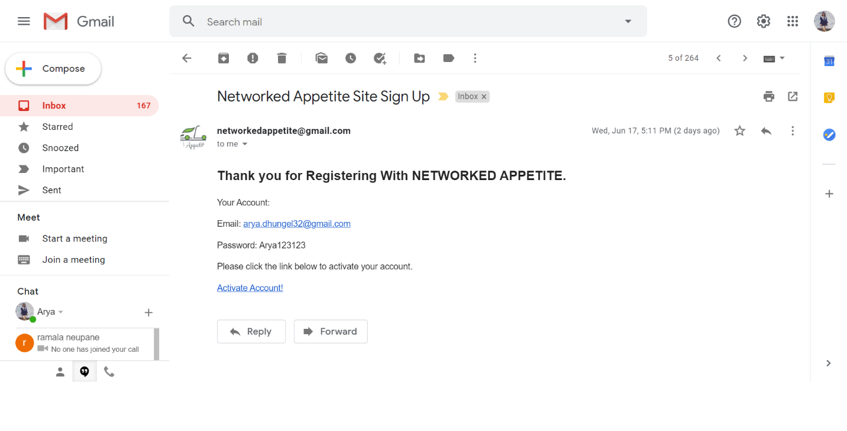

User gets email verification after they register and before they login.

1. User login with valid credentials(logged in with one of the user account)

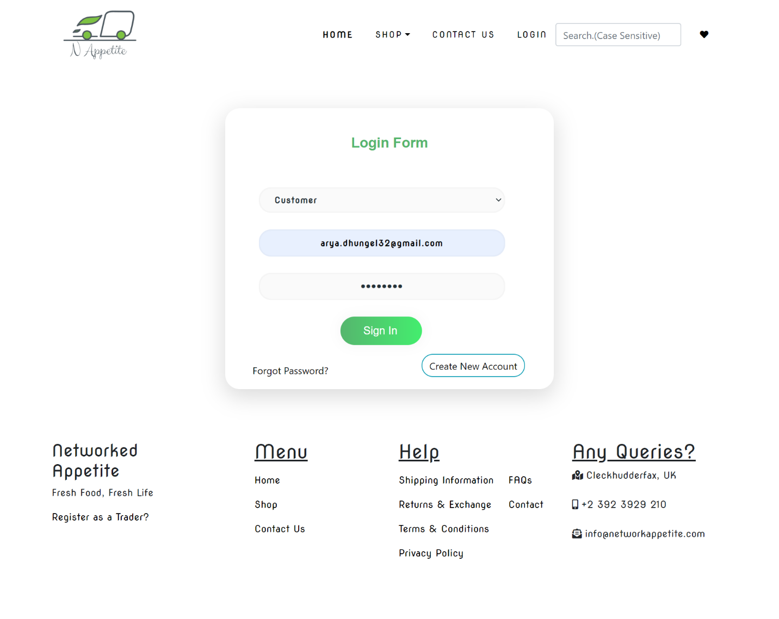

If user log in with valid credentials then user gains access to the shop.

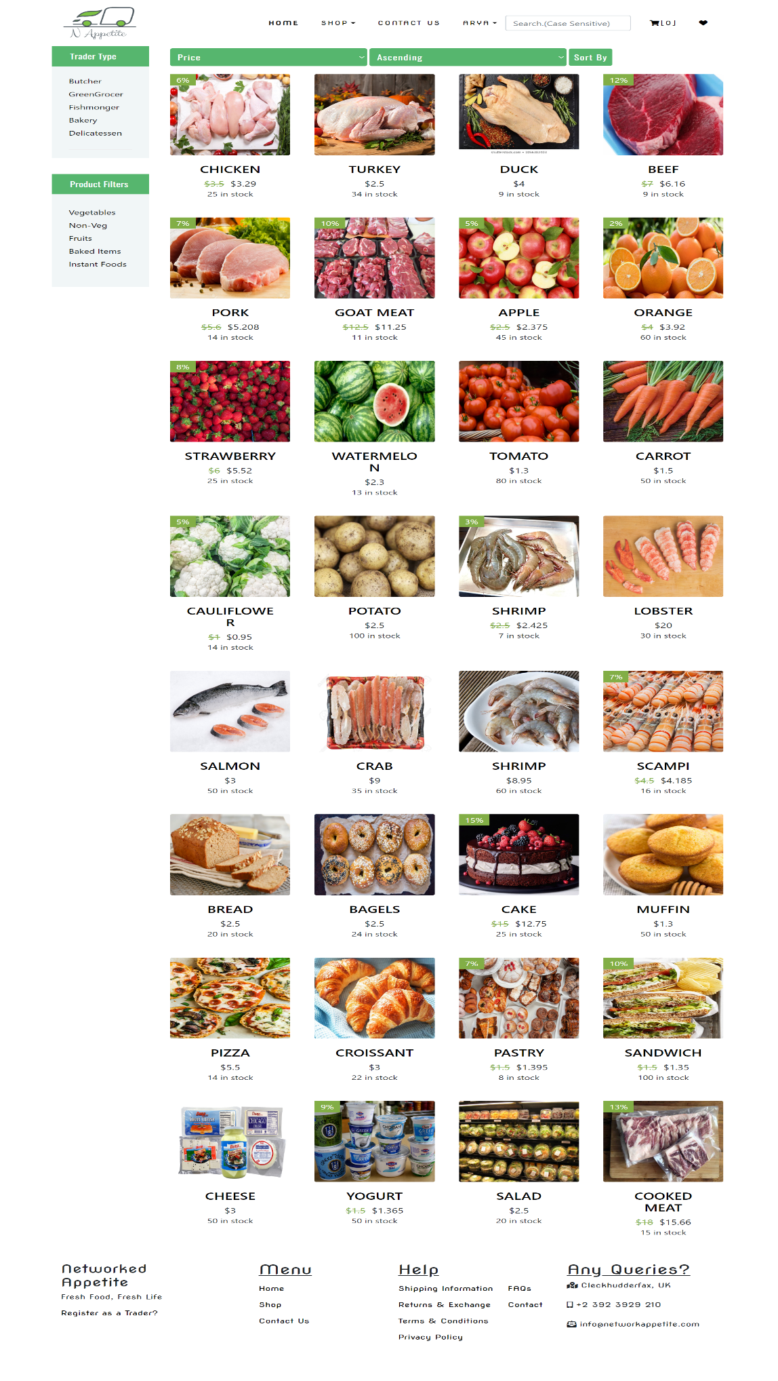

Sorting through alphabetical order -

# 

Adding Product to Cart

# 

Removing Product from cart

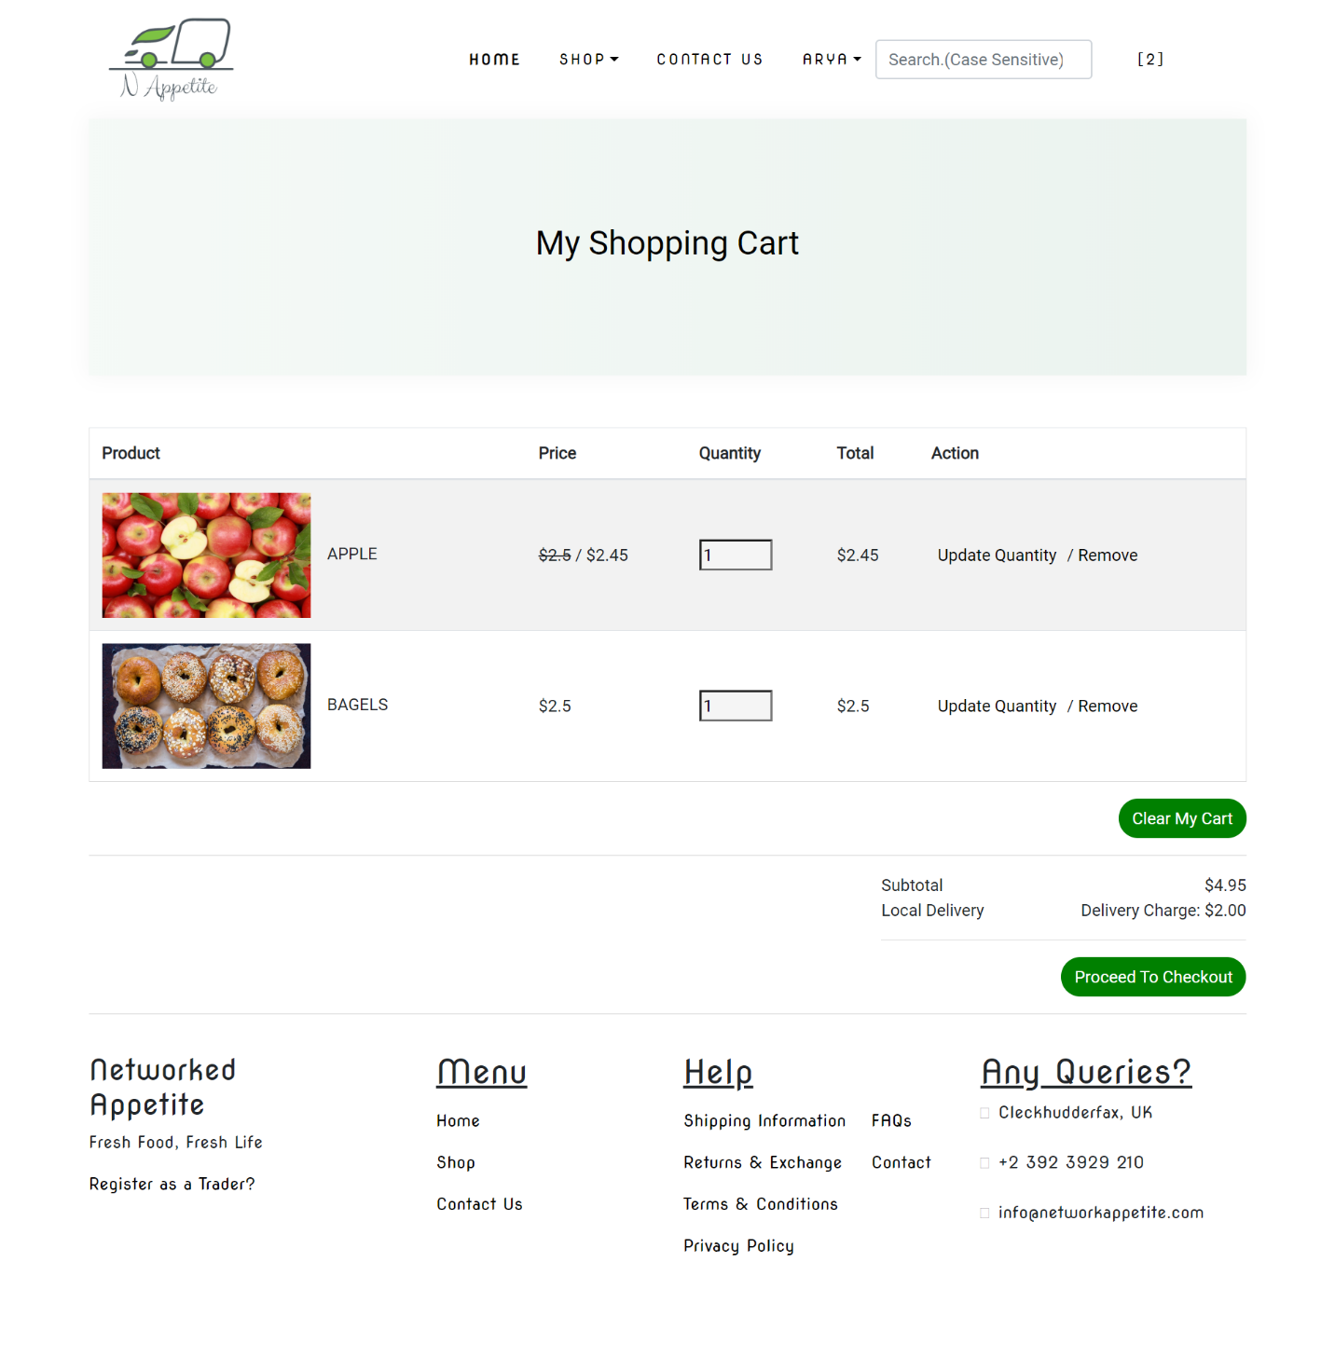

Clearing products from cart by clicking at ‘Clear All’ button

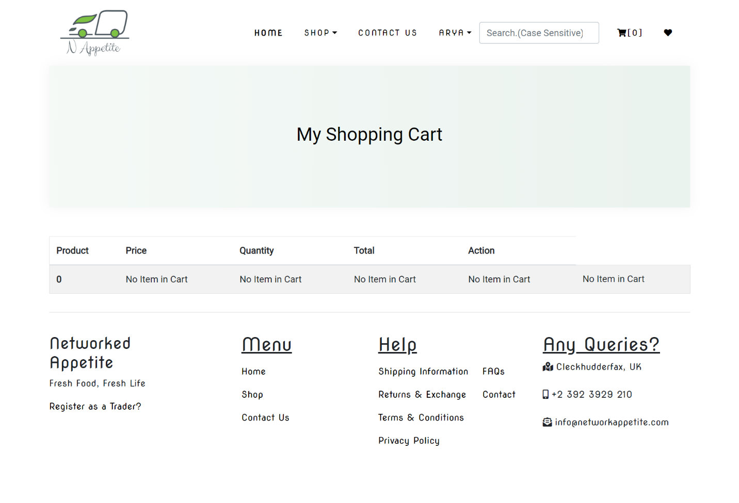

Checkout (Payment with PayPal)

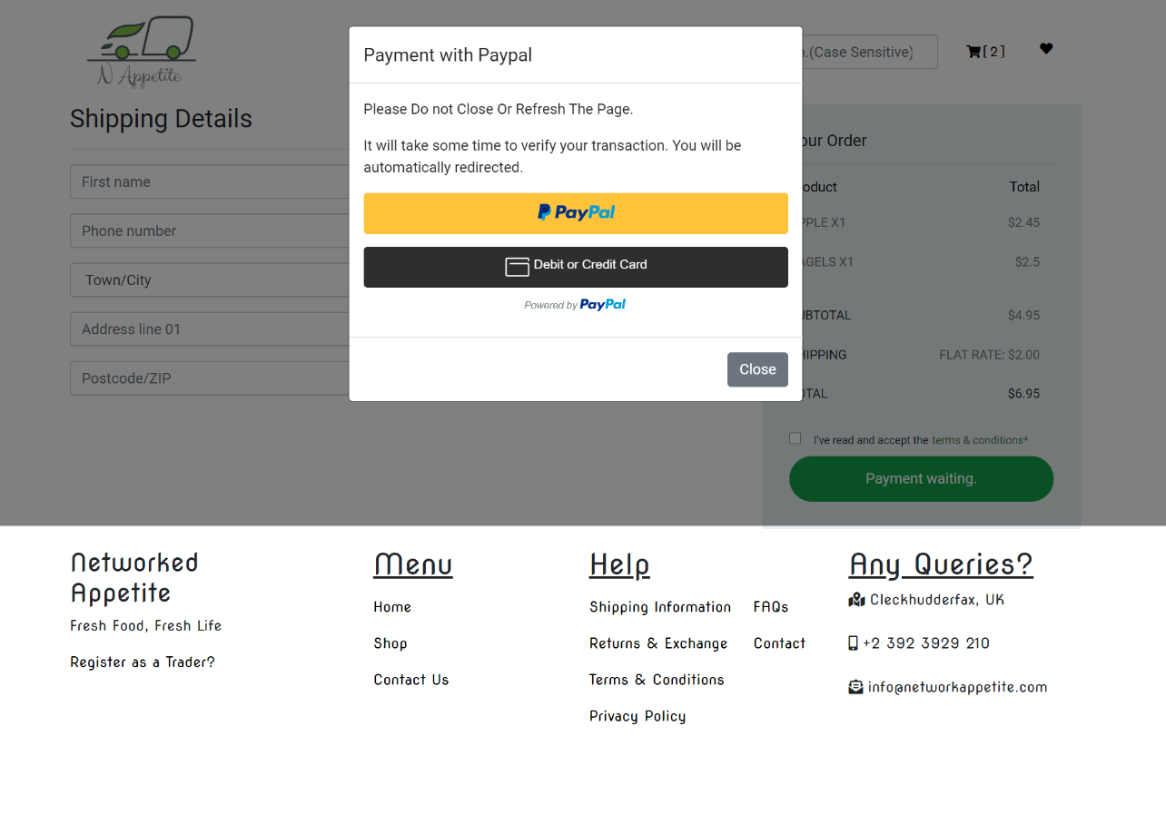

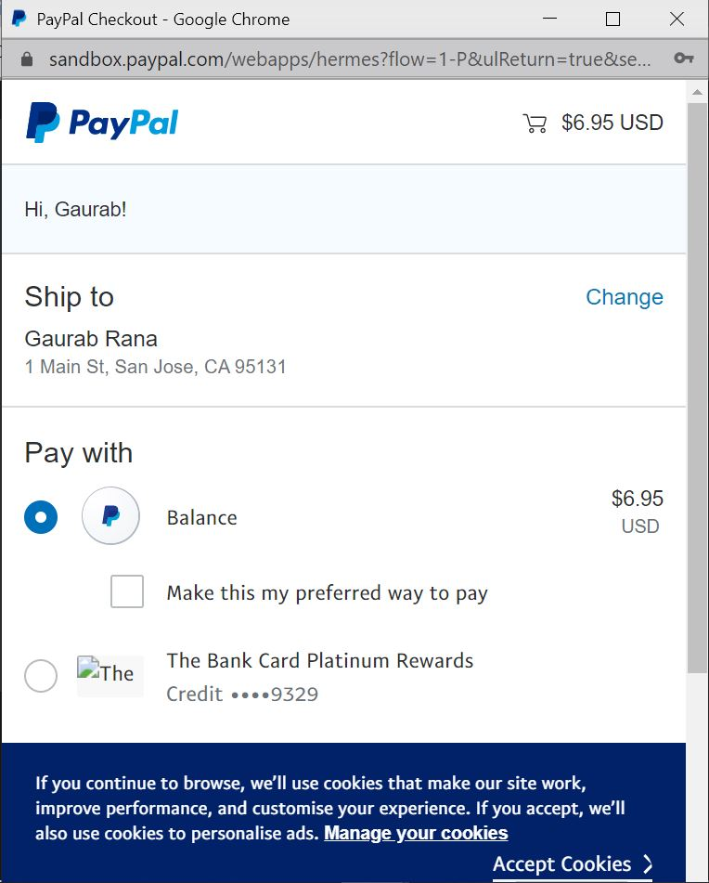

Order Confirmation

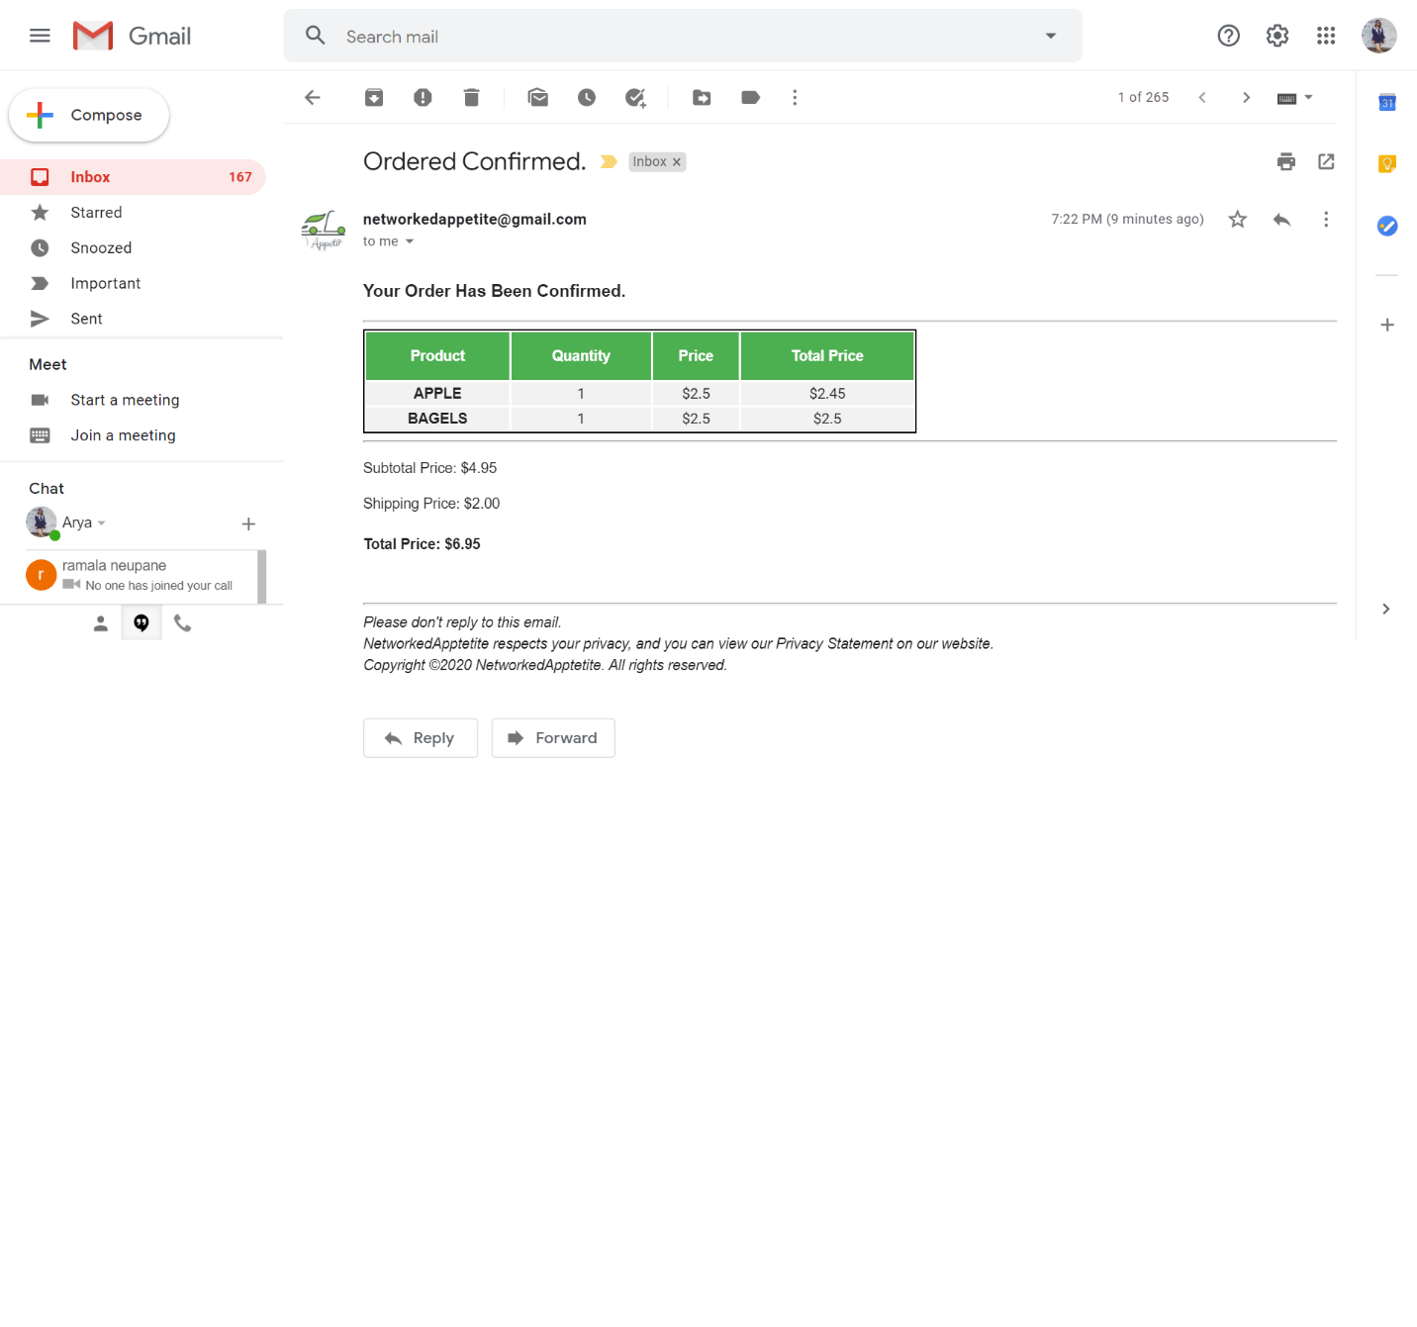

Surfing through trader type (Bakery)

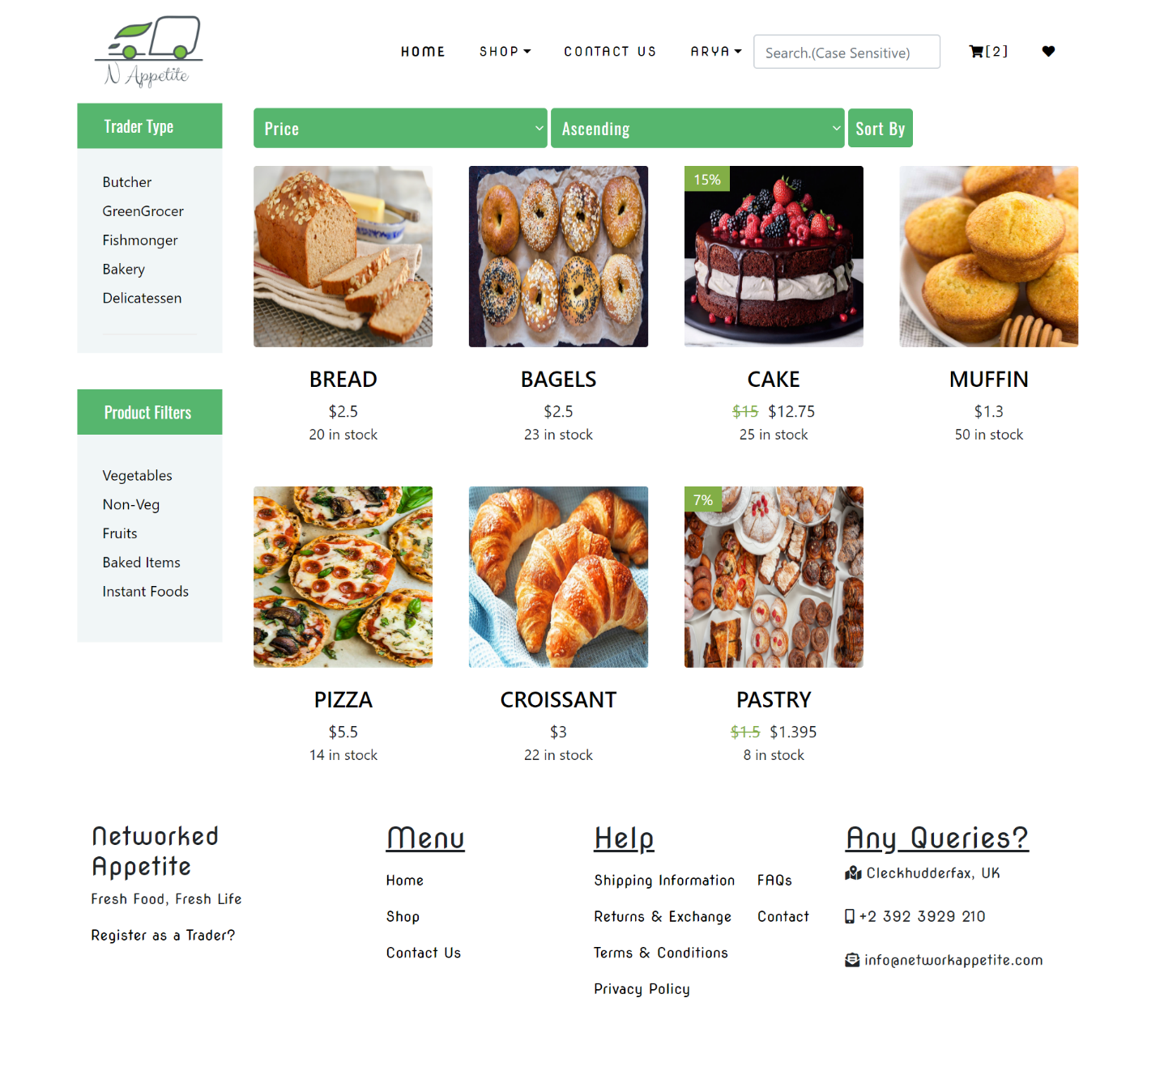

Logout

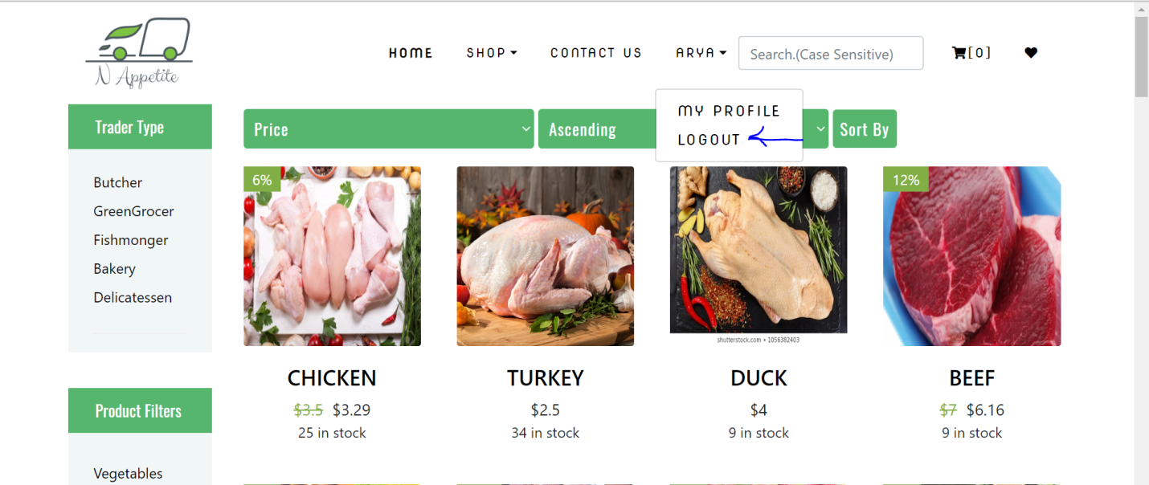

Users can logout from the page using Sign Out button at the drop-down menu by clicking at their name.

FAQ

1. How was e-commerce affected by corona virus, positive or negative?

- Ofcourse, e-commerce is fully affected by the covid-19 crisis, in a very positive way, either by a strong increase of home deliveries or either by a very large growth of pick-up operations on stores and drive-structures.

2. How can maximizing the revenue by any company that adopting E- Commerce rather than traditional commerce due to COVID-19 pandemic?

-To promote the importance of its services provided in avoiding and protecting against the spread of Corona virus.

3. What are the implications of digital transformation on audit procedures?

-The most important features of the digital transformation are e-business, e-government and e-commerce activities, which is an advanced step in the field of benefiting from information technologies and the communications revolution, especially the Internet.

1. How can you take credit cards payments across the net?

-There are three ways that merchants can take credit cards across the net. The first is by capturing card details securely, transmitting them to the desktop PC and then processing them through a normal PDQ facility. This option is only suitable if the ecommerce software has the appropriate security and is bank-approved. It costs the least and minimize change and hassle for an existing business.

1. Should I manage my store through a browser interface?

-At the moment, the most hyped topic around is that of the Application Service Provider or ASP. The theory is that everything can be done through a browser interface. Browsers are great, but don’t believe all that you hear. If you have to use your ecommerce site a lot – like processing orders, changing products and prices and so on, you will find it slicker and quicker via a local PC, and you won’t be reliant on your internet connection.